Problem Solving an Object Orientated Programming Assignment

Object Orientated Programming

Arden university

­­

Part. I UML

In the system's design, various fundamental relationships between classes demonstrate the design and interactions among different components, such as inheritance, composition, and dependency, each serving a specific purpose in structuring the program.As Simon (2014) says “Classes are the basic components of any object oriented software system and UML class diagrams provide an easy way to represent these. As well as showing individual classes, in detail, class diagrams show multiple classes and how they are related to each other. Thus a class diagram shows the architecture of a system.”

For starters, inheritance is quite important. The Fulltimestaff, Parttimestaff, and Customer classes are all extensions of the Person class. This implies they inherit all of Person's properties and methods, including the ability to add or edit attributes relevant to their roles. For example, Fulltimestaff may have a salary element, whereas Customer may track bootcamp fees. Inheritance simplifies the design by offering shared functionality while still allowing for specialization.In the words of Richard and Lewis (2000) "Inspired from biological modeling, inheritance allows new classes to be constructed that inherit characteristics (fields and methods) from ancestor classes while typically introducing more specialized characteristics, new fields, or methods. A subclass is logically considered to be a specialized version or extension of its parent and by inference its ancestor classes"

Composition relationships control the lifecycle of items. The Fulltimestaff_crud, Customer_crud, and Parttimestaff_crud classes all have composition relationships with their respective entities: Fulltimestaff, Customer, and Parttimestaff. This means that these CRUD classes store and manage the lifecycles of their linked things. This tight linkage ensures that entities are properly handled, including processes like as creation, retrieval, updating, and deletion.As Simon (2014) says “Composition is similar to aggregation but implies a much stronger belonging relationship i.e. Object(s) of Class B are ‘part of ’ a Class A object”.

Several dependencies define component interactions. The Main_Menu class is dependent on the CRUD classes (Fulltimestaff_crud, Customer_crud, Parttimestaff_crud), Bootcamp_Prices, Training_Programs, Shopping, and Shopping_Prices. Main_Menu invokes methods from these classes to manage functions such as staff management, training programs, and shopping information. This centralization in Main_Menu enables consistent operation and user-friendly interaction.In the words of Simon (2014) “Typical use of dependency lines would be where Class A has a method which is passed a parameter object of Class B, or uses a local variable of that class, or calls ‘static’ methods in Class B.”

Bootcamp extends Bootcamp_Prices, inheriting its methods and attributes. It enables Bootcamp to use cost-effective functionalities while also offering specialized features linked to certain bootcamp options.

Finally, the Project_Main class depends on Main_Menu, implying that it uses Main_Menu to initialize and operate the application's main interface and flow. This ensures that Project_Main can effectively help users navigate and interact with other system components.

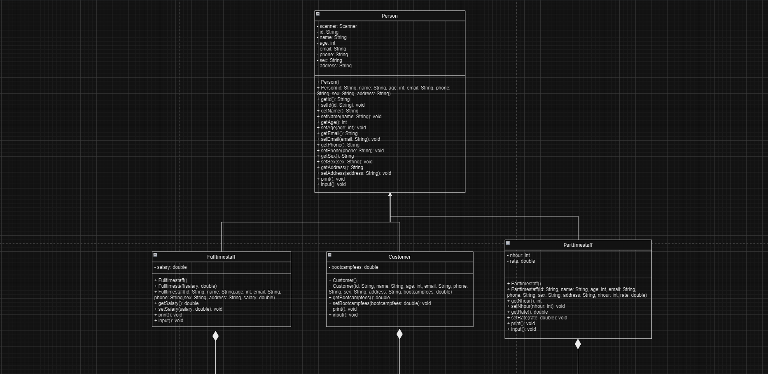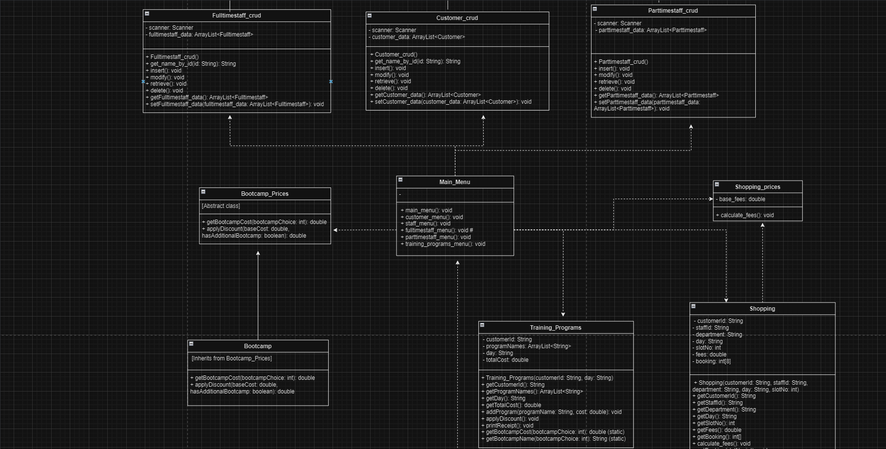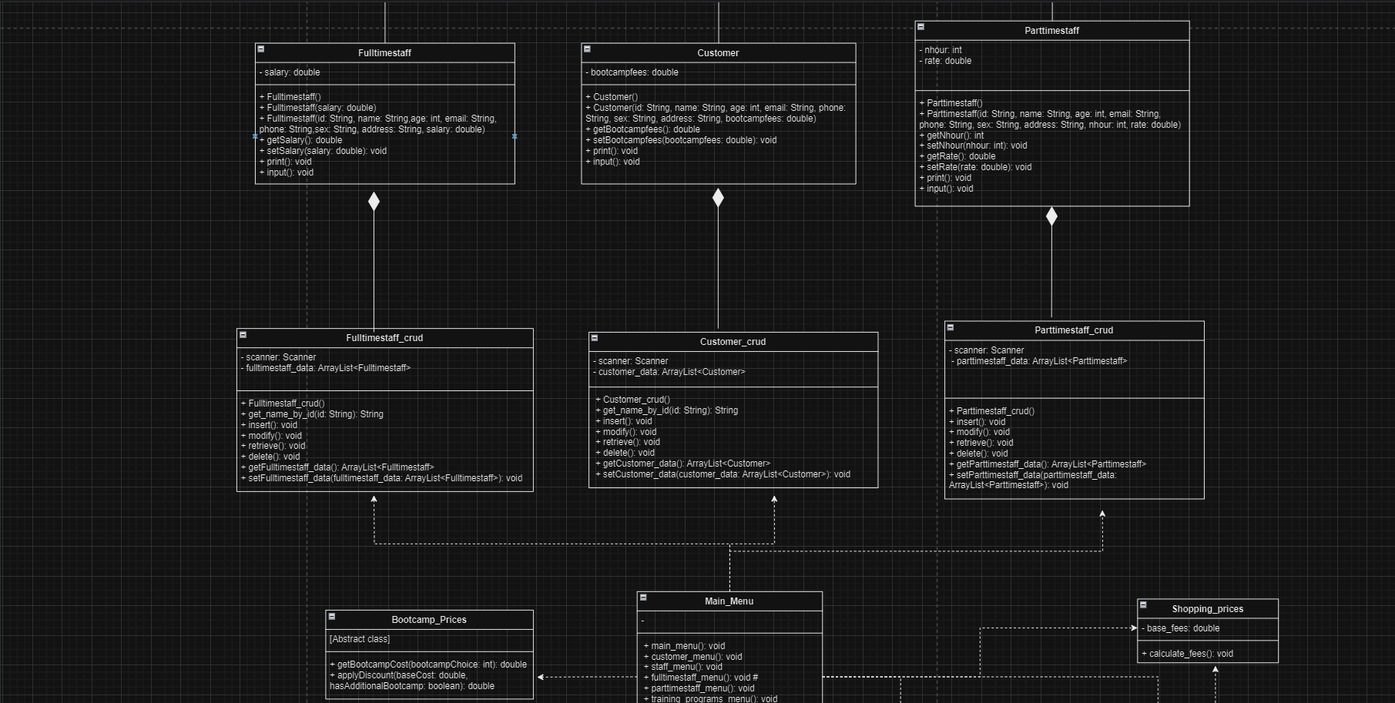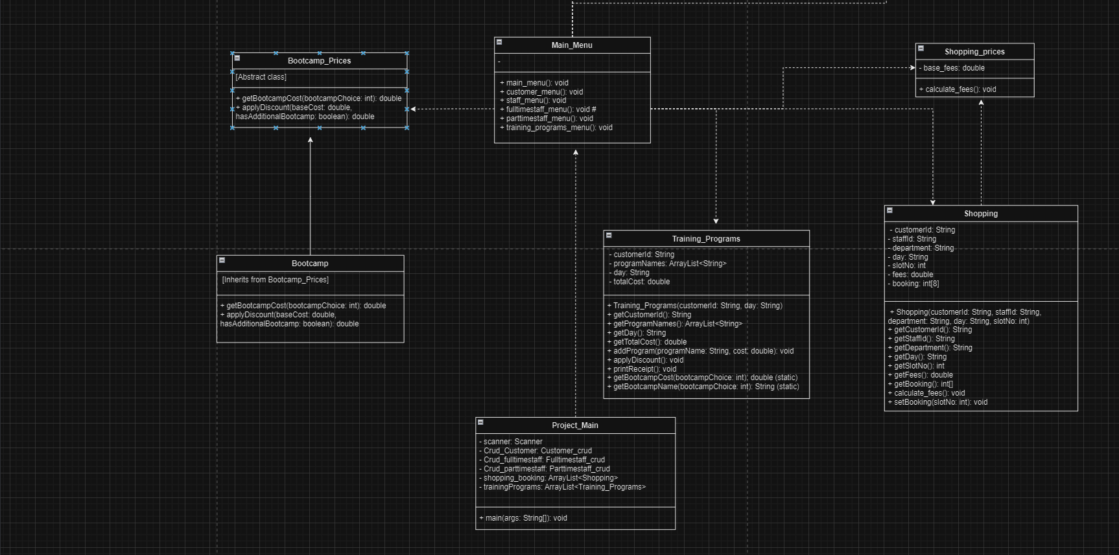

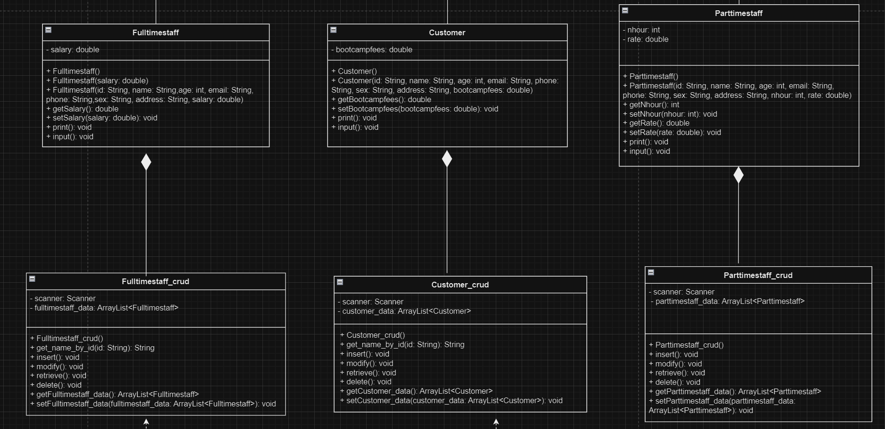

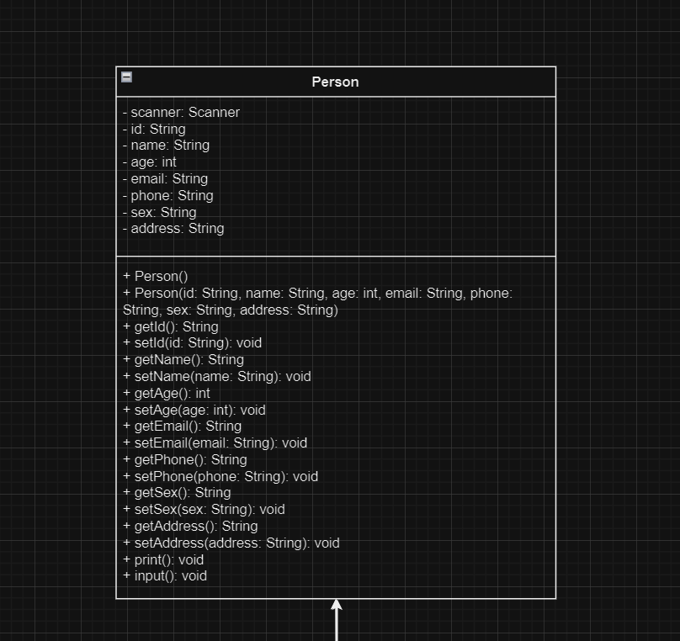

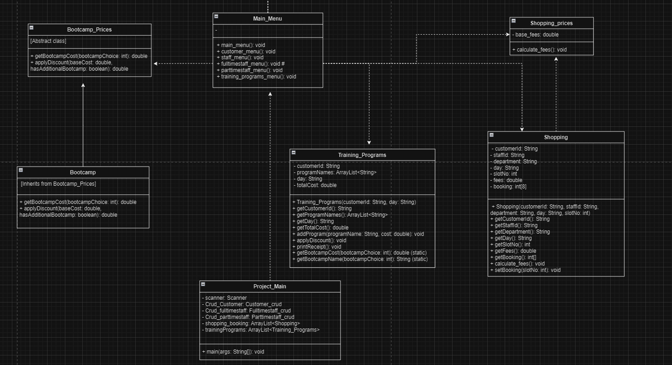

Part. II Base Class Testing

To test the UML concepts I built simplified prototypes of the Bootcamp_Prices and Person classes. For Bootcamp_Prices, I developed basic versions of the getBootcampCost and applyDiscount methods to guarantee that charges and discounts were correctly computed and applied. This proved that the methods will work as expected in the final system.For Person, I created a prototype with basic characteristics and methods for testing the class's interactions and capabilities. These prototypes helped test that the essential capabilities were correct and well-integrated, laying a solid foundation for the main OOP implementation.

Person Test:

This is the prototype code for the Person class:

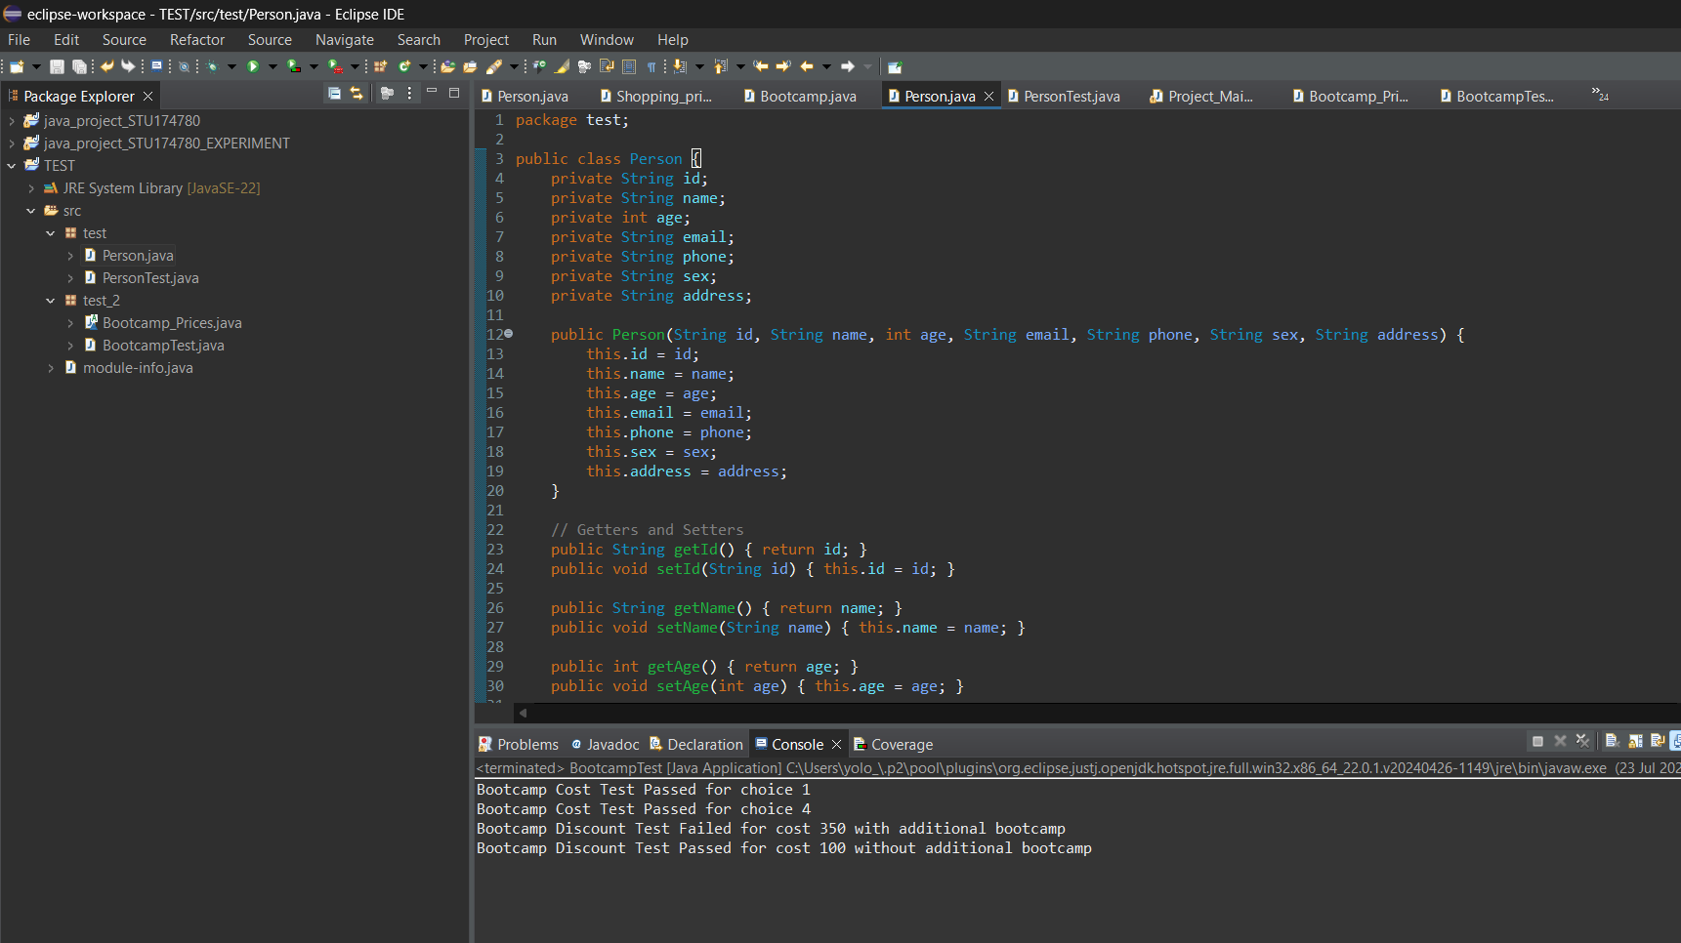

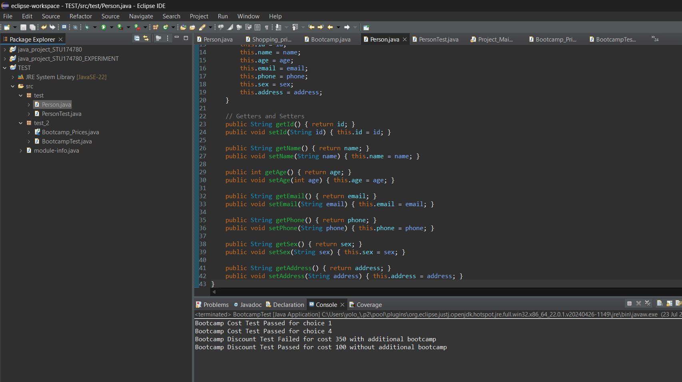

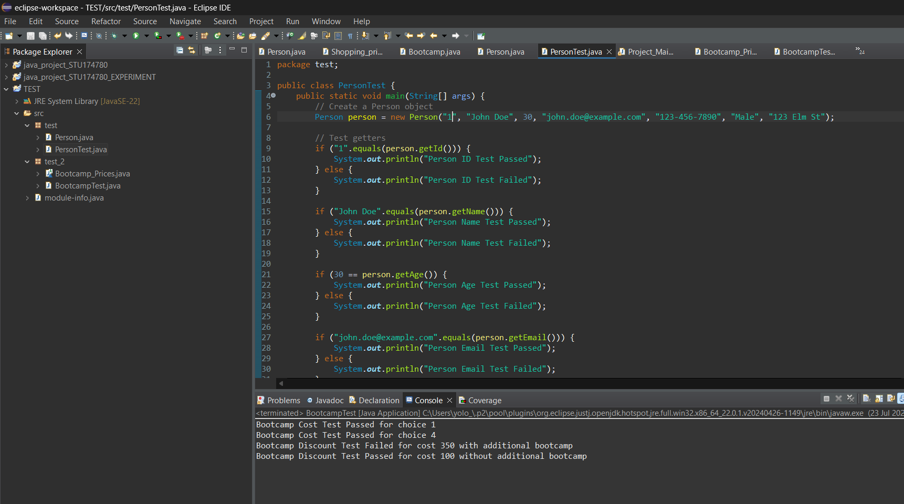

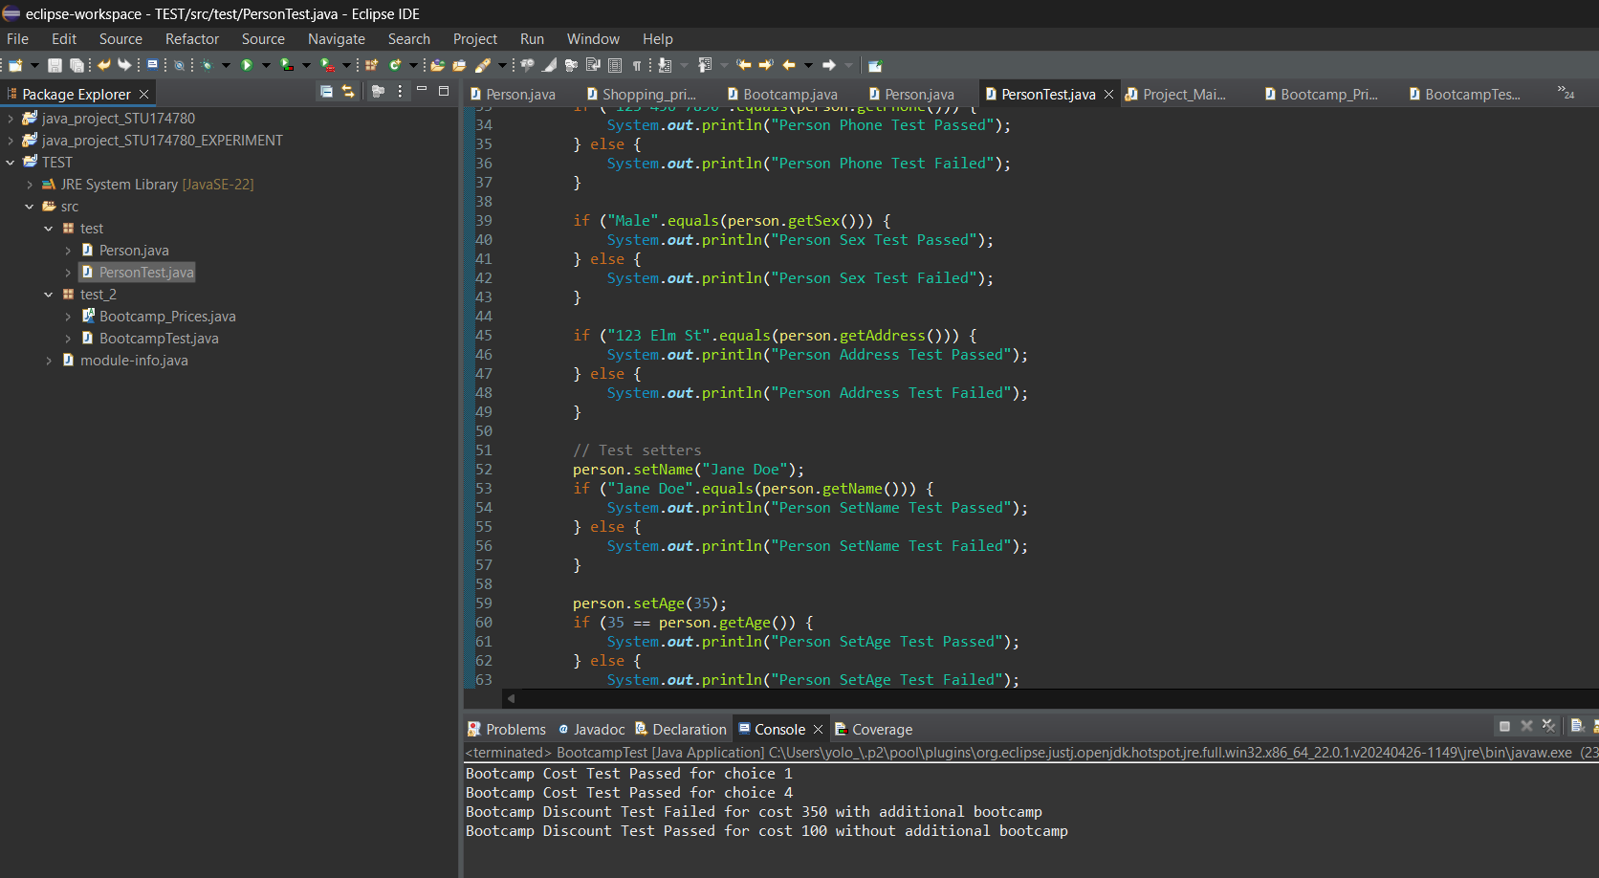

Example of how if the right values are modified,the test would result in a “fail”,which validates the fact that the initial prototype code is apt to be put in the main OOP:

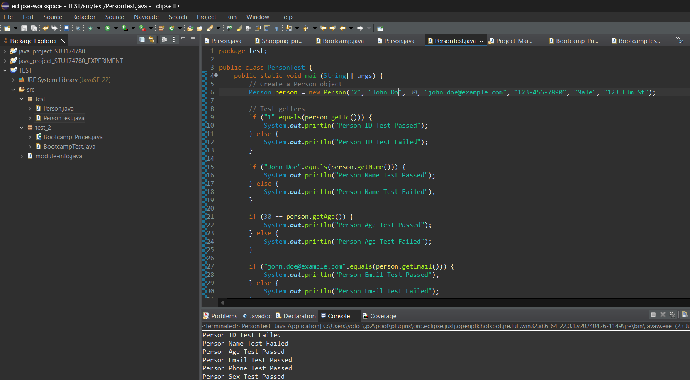

Bootcamp_Prices Test:

This is the prototype code for the Bootcamp_Prices class:

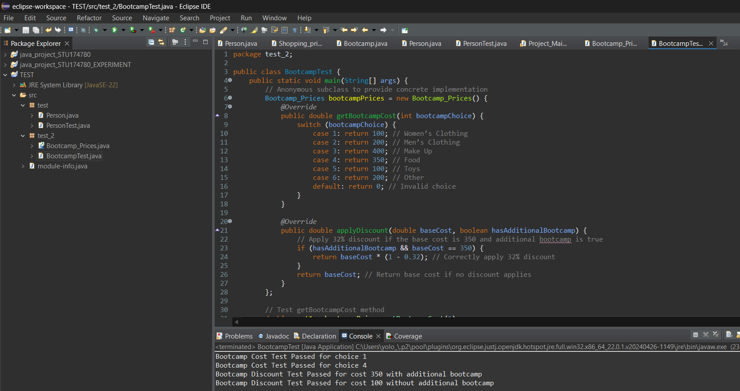

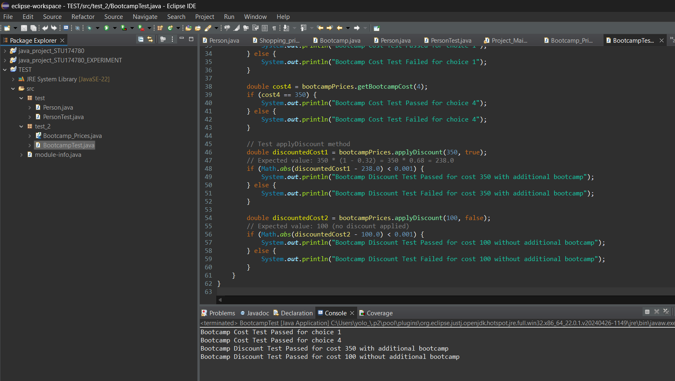

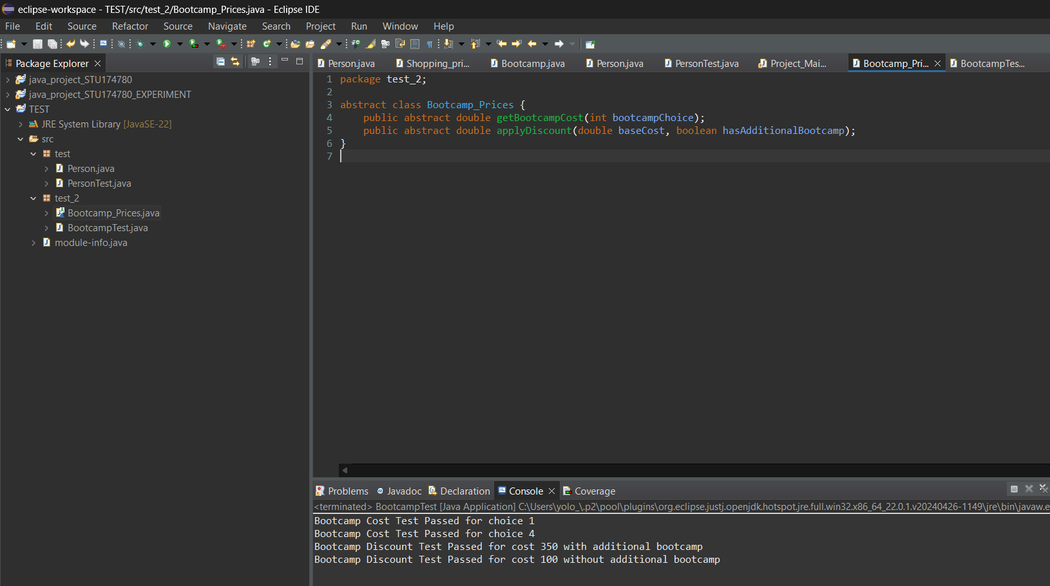

Example of how if the right values are modified,the test would result in a “fail”,which validates the fact that the initial prototype code is apt to be put in the main OOP:

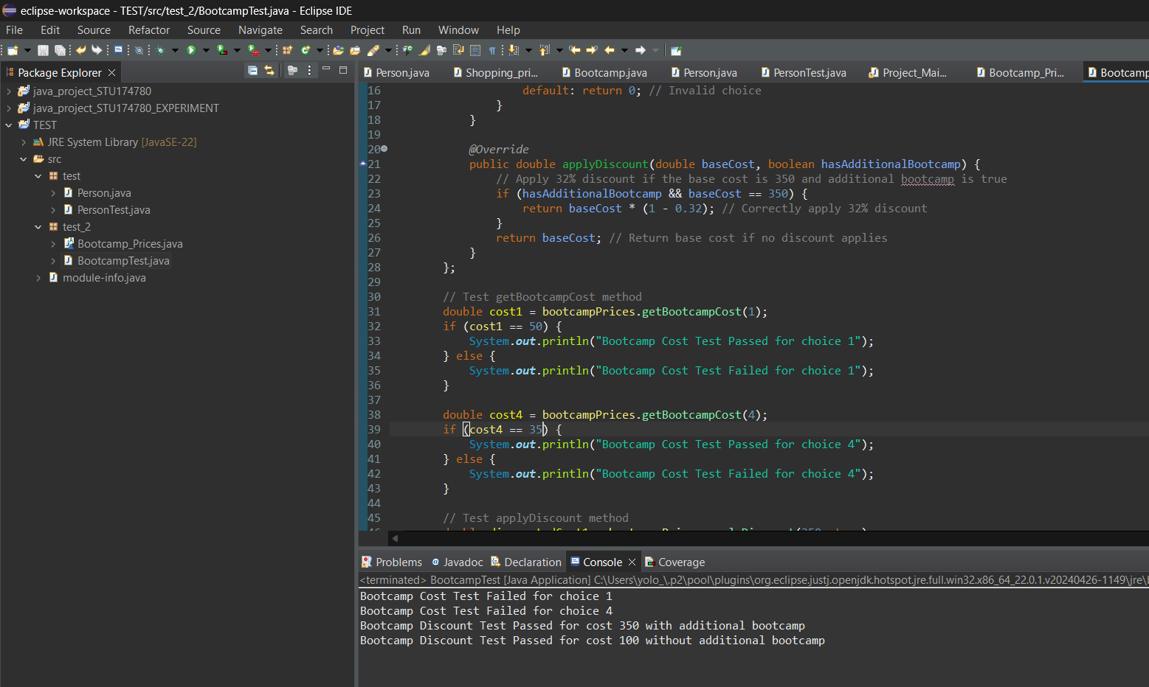

Part. III Hierarchy in Java

In creating my Java system, I used Person and Bootcamp_Prices as base classes, with Customer, Fulltimestaff, Parttimestaff, and Bootcamp extending them. This technique is both rational and efficient, allowing my application to be more clear, maintainable, and flexible.I used Person as a base class to encapsulate common characteristics and methods for individuals, such as id, name, age, email, phone, gender, and address. By storing these details in Person, I eliminate code duplication and assure consistency across classes such as Customer and Fulltimestaff. This approach not only saves maintenance but also makes it easier to upgrade shared capabilities. Bootcamp_Prices is an abstract base class with methods such as getBootcampCost() and applyDiscount(). This enables individual bootcamps to implement their own pricing and discount algorithms while sticking to a uniform interface. For example, the Bootcamp class provides real implementations of these methods, ensuring that each bootcamp can manage its own pricing strategy.Overall, utilizing Person and Bootcamp_Prices as base classes helps me organize my hierarchy and ensures reusable code and adaptability. Its design follows object-oriented concepts, making the system easier to adapt and maintain as it grows.In the words of Richard and Lewis (2000) "Another cornerstone of OOP is inheritance. Inspired from biological modeling, inheritance allows new classes to be constructed that inherit characteristics (fields and methods) from ancestor classes while typically introducing more specialized characteristics, new fields, or methods. A subclass is logically considered to be a specialized version or extension of its parent and by inference its ancestor classes. "

Part. IV Java Project Creation/Class Justifications:

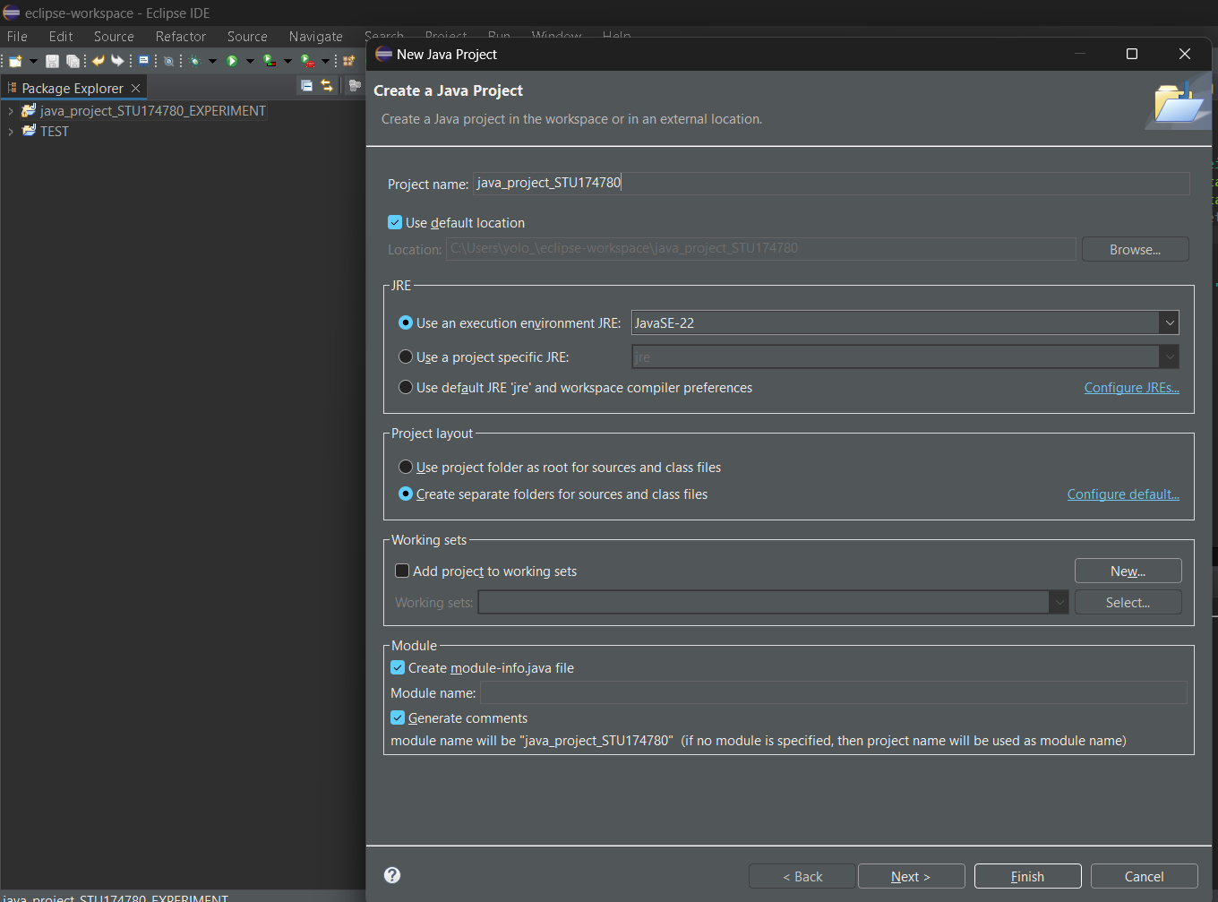

I chose the name “java_project_STU174780” for my project,and created it.

Project_Main

The Project_Main class is the entry point for the Java application that manages clients, staff, bookings, and training programs. This class manages user interactions and orchestrates numerous functionalities through its methods. It basically initializes objects for CRUD (Create, Read, Update, and Delete) activities involving customers and employees, as well as collections for bookings and training programs. The main method includes an infinite loop that displays a menu to the user and processes their selections based on their input.In the words of Richard and Lewis (2000) "A method is a function or procedure that defines the action associated with a message. It is given as part of a class description. When a message is invoked on an object the details of the operation performed on the object are specified by the corresponding method." It manages customer and employee data, checks slot availability for reservations, and enrolls users in training programs. As users navigate the application's menu, they can execute several tasks. They, for example, have the ability to add, retrieve, amend, and remove customer and employee records. The class also lets users check the availability of booking slots and schedule appointments with staff members. It also oversees the enrollment process for training programs, including workshops and bootcamps. The primary purpose of the Project_Main class is to serve as the core controller, integrating various components of the application into a unified user experience. It accepts user input, delegated responsibilities to other classes, and maintains the overall application logic. It makes it easier to handle clients, personnel, bookings, and training programs by offering a single point of interaction with the system.

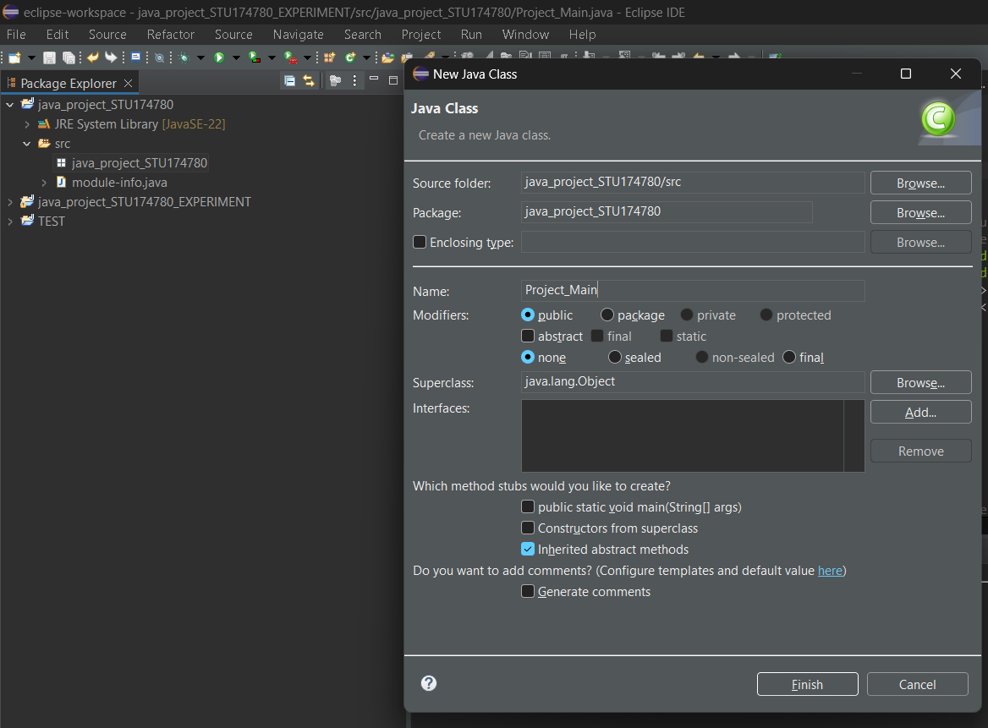

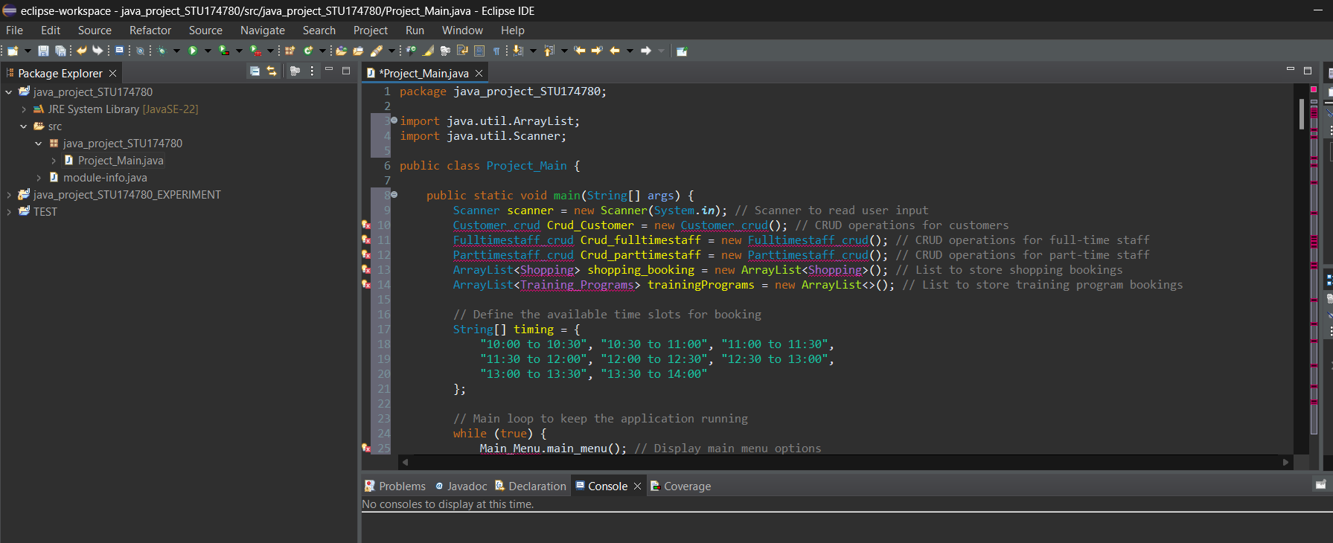

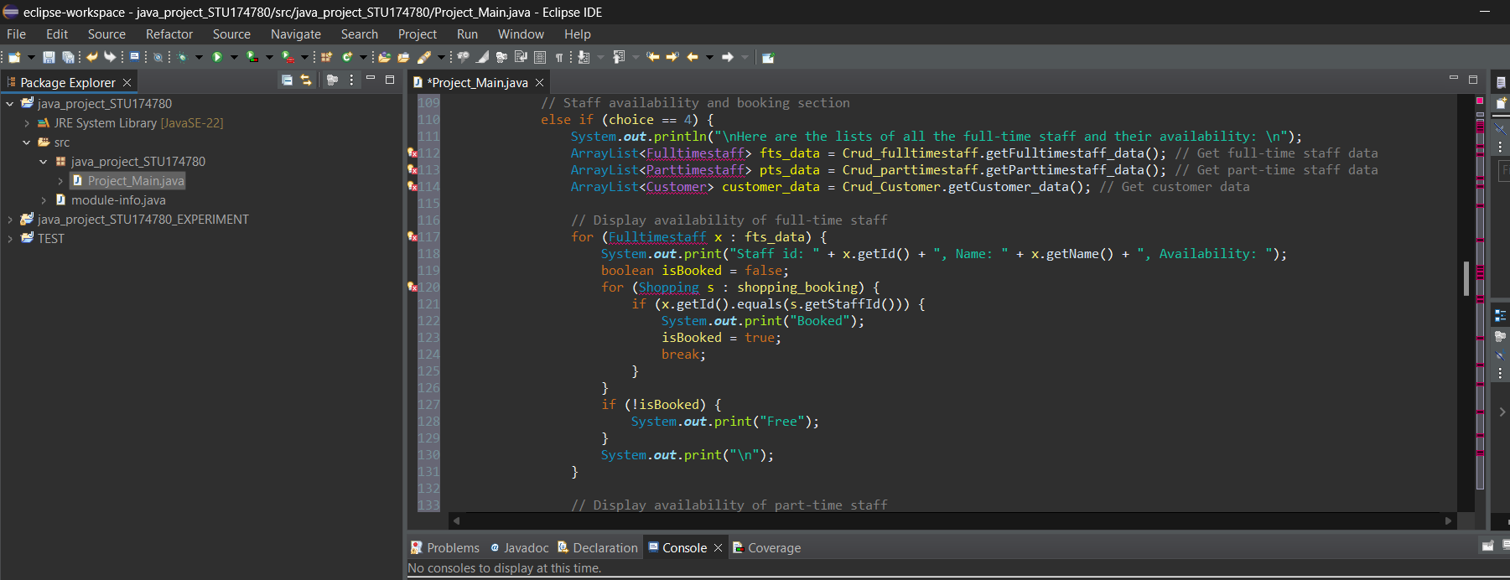

Main_Menu

The Main_Menu class is a utility class that displays multiple menu selections to the user in the Java application. It includes static methods for displaying several menus relating to customer administration, personnel management, slot checking, booking, and training program registration.The **main_menu** method displays the application's main menu, which includes options for accessing customer-related actions, staff management, checking available shopping slots, booking shopping slots, closing the application, and registering for training programs. This method serves as the application's core navigation point.The **customer_menu** method provides options for handling customer information. Users can add a new client, obtain facts about an existing customer, change customer information, or delete a customer. This menu facilitates the efficient processing of customer records.The **staff_menu** method is intended to manage staff-related operations and offers two primary options: full-time and part-time staff. This menu allows users to access more specific personnel management features.The **fulltimestaff_menu** and parttimestaff_menu methods further categorize staff management options as full-time and part-time. Each of these techniques enables users to insert, retrieve, amend, and delete records for full-time and part-time employees, respectively.Finally, the **training_programs_menu** function is used to register for training programs. It allows you to register for workshops and bootcamps, as well as return to the main menu. This option allows you to handle training program enrolments more easily.

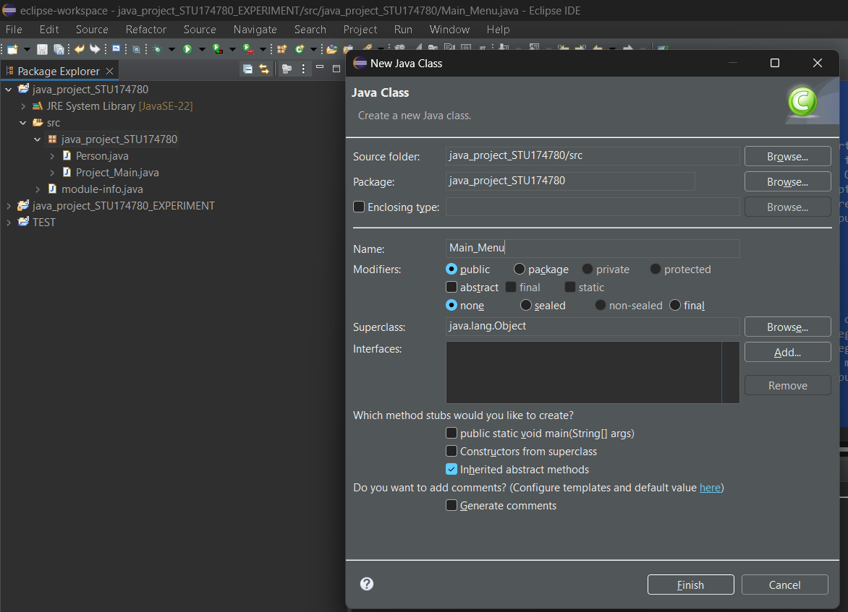

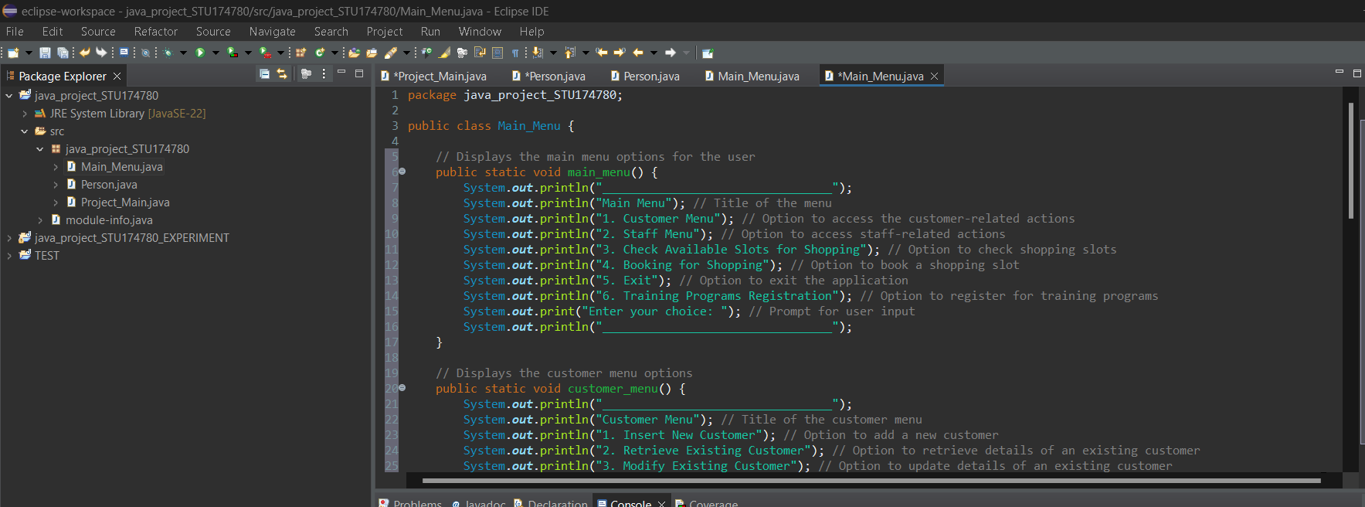

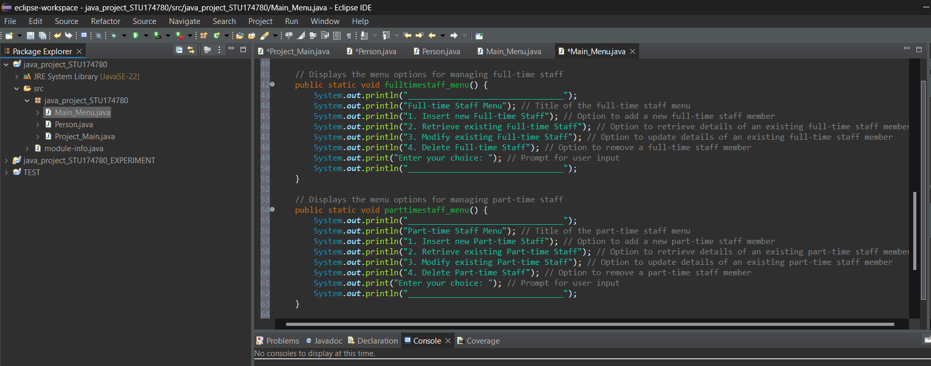

Person

The Person class gives a template for building objects that represent individuals and their unique personal characteristics. It has private fields for saving data such as an ID, name, age, email, phone number, gender, and address. This class has two constructors: a default constructor, which initializes the object with default values, and a parameterized constructor, which allows all fields to be initialized with specific values. The Person class's characteristics and methods are passed down to the Parttimestaff, Fulltimestaff, and Customers classes via inheritance.As Simon (2014) says “All the characteristics from classes above a class/object in the hierarchy are automatically featured in it – we call this inheritance.” This creates a hierarchy, with Person as the base class and Parttimestaff, Fulltimestaff, and Customers as derived classes. The class offers getter and setter methods for each field, allowing for controlled access and alteration of the person's data. For example, the getId and setId methods handle the ID field, while comparable methods handle other attributes like name, age, email, phone, sex, and address. In addition to these basic tasks, the Person class has methods for interacting with user input. The print method prepares and displays the person's information, allowing you to output the object's data in a legible format. In contrast, the input method reads user input from the console via a Scanner object, allowing the user to enter and set fieldvalues interactively.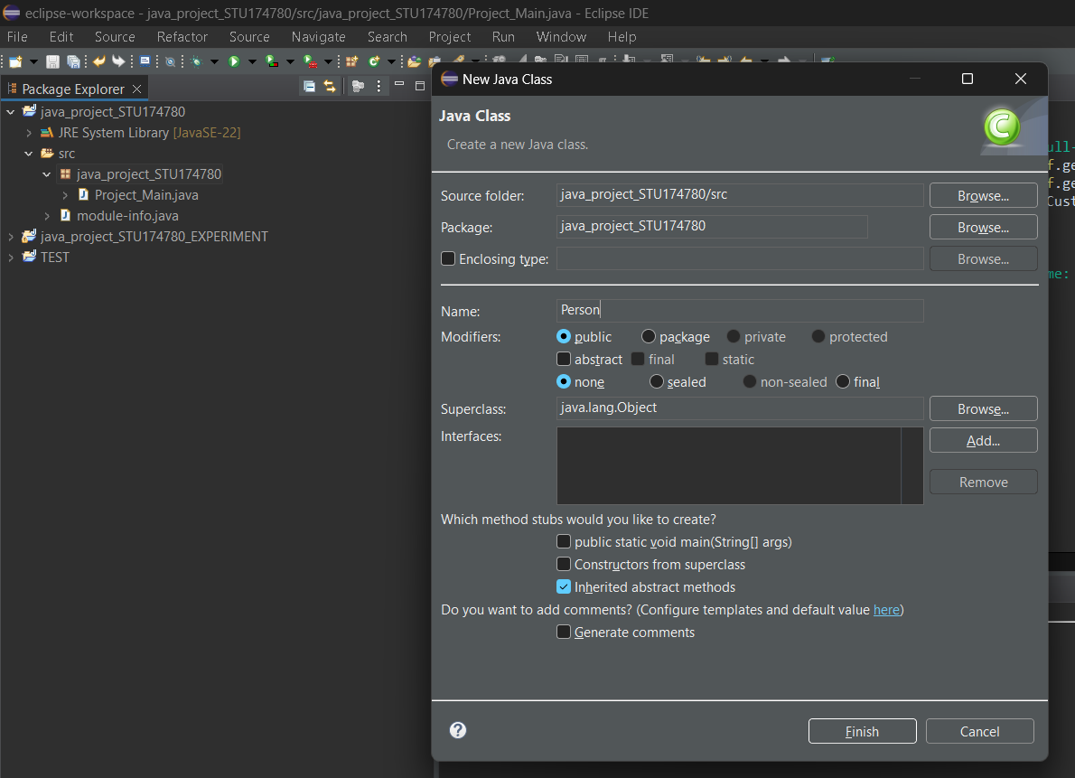

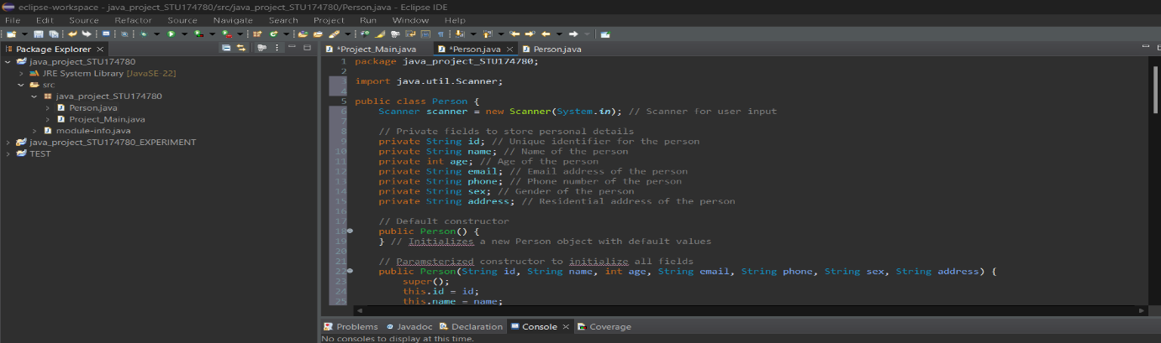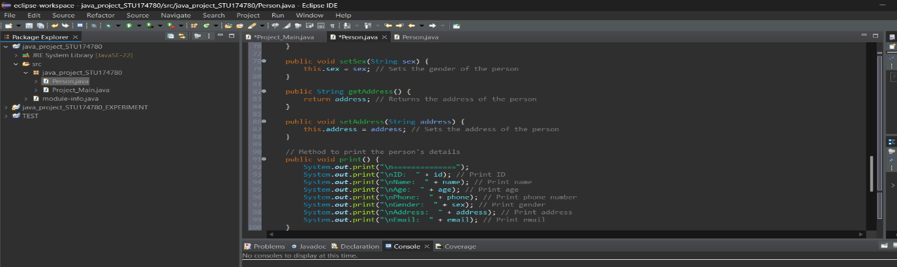

Customer

The Customer class extends the Person class, which implies it builds on Person's basis to represent a more specific form of individual a customer. In addition to the attributes inherited from Person, the Customer class adds a new attribute exclusive to customers: bootcampfees, which monitors the costs connected with a bootcamp program. This class offers a default constructor that initializes a Customer object with its default configuration, as well as a parameterized constructor that allows you to change both inherited properties (from Person) and the new bootcampfees attribute when the object is created. This constructor initializes all fields, making it suitable for building fully detailed Customer instances. The Customer class includes getter and setter methods for bootcampfees, allowing for limited access to this new feature. The getBootcampfees function returns the current fee, while the setBootcampfees method updates it. These methods maintain the bootcamp fee data separately from the inherited attributes. The class overrides the Person class's print method to add the bootcamp fees in the output. Calling super.print() first launches the Person print function to display inherited personal details, followed by the bootcamp fee information. This exemplifies polymorphism, as the Customer class provides a specific implementation of the print method that expands the underlying class' capability.In the words of Richard and Lewis (2000) " The word polymorphism derives from "many forms." In the case of OOP, many forms refer to the different versions of a specific method defined in different subclasses. "

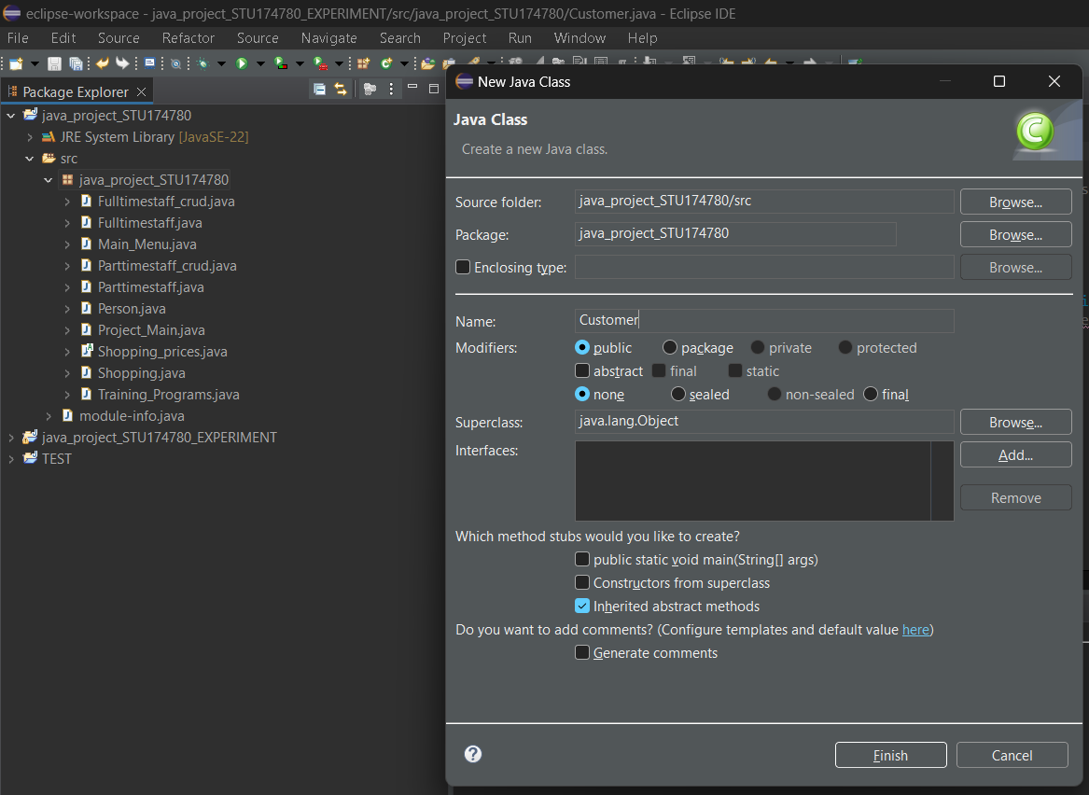

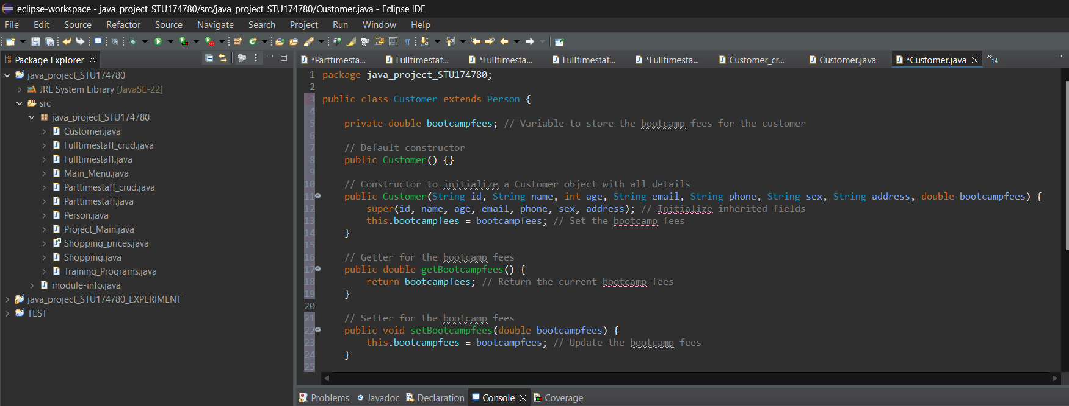

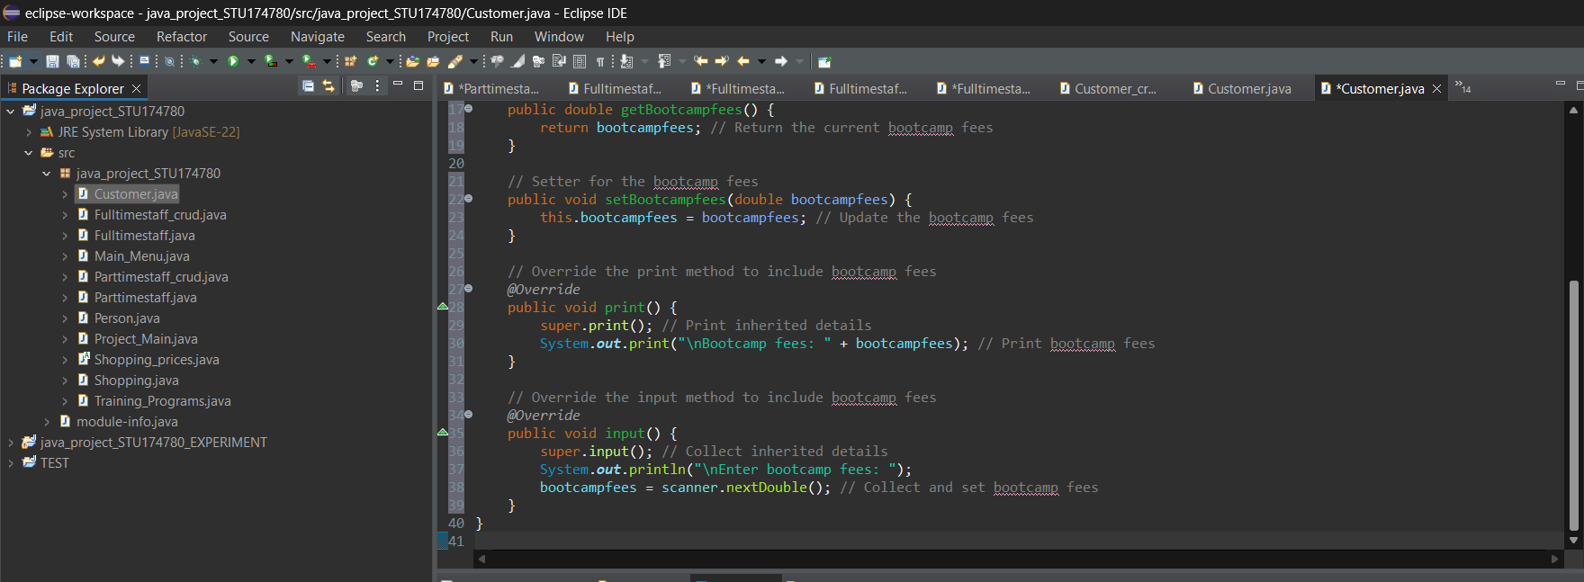

Fulltimestaff

The Fulltimestaff class extends the Person class to represent full-time employees with additional features and behaviors. It adds a new attribute called salary, which tracks the wage of a full-time employee. The class has two constructors: one that initializes a Fulltimestaff object with default values, and another that initializes only the salary attribute, depending on the superclass's default constructor (Person) to handle the inherited properties. In the words of Simon (2014) “Each subclass can have its own constructor for specialised initialization but it must often invoke the behaviour of the superclass constructor. It does this using the keyword super.”This constructor creates a Fulltimestaff object based solely on the wage specified.A third constructor is available to initialize both inherited properties (such as ID, name, age, email, phone, gender, and address) and the salary attribute. This parameterized constructor ensures that all important information for a full-time employee may be entered at the time of object creation, allowing for greater flexibility in object initialization. The Fulltimestaff class offers getter and setter methods for the salary property, which allows for controlled access and update of this new field. The getSalary method returns the current salary, whereas setSalary updates it.In terms of functionality, the Fulltimestaff class overrides the Person class's print method. By executing super.print(), it first prints the details inherited from the Person class, followed by the salary information. This demonstrates how the Fulltimestaff class enhances the base functionality offered by Person by including additional data particular to full-time employees. Similarly, the input mechanism is modified to accept salary input. It uses super.input() to collect the inherited personal information, then prompts the user to enter their wage, which is read and assigned to the salary attribute. This demonstrates how the Fulltimestaff class customizes the input process to add context-specific information.

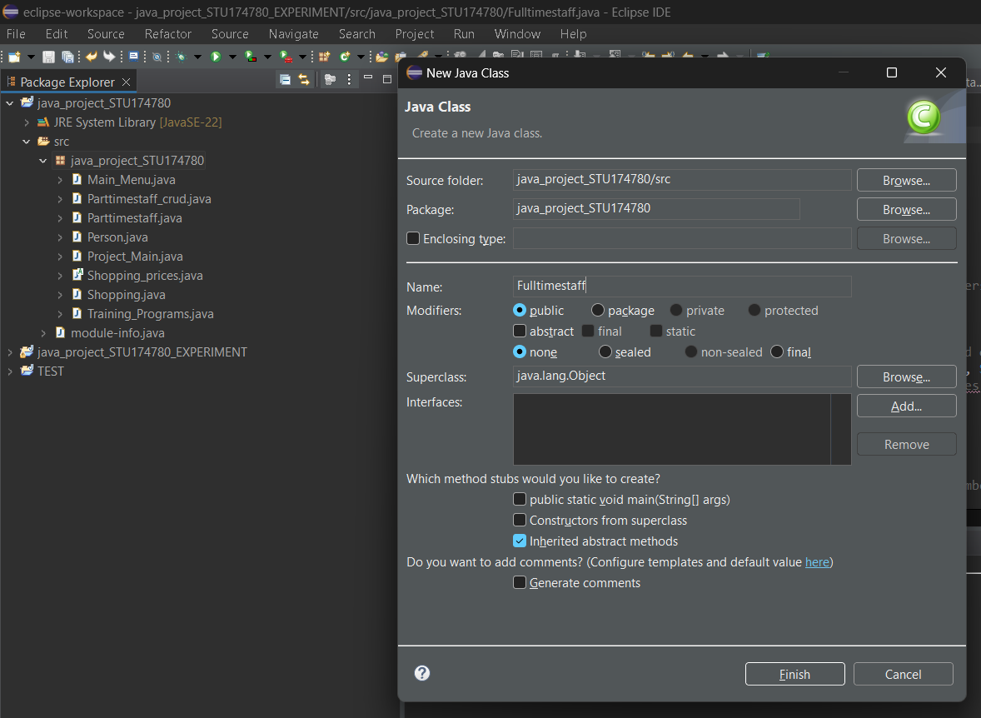

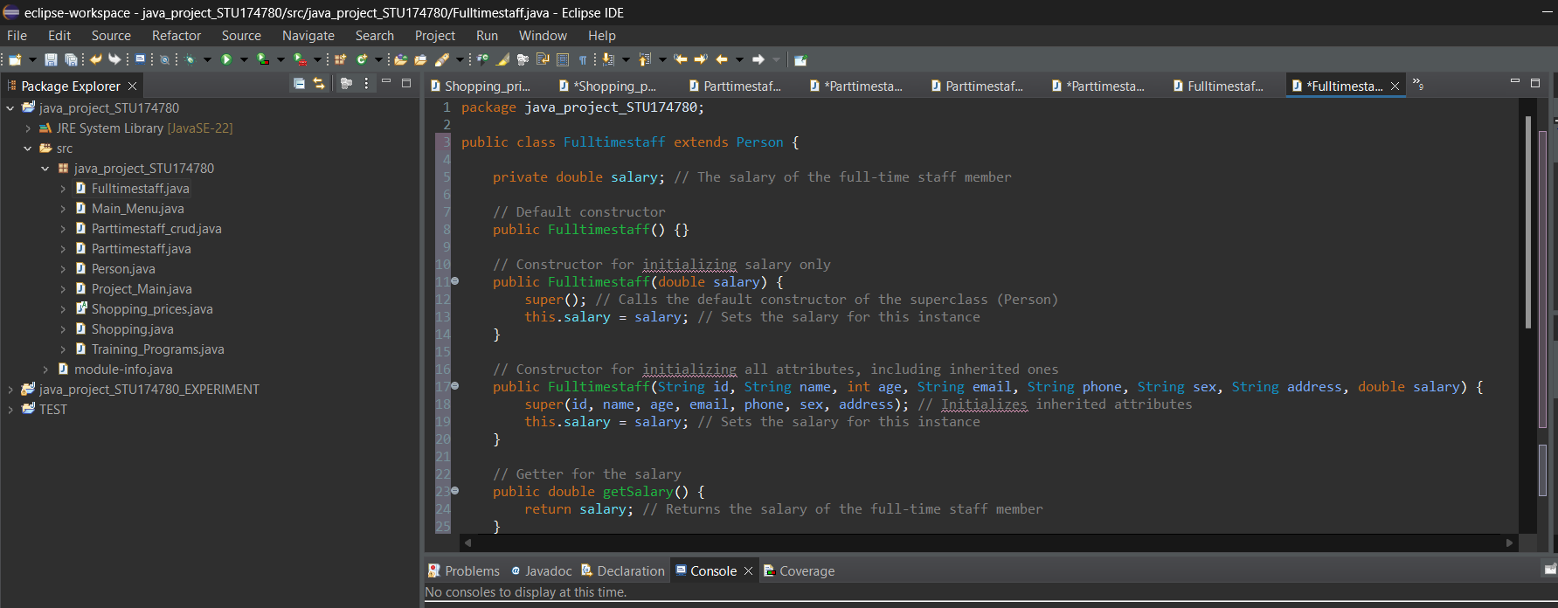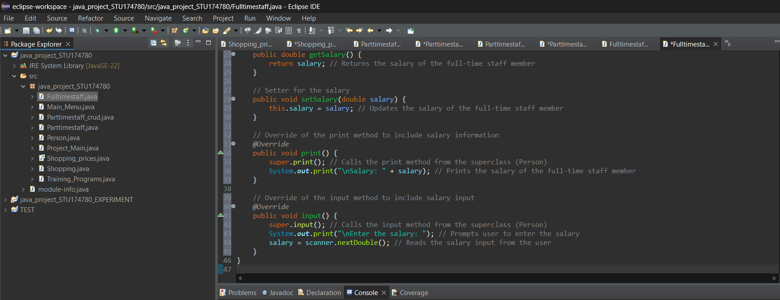

Parttimestaff

The Parttimestaff class extends the Person class to give a more specialized representation of part-time employees, including traits and methods unique to their roles. It adds two new fields: nhour for the number of hours worked and rate for the hourly wage of part-time employees.In the words of Ralph and Ralph (2017) “As we described in Chapter 0, class inheritance is the mechanism whereby a class acquires (inherits) the methods and variables of its superclasses.” This class has two constructors: a default constructor, which initializes a Parttimestaff object with default values, and a parameterized constructor, which initializes all necessary fields, including inherited attributes from the Person class and additional fields nhour and rate. This constructor allows you to create a Parttimestaff object with all of the information at once.The Parttimestaff class includes getter and setter methods for the nhour and rate fields. The getNhour and setNhour methods control the amount of hours worked, whereas getRate and setRate handle the hourly rate. These methods provide controlled access to and modification of the new attributes. Part-time employees. In terms of functionality, the Parttimestaff class overrides the Person class's print method. It first calls super.print() to display the general personal characteristics inherited from Person, and then adds information specific to part-time employees, such as the number of hours worked and the hourly rate. This demonstrates how the Parttimestaff class extends the Person class's base functionality by including extra specialized features. likewise, the input method is altered to increase the functionality of the Person class. It uses super.input() to collect the inherited personal information before prompting the user to submit extra information unique to part-time employees, such as the number of hours worked and the hourly rate. This strategy ensures that all relevant information is obtained from the user interactively.

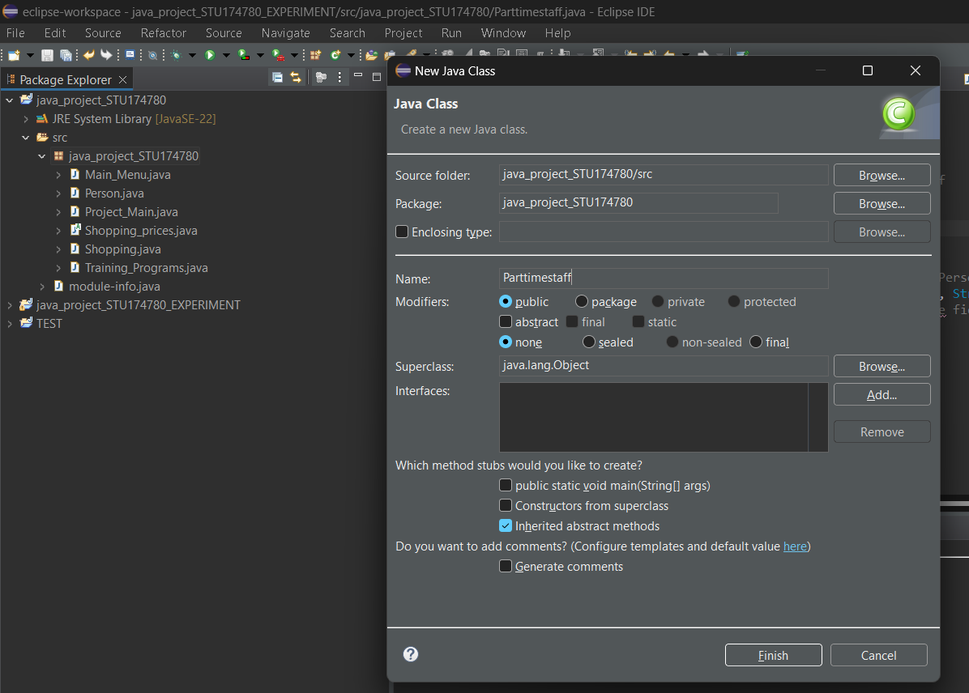

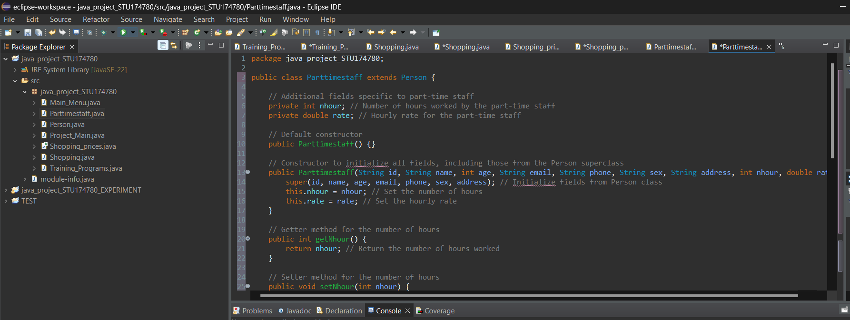

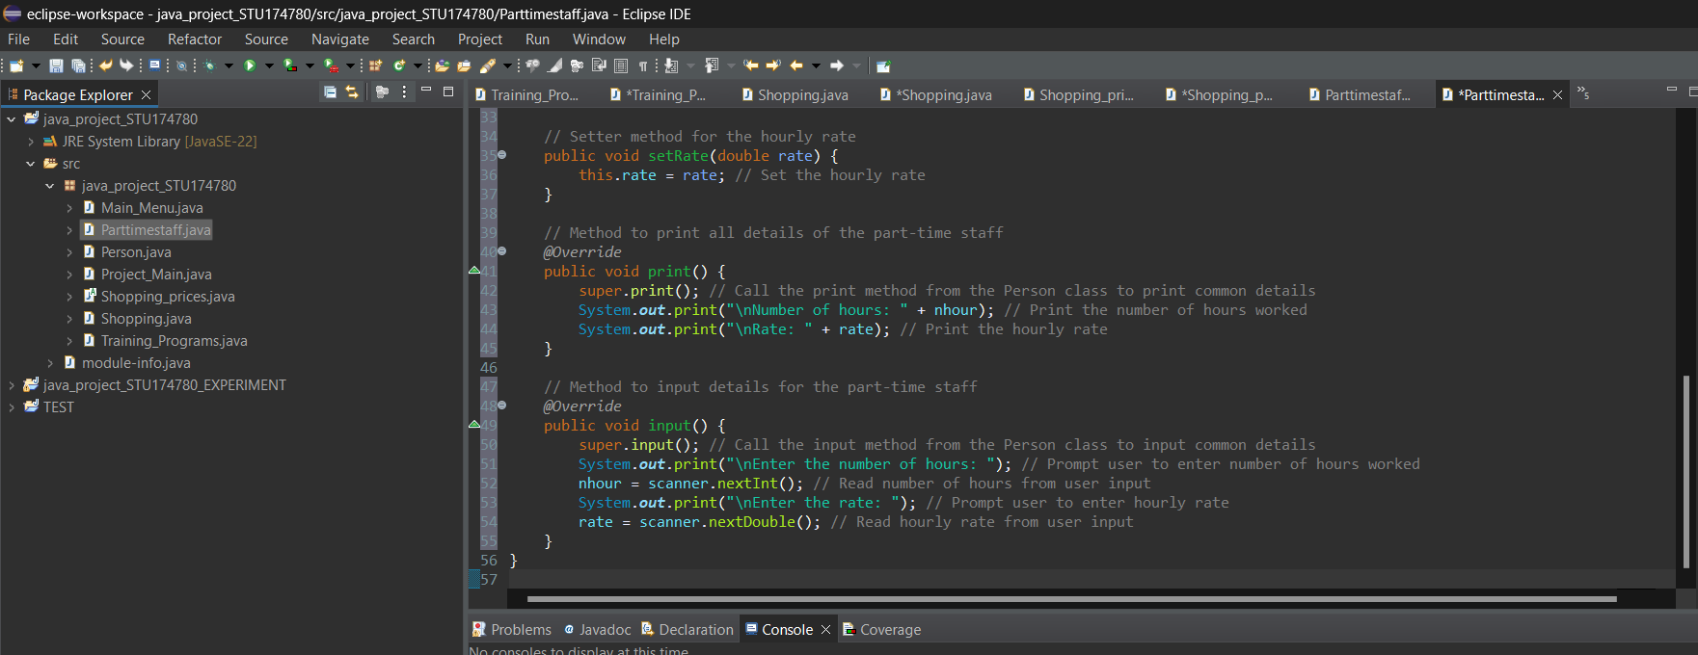

Customer_crud

The Customer_crud class in this Java code implements the CRUD (Create, Read, Update, and Delete) interface for managing a list of Customer objects. It contains a Scanner object for reading user input and an ArrayList for storing customer information. When the Customer_crud class is initialized, it has some preconfigured customer entries. This is accomplished by generating Customer objects with particular attributes and adding them to the customer_data list. The get_name_by_id method retrieves a customer's name based on their ID by iterating through the customer_data list and comparing each customer's ID to the specified ID. If a match is discovered, the method returns the name; otherwise, it returns null. The insert method allows for the addition of a new customer to the list. It generates a new Customer object, collects information for the new customer's details using the Customer class's input function, and adds the new customer to the customer_data list. After a successful addition, a confirmation message is presented. The modify method allows you to change the details of an existing customer. It prompts the user to enter the customer's phone number to be changed, searches the customer_data list for a match, and displays the current details before prompting the user to enter new information. The customer's information is changed depending on the new input, and a confirmation message appears. If no matches are identified, a suitable message is displayed. The retrieve method retrieves and displays information about a consumer based on their phone number. It prompts the user to enter their phone number, then searches the customer_data list for a match and displays the customer's information if one is found. If no matches are identified, a suitable message is displayed. The delete method allows deletion of a customer based on their phone number. It prompts the user to enter the phone number, searches the customer_data list for a match, and, if found, presents the customer's information and requests confirmation before deleting it. If the user confirms, the customer is removed from the list and a confirmation notice appears. If no matches are identified, a suitable message is displayed.

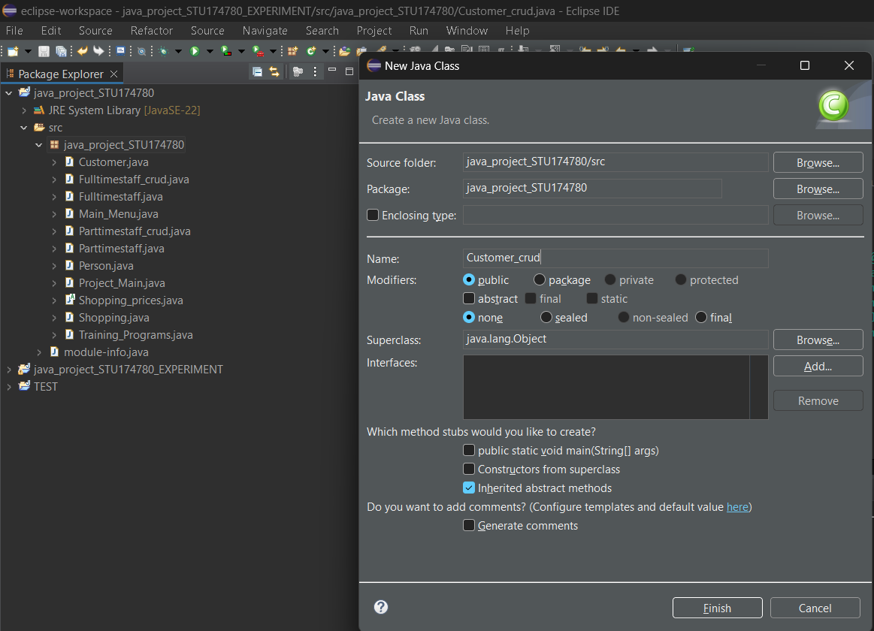

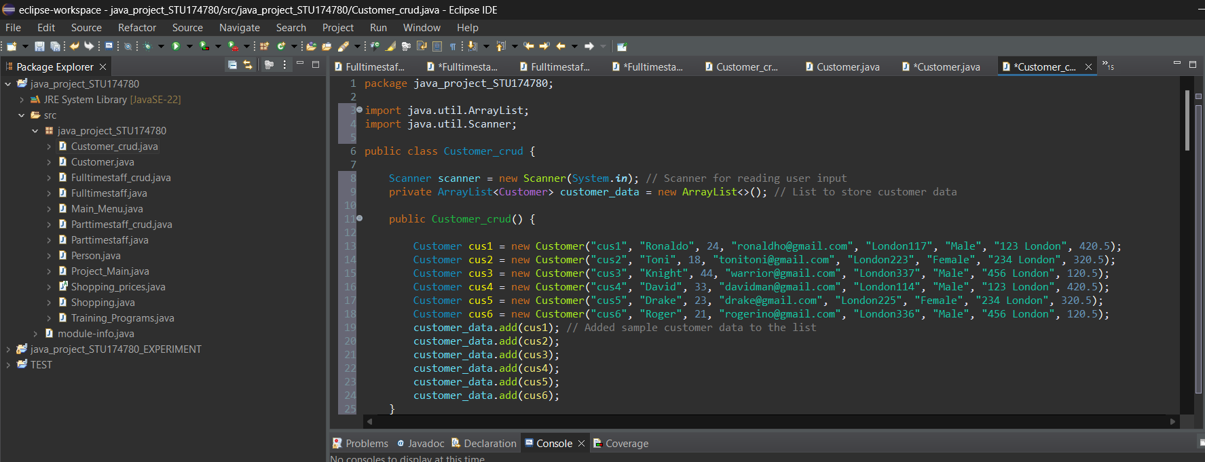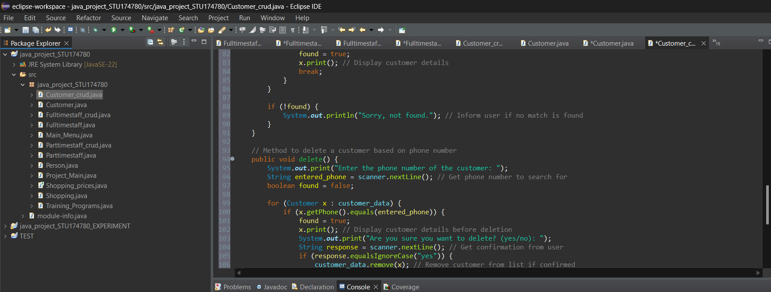

Fulltimestaff_crud

The Fulltimestaff_crud class implements a CRUD (Create, Read, Update, and Delete) interface for managing Fulltimestaff instances. It employs a Scanner for user input and an ArrayList to store full-time employee information. Upon initialization, the class populates the fulltimestaff_data list with predefined full-time staff records. The get_name_by_id method finds a staff member's name using their ID and returns null if no match is found. The print_all_names method prints the IDs and names of all full-time employees. The insert method adds a new staff member by building a Fulltimestaff object, taking user input for details, and adding it to the list, followed by a message verifying success. The alter method updates an existing staff member's information by searching for their phone number, showing current information, and gathering new data. If a match is discovered, the details are updated and a confirmation message appears; otherwise, a "not found" message is presented. The retrieve method displays a staff member's information based on their phone number and returns a "not found" message if no match is discovered. The deletion method eliminates a staff member based on their phone number after presenting their information and requesting confirmation. If the deletion is validated, a success message will appear. The getter and setter methods for the fulltimestaff_data list enable controlled access and updating of the staff data. Overall, the Fulltimestaff_crud class encapsulates the necessary CRUD activities for handling full-time staff data, provides a user-friendly console interface, and demonstrates basic Java CRUD capability.

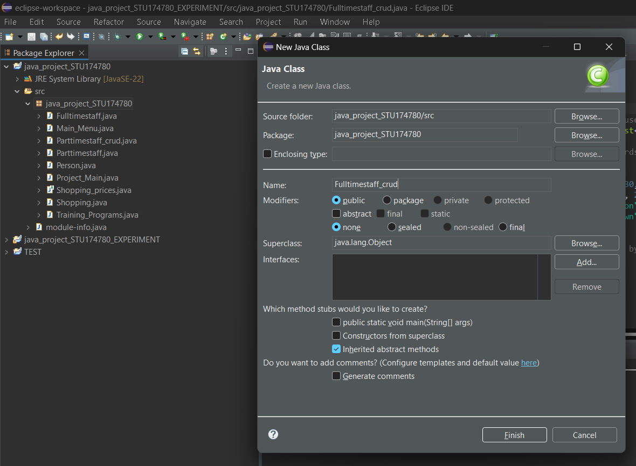

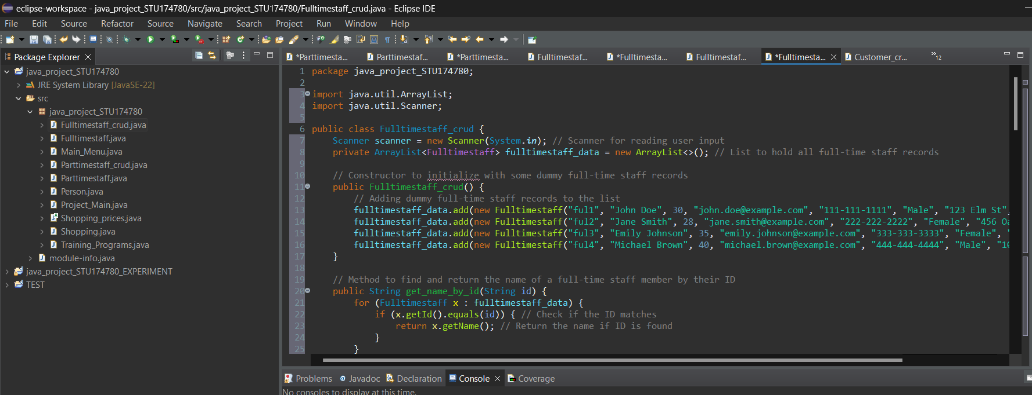

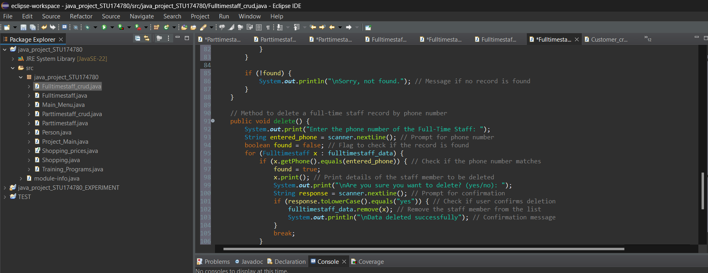

Parttimestaff_crud

The Parttimestaff_crud class implements a CRUD interface for managing Parttimestaff objects by utilizing a Scanner for user input and an ArrayList to hold part-time staff data. The constructor sets up the list with some dummy records. The get_name_by_id method returns a staff member's name by ID. The print_all_names method outputs all part-time employees' names and IDs. The insert method creates a new part-time staff record by gathering user input and adding it to the list before confirming success. The edit method modifies an existing record by searching for a phone number, printing current details, gathering new input, and updating the record if it is found, otherwise returning a "not found" message. The retrieve method outputs information on a staff member using their phone number, returning a "not found" message if no match is discovered. The delete method deletes a record by phone number after presenting details and verifying deletion and returns a "not found" message if no match is discovered. The parttimestaff_data list's getter and setter methods provide controlled access and alteration of the data. This class covers the essential CRUD functions for part-time personnel management.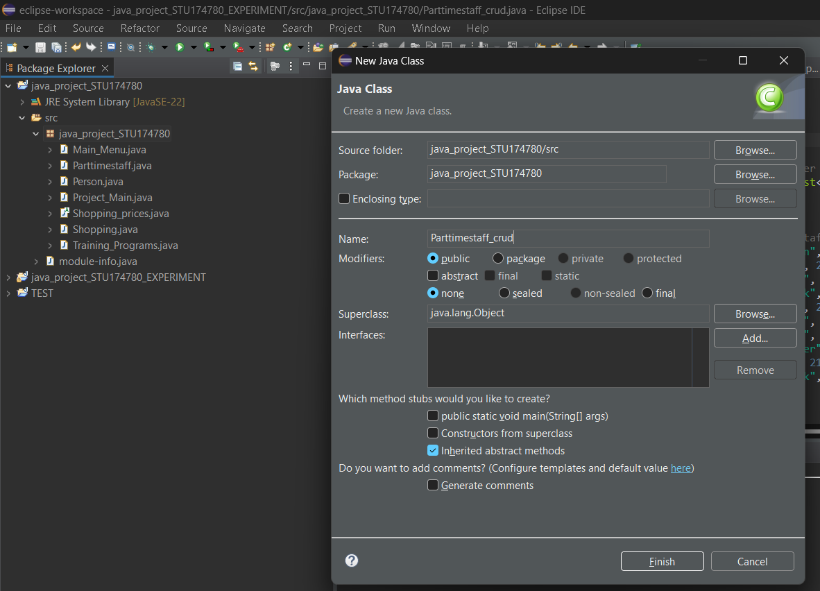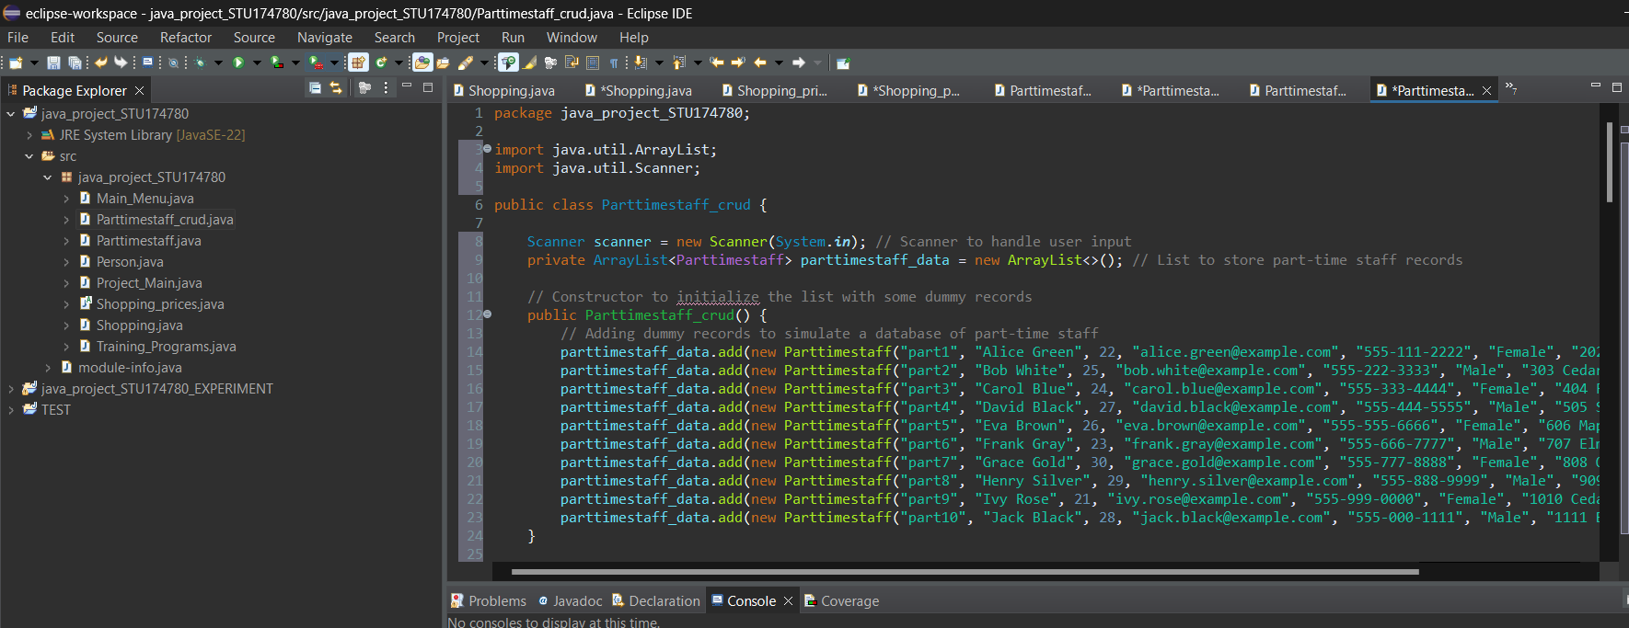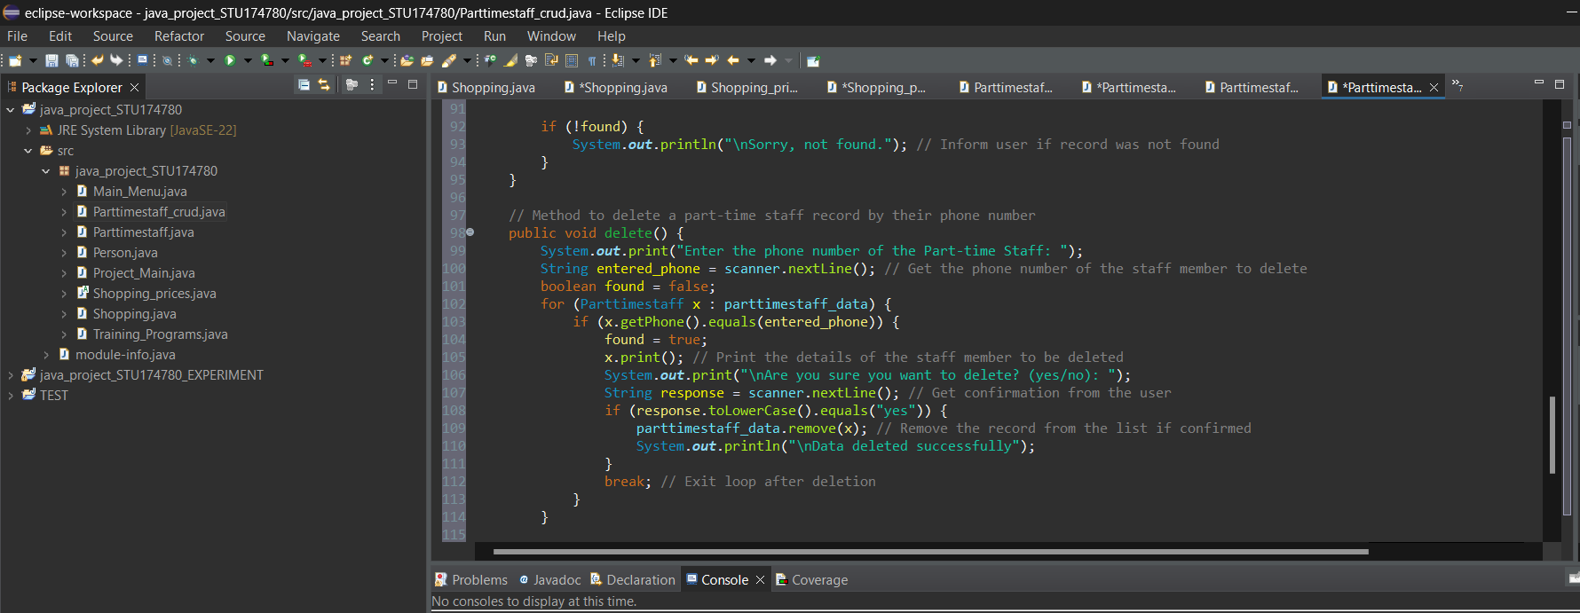

Training_Programs

The Training_Programs class keeps track of customer enrollments in various training programs, including program names, preferred days, and total cost. It contains client information such as customerId and day, as well as program management details like programNames and totalCost. The class includes constructors and getters for initializing and accessing the attributes. The Training_Programs (String customerId, String day) constructor populates the object with the customer's ID and selected day, creates an empty program list, and sets the total cost to zero. The getters (getCustomerId(), getProgramNames(), getDay(), and getTotalCost()) return the customer ID, program list, chosen day, and total cost, accordingly. The addProgram function adds a program to the list while updating the total cost. The applyDiscount method applies a discount if one is available, with a focus on the "Food (Bakery)" program if multiple programs are enrolled. The printReceipt method generates a receipt with the client ID, enrolled programs, chosen day, and total cost. Furthermore, the static methods getBootcampCost(int bootcampChoice) and getBootcampName(int bootcampChoice) return the cost and name of a specific bootcamp based on the supplied option.

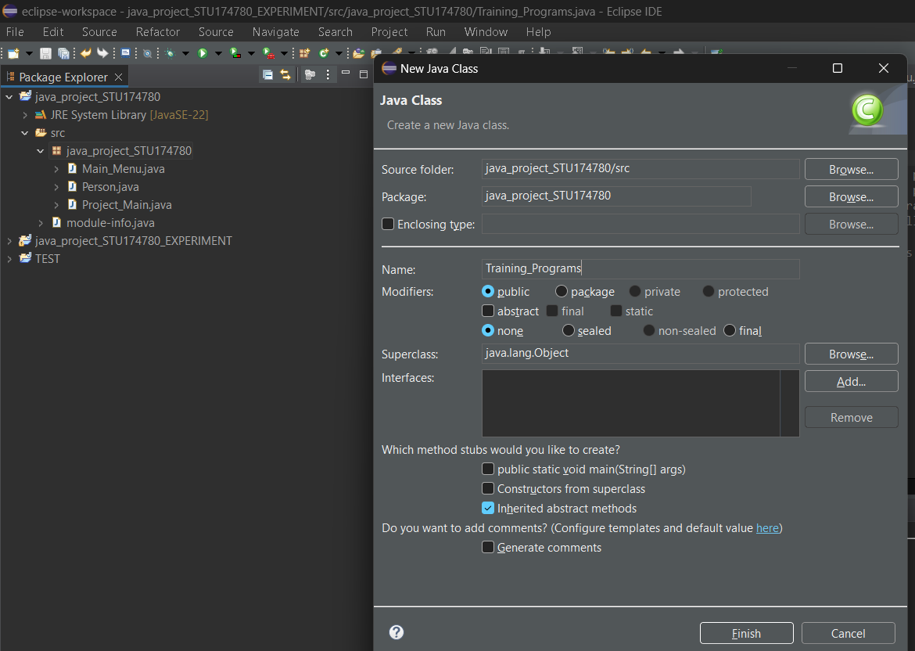

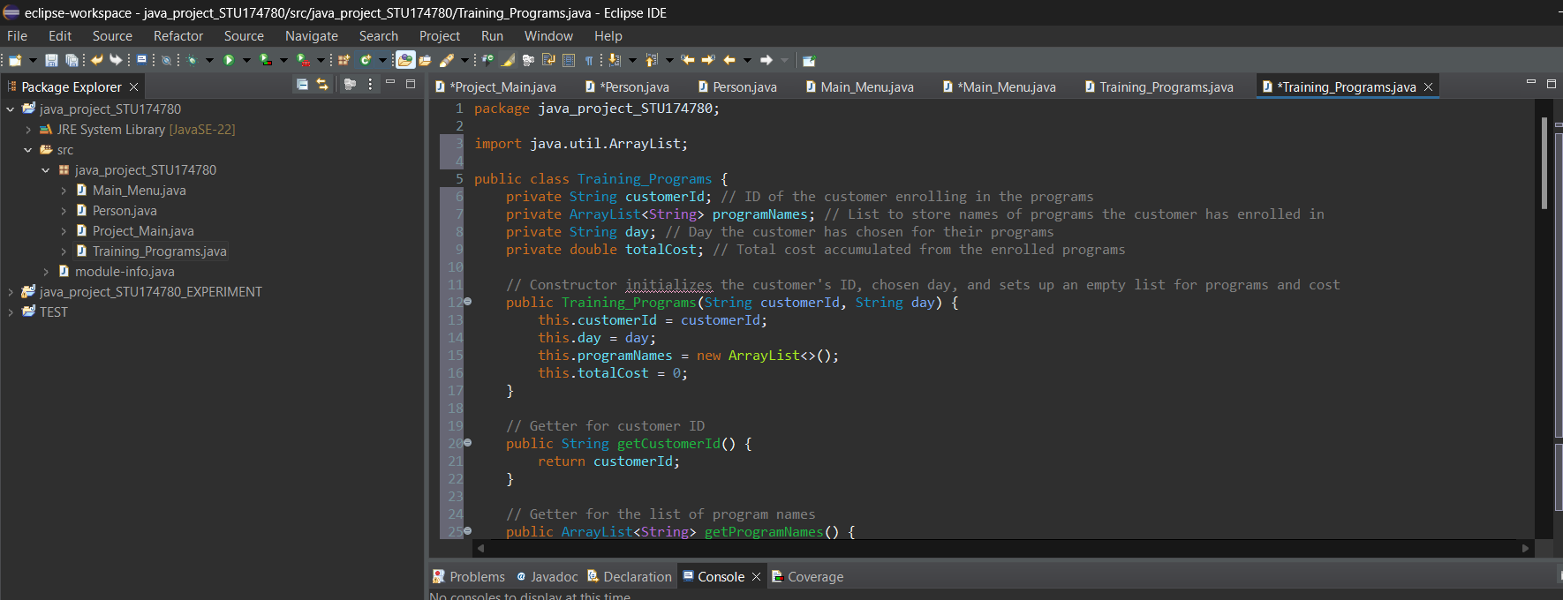

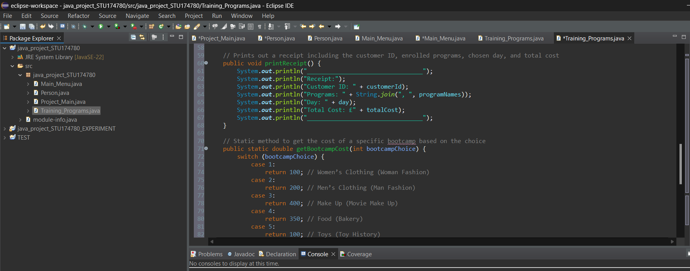

Shopping

The Shopping class coordinates customer appointments with employees in a specific department. It keeps track of information such as customer ID, staff ID, department, day, slot number, and total fees. It also has an array that represents the availability of eight booking slots.Constructor: Creates a new booking instance with a customer ID, staff ID, department, day, slot number, and an array of eight time slots. It starts with no fees.Getters: Allows access to the customer ID (getCustomerId), staff ID (getStaffId), department (getDepartment), day (getDay), slot number (getSlotNo), total fees (getFees), and booking array. Fees Calculation: The calculate_fees function specifies a fixed fee of 50.Booking Slots: The setBooking method marks a certain slot as booked. The slot number provided is 1-based, so it is adjusted by subtracting 1.The class allows for easy tracking and maintenance of booking details, including adjustments to booking slots and prices as needed.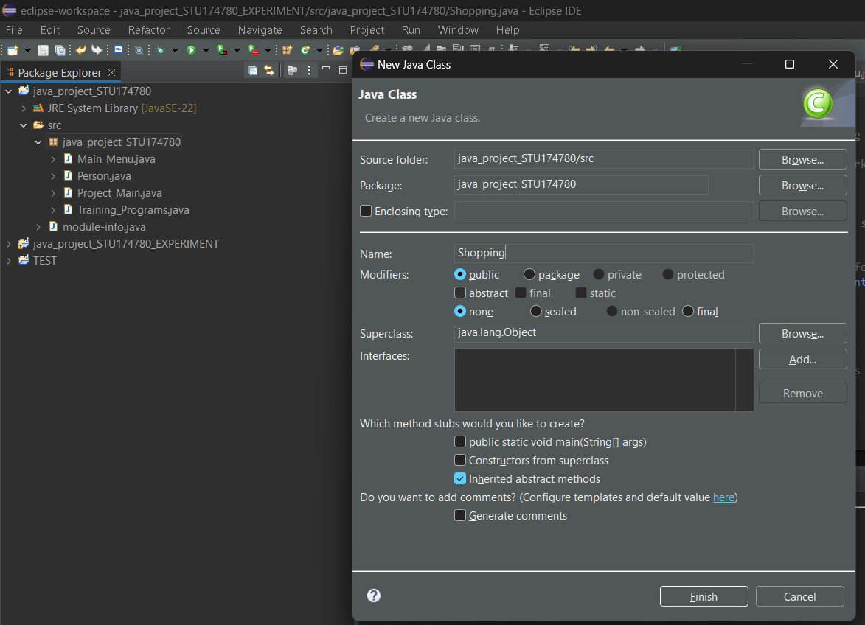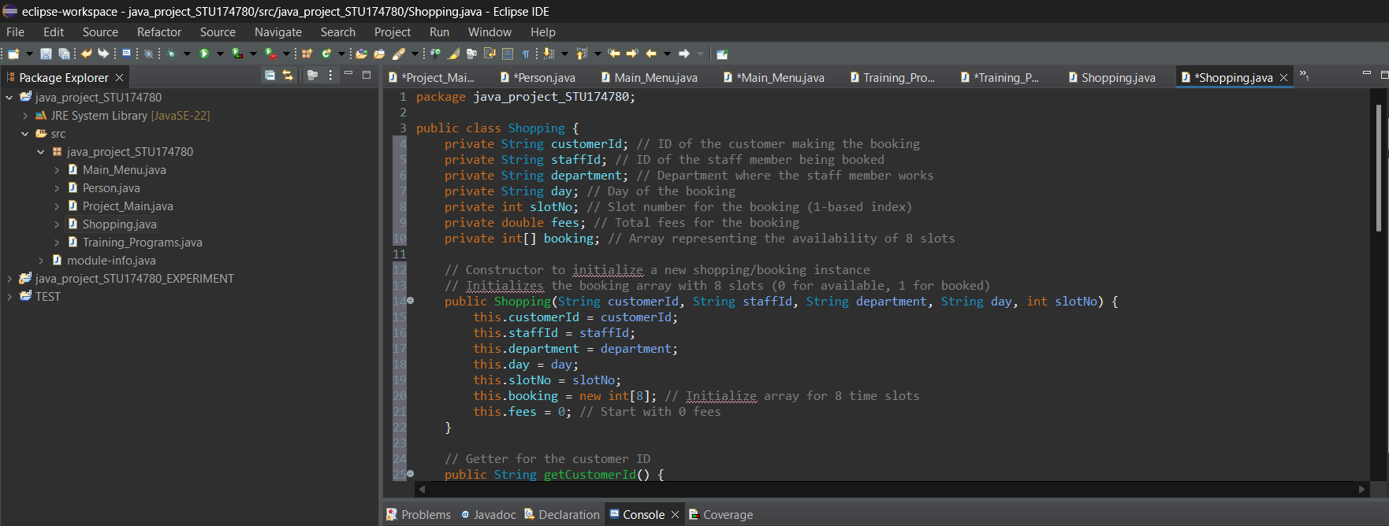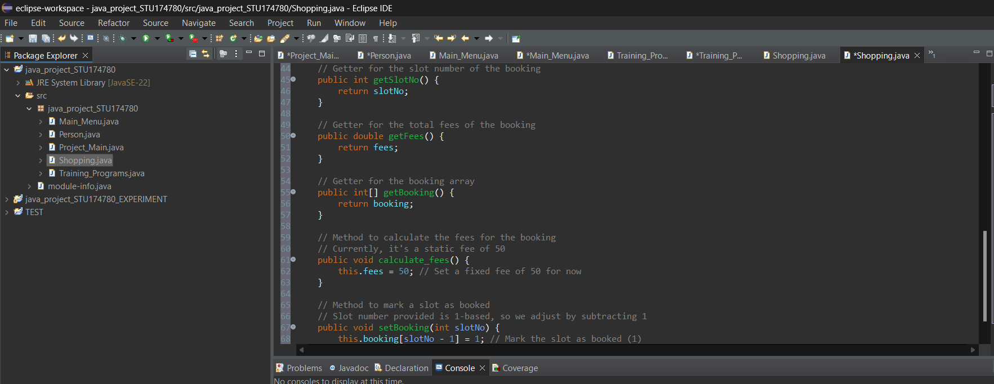

Shopping_prices

The Shopping_Prices class is an abstract foundation class for computing shopping costs. It contains a static variable base_fees, initialized to 5, that serves as the beginning point for fee calculations. The class defines an abstract function calculate_fees() that must be implemented by any subclass. This technique allows each subclass to define its own logic for computing total fees, resulting in flexible and adaptable cost structures for a variety of shopping or booking scenarios.As Richard and Lewis (2000) say "Abstract classes are often defined near the top of a hierarchical structure of classes. Undefined or abstract methods are used in an abstract class to establish required behavior in any descendent concrete class. An instance of an abstract class cannot be created."

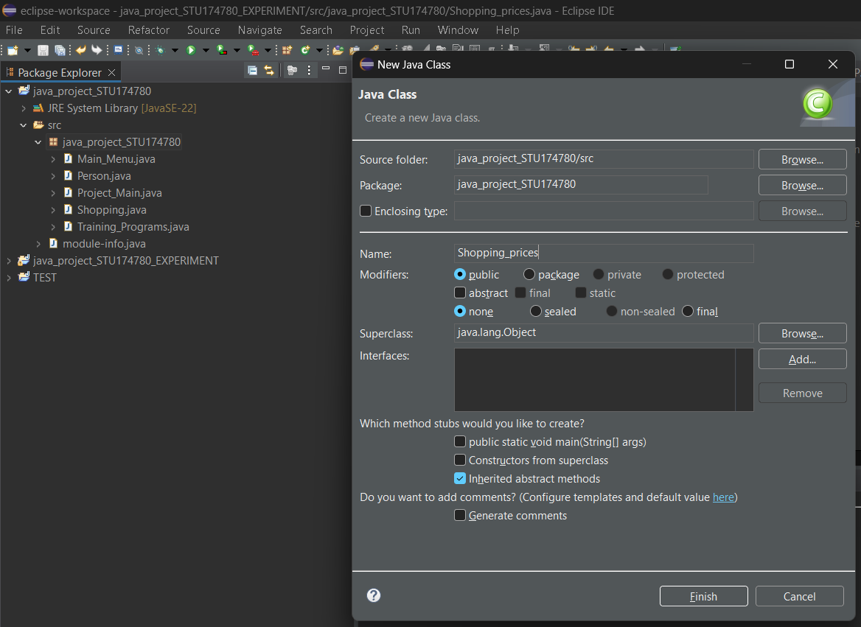

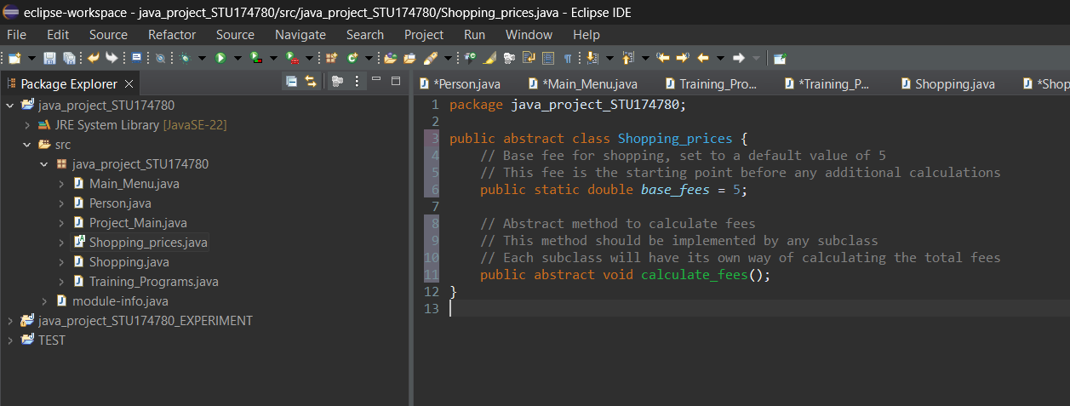

Bootcamp

The Bootcamp class extends the Bootcamp_Prices abstract class, providing concrete implementations of its abstract functions.As Ralph and Ralph (2017) say “In Java, the public and protected instance methods and instance variables of a superclass are inherited by all of its subclasses. This means that objects belonging to the subclasses can use the inherited variables and methods as their own…” It specifies how to utilize the getBootcampCost method to calculate the cost of various bootcamps based on the user's selection. This method returns different costs based on the bootcamp chosen, for as 100 for Women's Clothing, 200 for Men's Clothing, 400 for Make Up, and so on. It also includes the applyDiscount method, which applies a discount if specific circumstances are met. If the customer purchases further bootcamps with a basic cost of 350 (particularly, the Food (Bakery) bootcamp), a 32% discount is applied. Otherwise, it restores the original cost with no discount.In the words of Richard and Lewis (2000) "Abstract class – A class in which one or more methods are not implemented. No instances may be created of an abstract class."

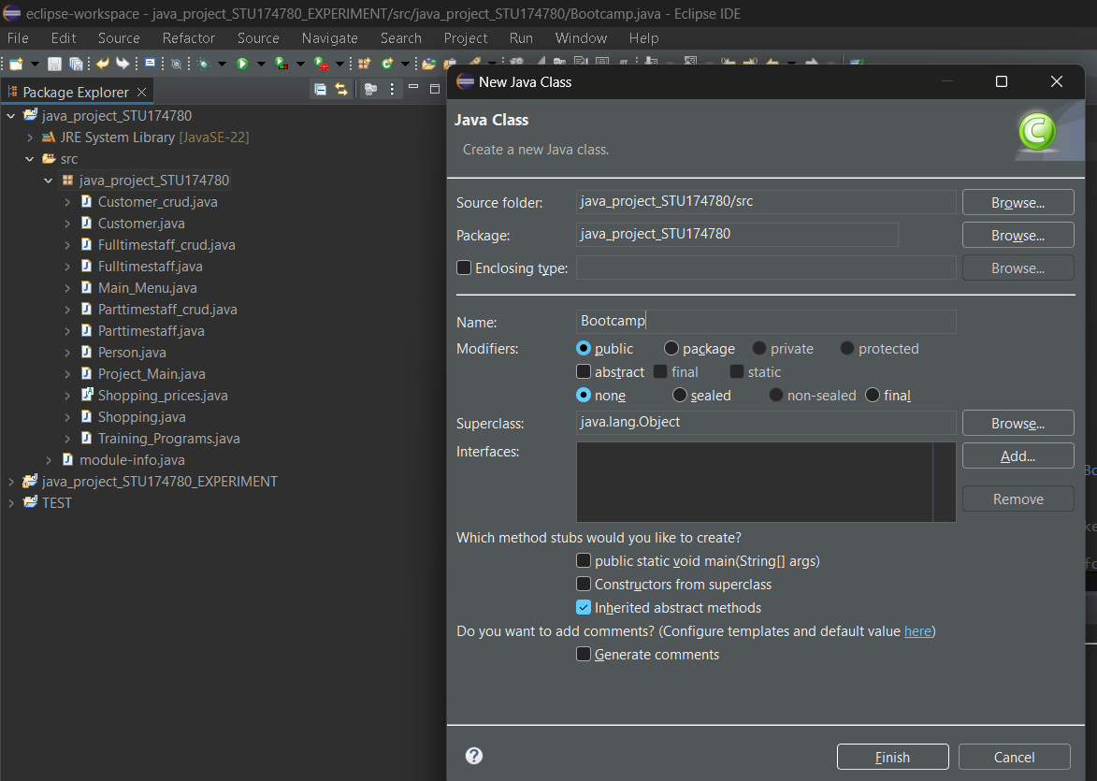

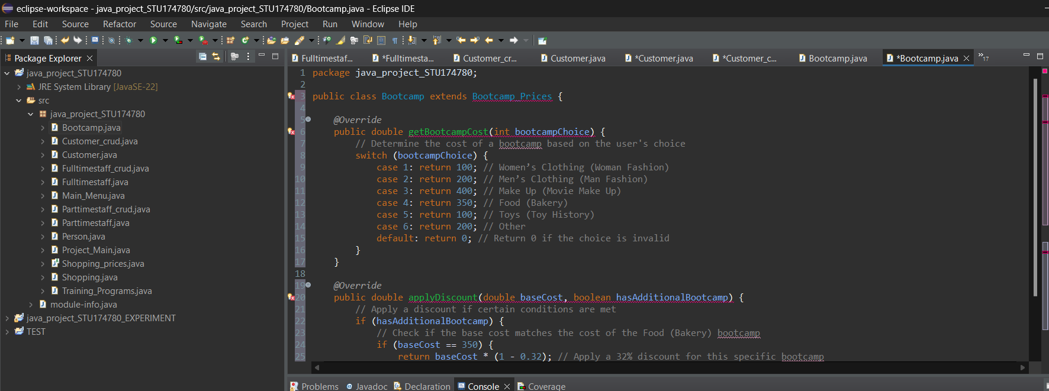

Bootcamp_Prices

The Bootcamp_Prices class is an abstract class that defines the foundation for calculating bootcamp expenses and offering discounts.In the words of Ralph and Ralph (2017) say “Any class that contains an abstract method, must itself be declared abstract.” It contains two abstract methods that must be implemented by any subclass: getBootcampCost(int bootcampChoice), which is intended to return the cost of a specific bootcamp based on the user's selection, and applyDiscount(double baseCost, boolean hasAdditionalBootcamp), which calculates and returns the discounted cost, which may be influenced by factors such as additional enrollment. The class defines these methods abstractly, establishing the essential foundation for pricing and discount logic while allowing subclasses to offer unique implementations.

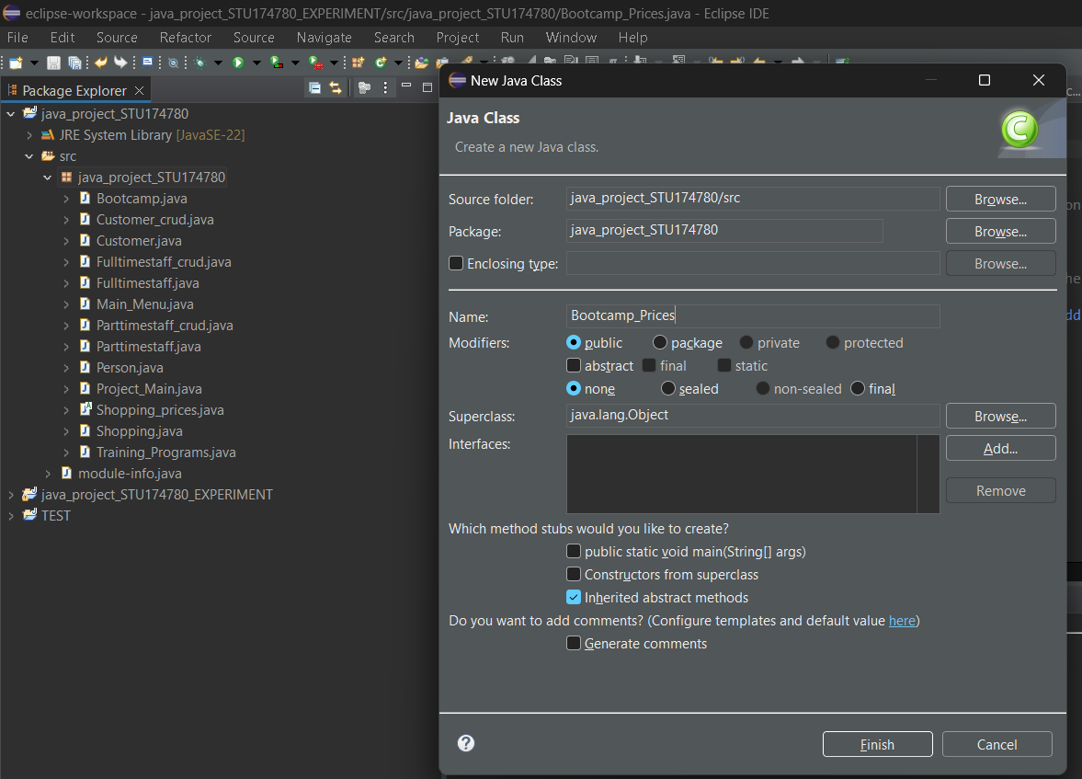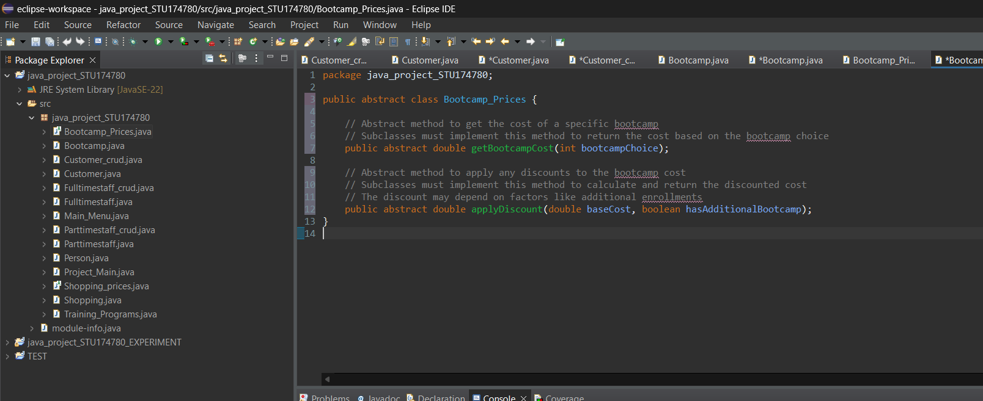

Part. V Testing/Explain (how it works,also things from the tasks present)

Main Menu:

The menu offers multiple ways for users to engage with the application. It offers options such as accessing the "Customer Menu" for customer-related actions, the "Staff Menu" for employee-related chores, and checking available shopping slots. Users can also schedule a shopping trip, exit the app, or sign up for training programs. The prompt "Enter your choice:" directs visitors to enter their decision, while the underscores before and after the menu act as visual separators for clarity.

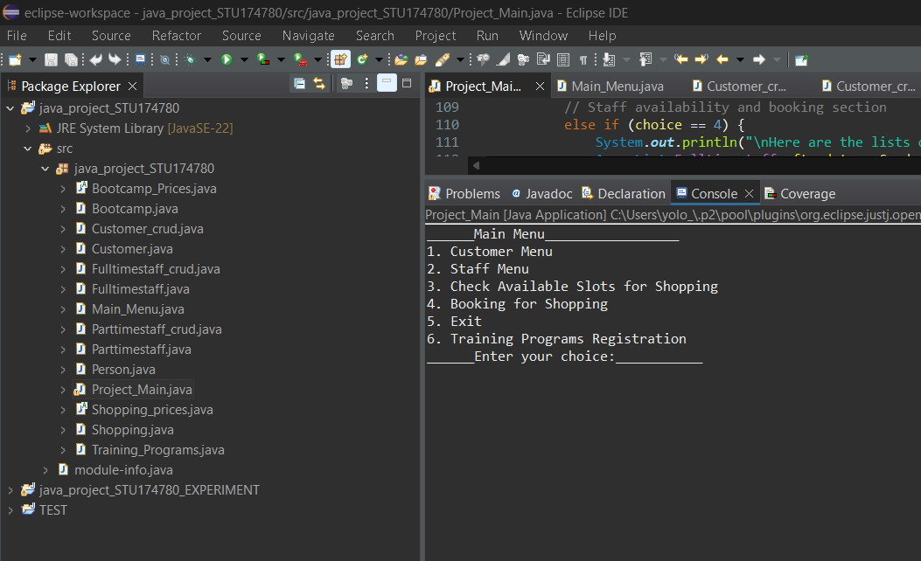

Exit:

When user input “5”,the program will close.

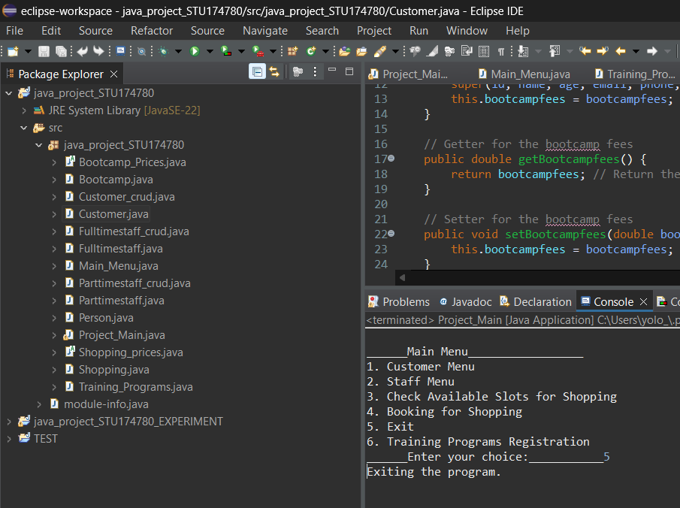

Customer Menu:

The "Customer Menu" provides many ways to manage customer-related duties. Users can select "Insert New Customer" to create a new record, "Retrieve Existing Customer" to view details about an existing customer, "Modify Existing Customer" to amend existing customer information, or "Delete Customer" to delete a client from the system. The prompt "Enter your choice:" prompts users to enter their decision, with underscores framing the menu to clearly define it.

**Customer add:**

An example of customer insertion in the database.Has all basic information like ID,name and phone number.Added the bootcamp fees for automatic insertion in case of a technical malfunction in the Bootcamp registration menu.

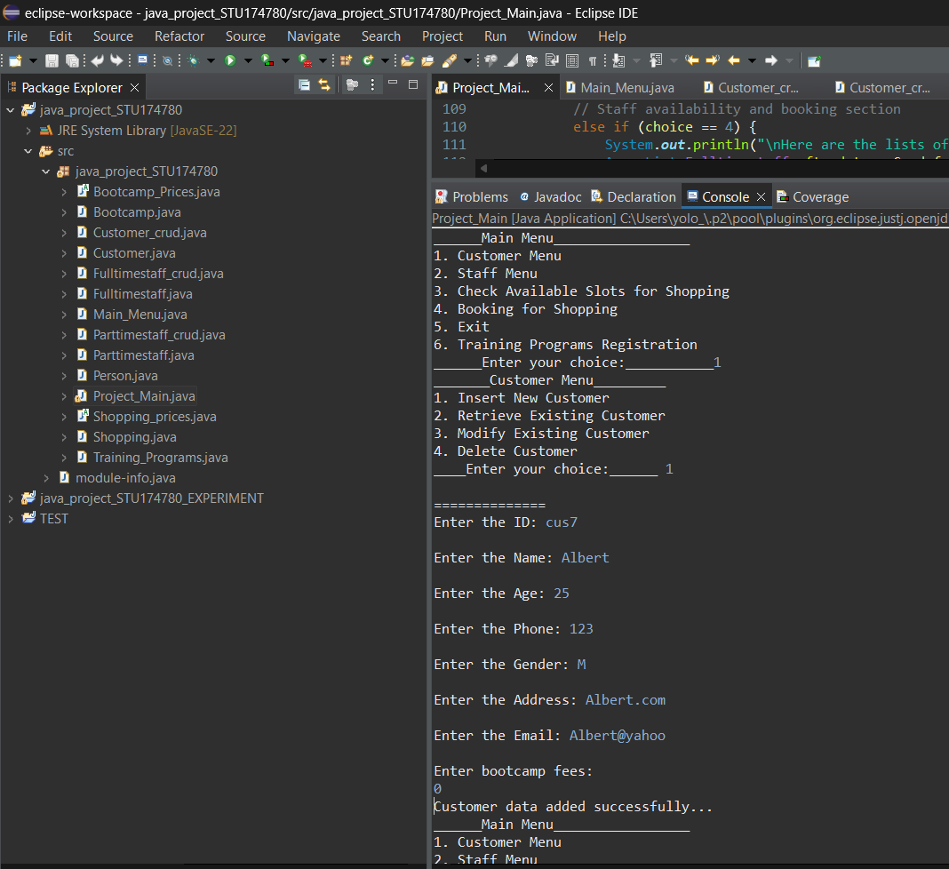

**Customer Retrieve:**

I made the program so customer data can be retrieved by telephone number. I chose phone numbers over id’s as the phone numbers are more reliable in areal life situation,id’s can be easly mistook for others in data malfunctions,phone numbers are forever allocated to one person only.

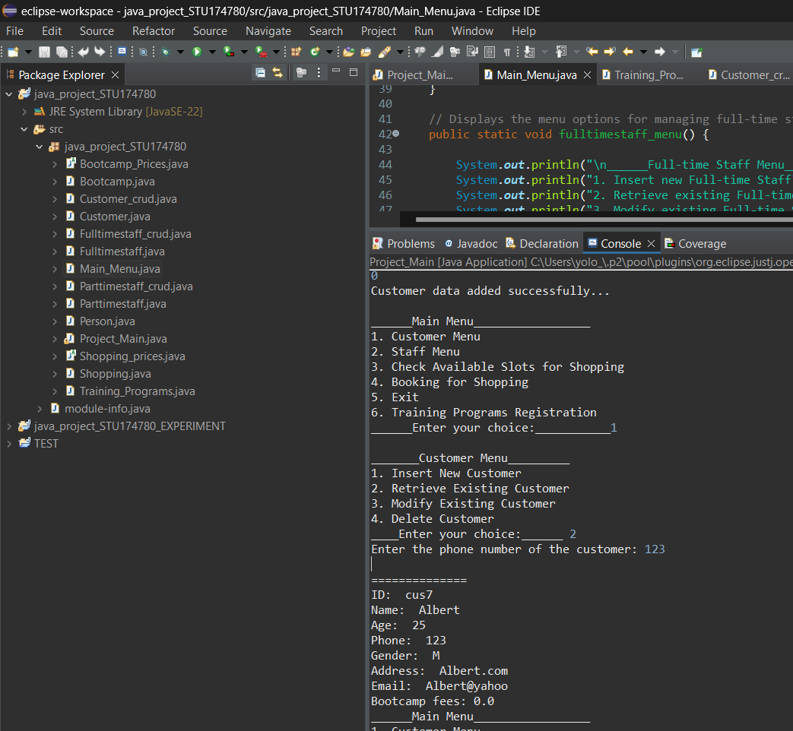

**Customer Modify:**

In order to modify a customer record you need to input customer phone number. You are prompted with current record and then you can modify the record as you like.

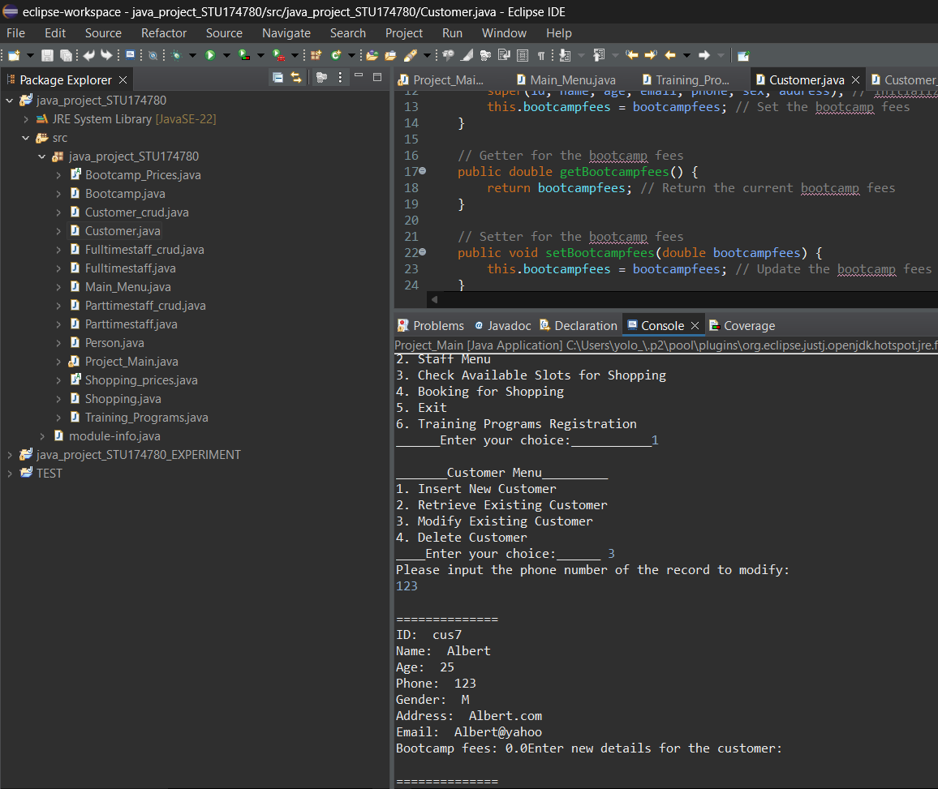

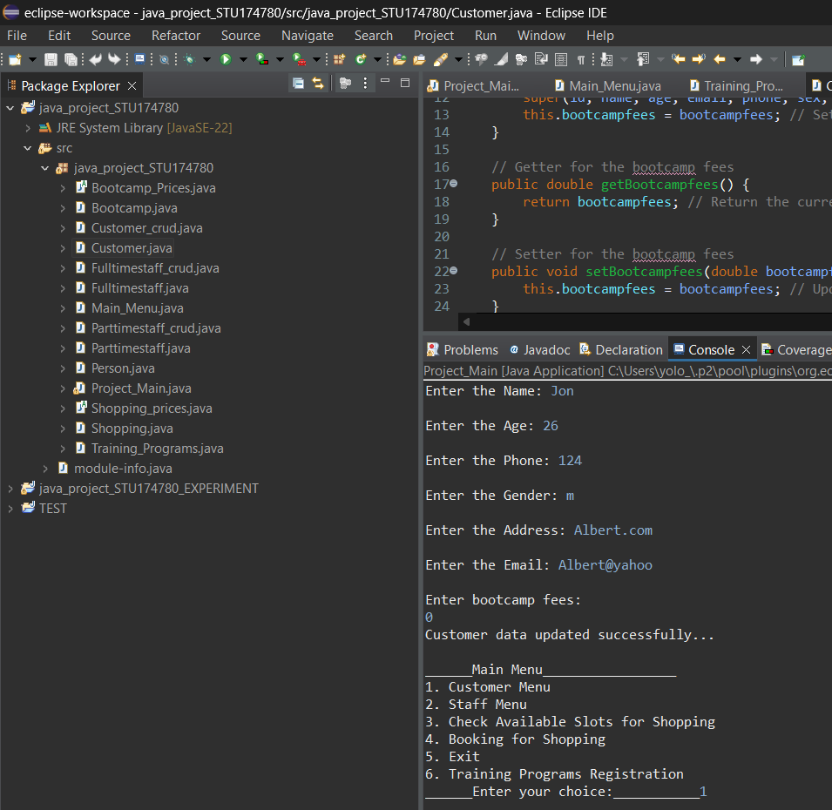

We can test if the record was modified by searching in the menu for the updated record.

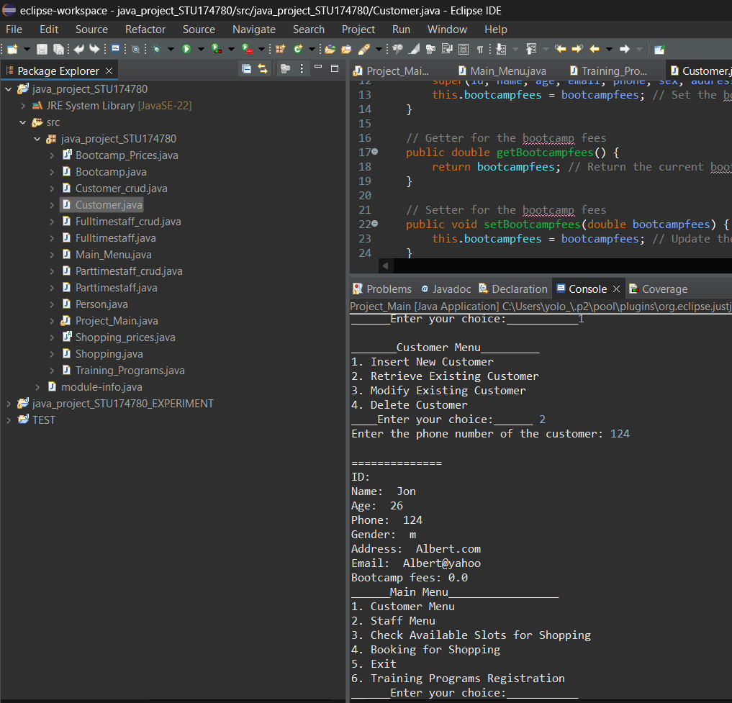

**Customer Delete:**

In order to delete a customer record, you need to insert the phone number.After you are provided with the current record you are asked again if you are sure you want to delete it.An extra security measure.

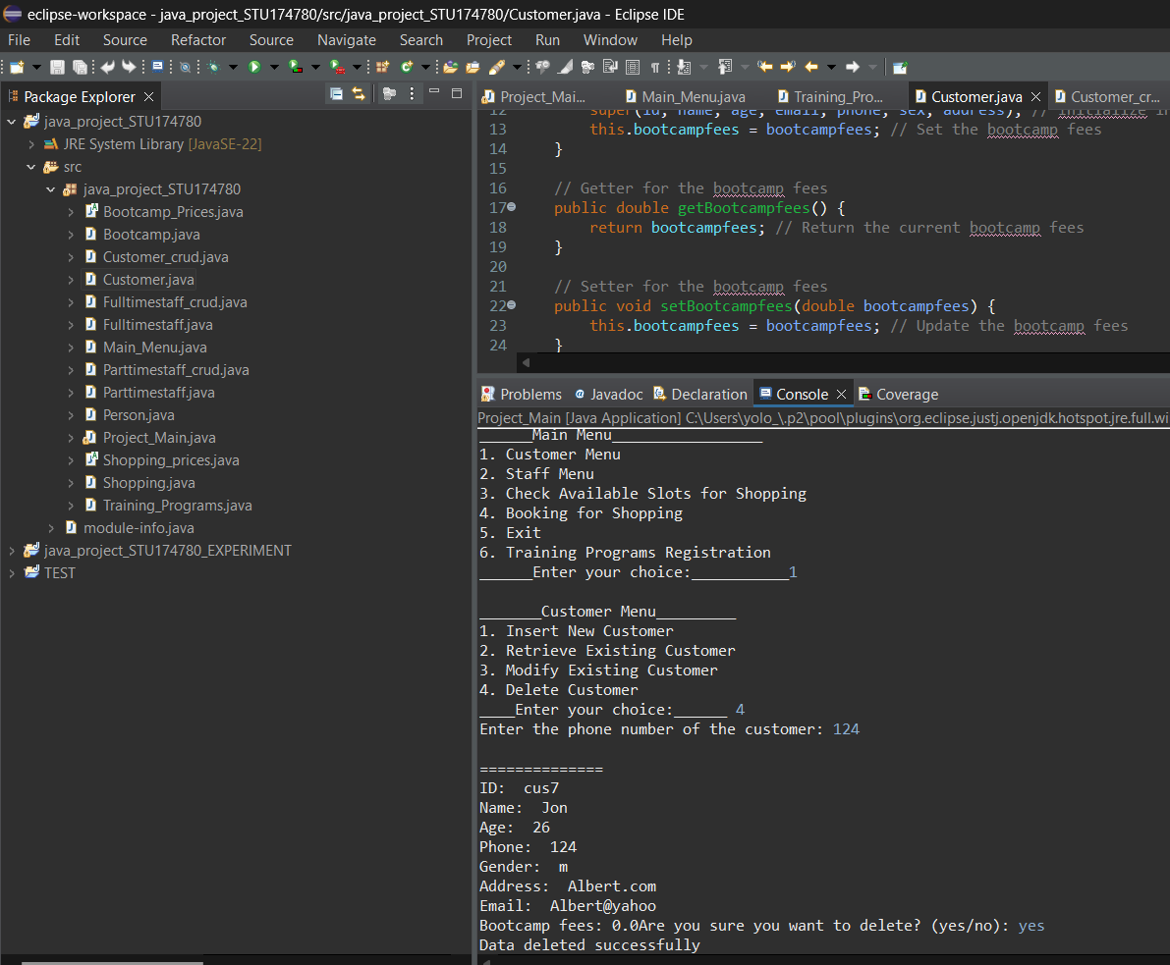

We can check if the record was deleted by inputing the phone number again.

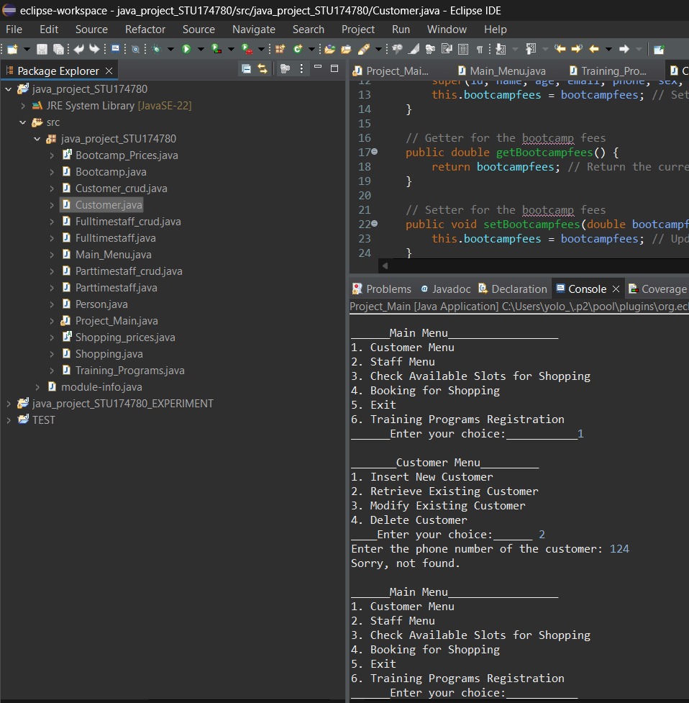

Fulltime Menu:

The "Full-time Staff Menu" provides a variety of options for managing full-time staff records. Users can select "Insert new Full-time Staff" to add a new employee to the system, "Retrieve existing Full-time Staff" to view the details of a current staff member, "Modify existing Full-time Staff" to update an existing staff member's information, or "Delete Full-time Staff" to remove a staff member from the records. The menu is clearly split by lines for easier reading, and users are encouraged to "Enter your choice:" to make their option.

**Fulltime Add:**

An example of customer insertion in the database. Has all basic information like ID,name and phone number.Added the salary for the fulltime as an exclusive feature.

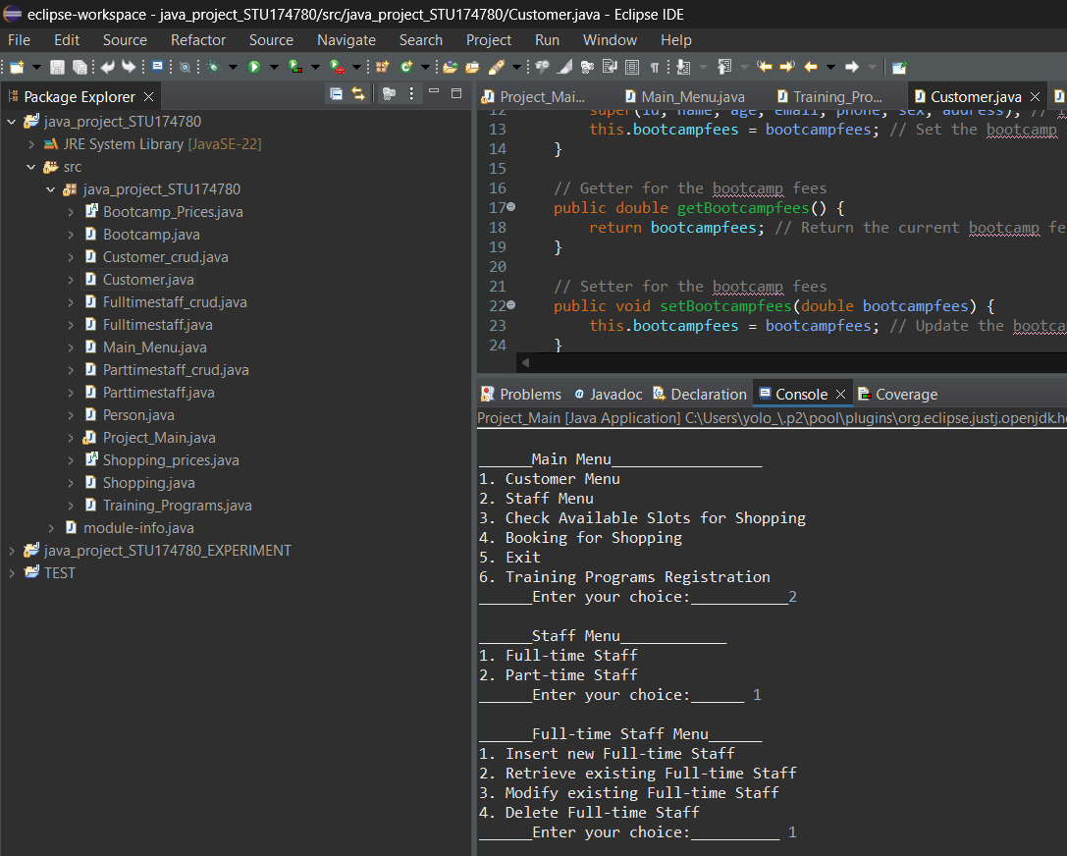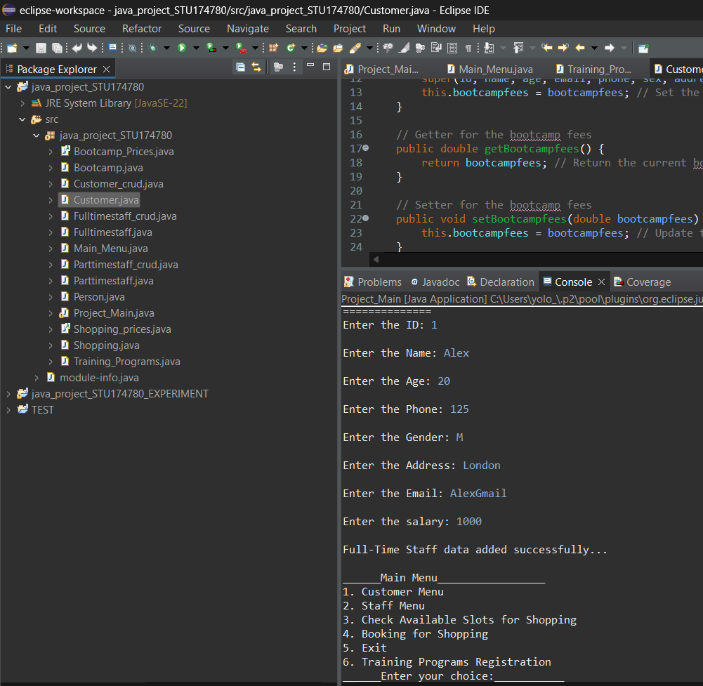

**Fulltime Retrieve:**

I made the program so fulltime staff data can be retrieved by telephone number.

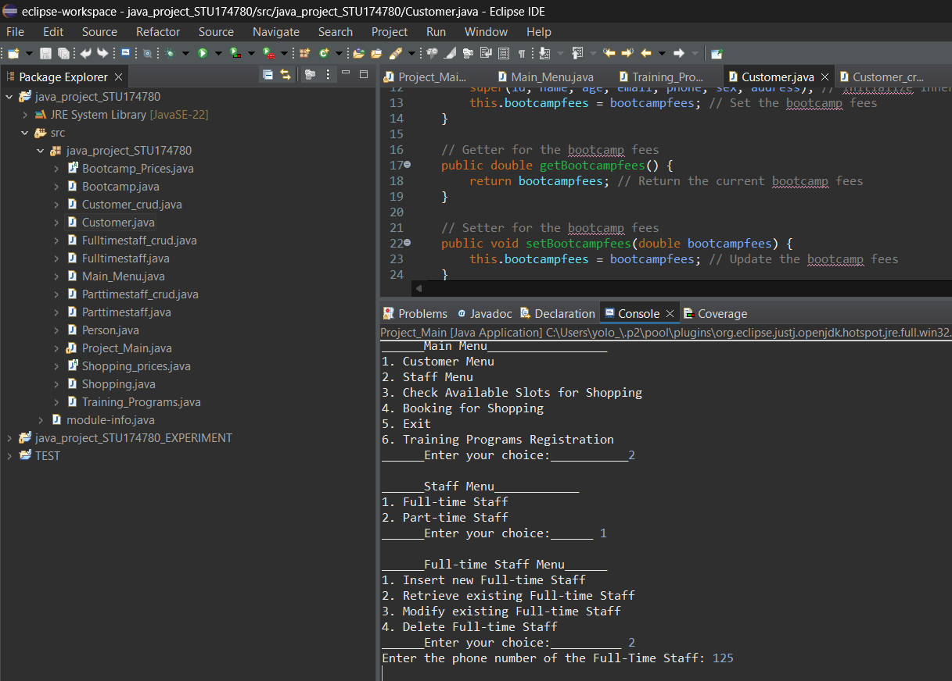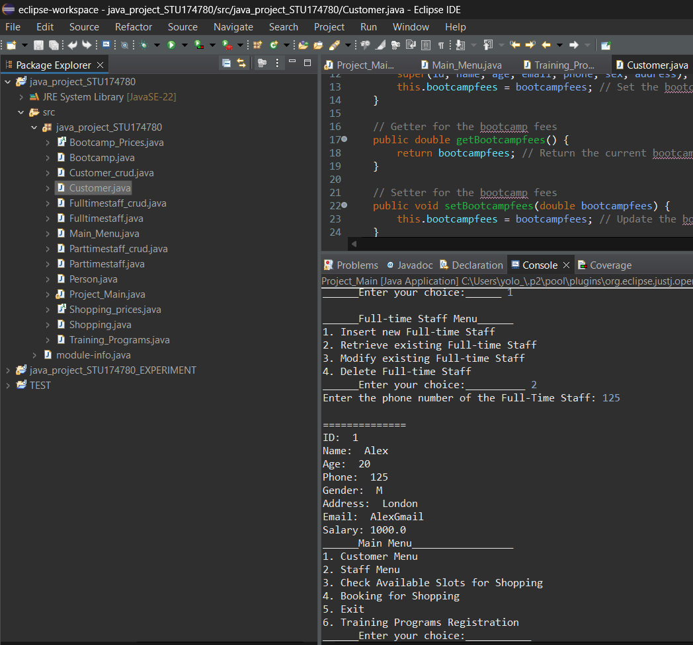

**Fulltime Modify:**

The modification aspect is done the same way as the customers data. You need to first insert the phone number and then you can easly modify the existing record.

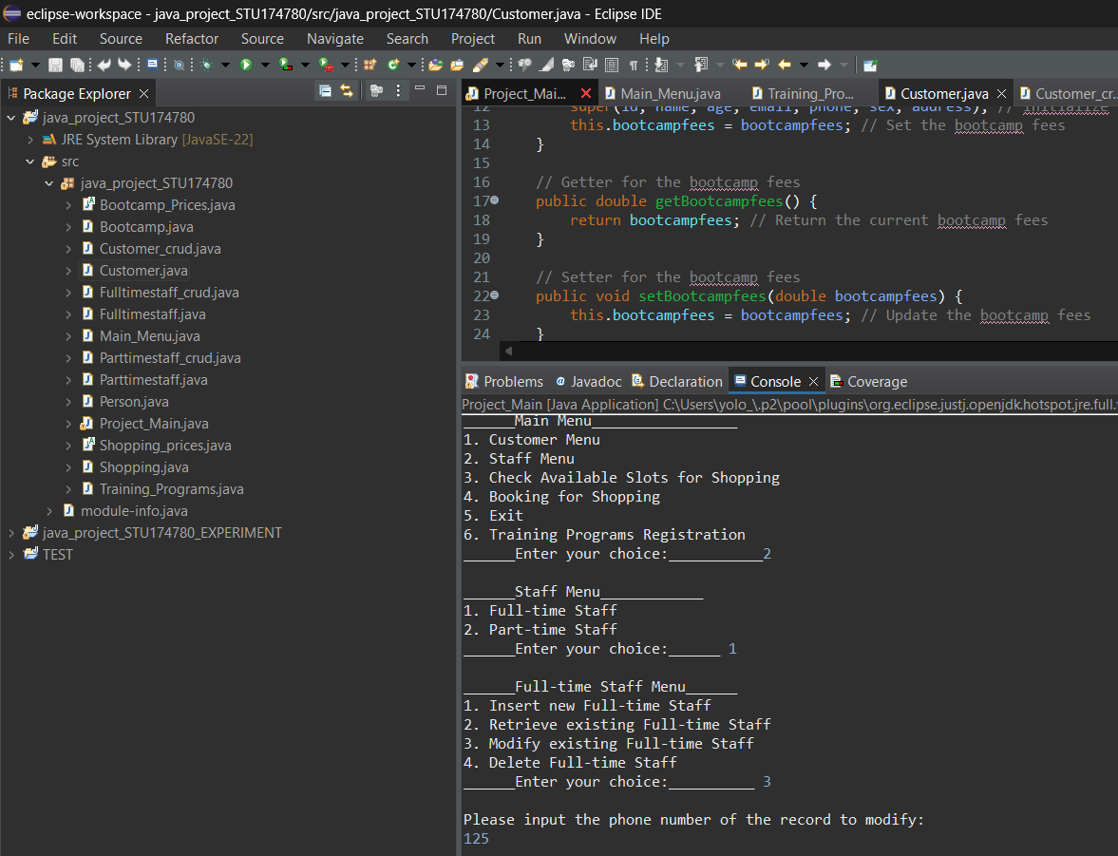

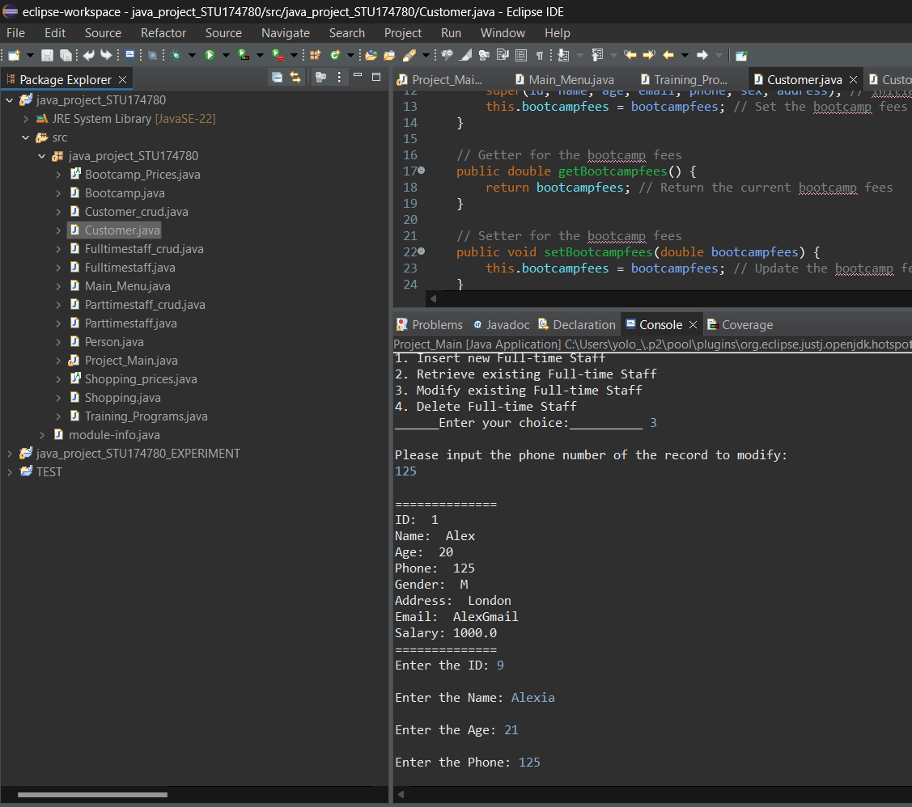

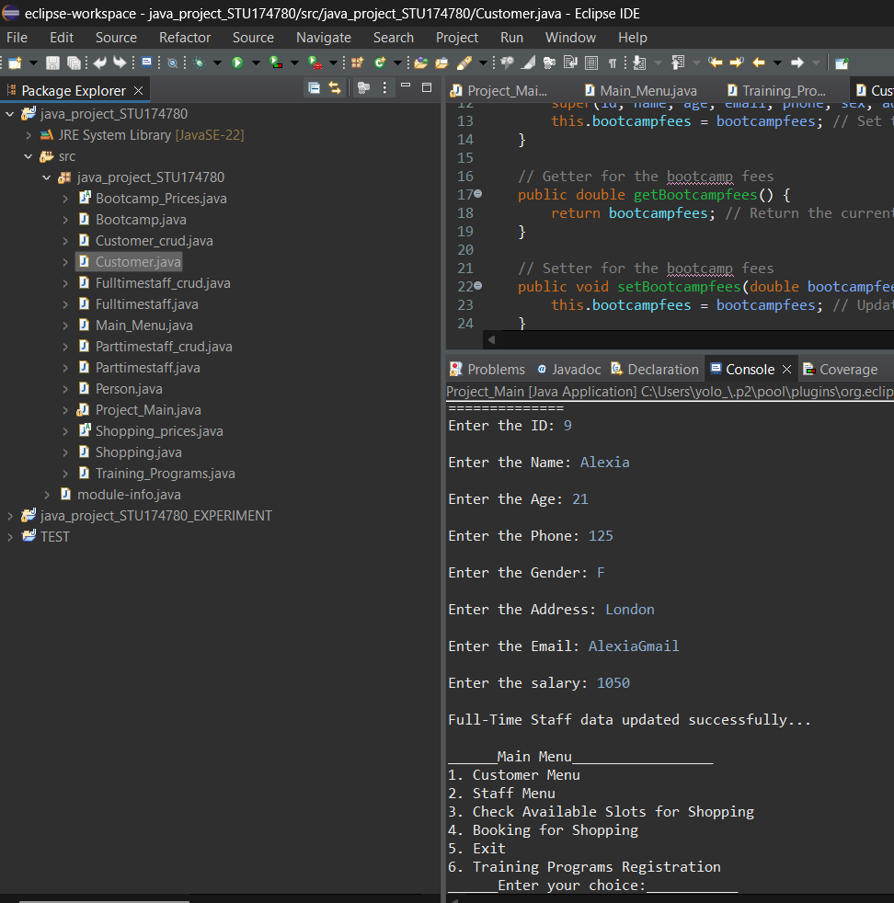

**Fulltime Delete:**

The deletion process is the done in the same way as in the customer menu. Insert the relevant phone number and then confirm the deletion by saying “yes”.

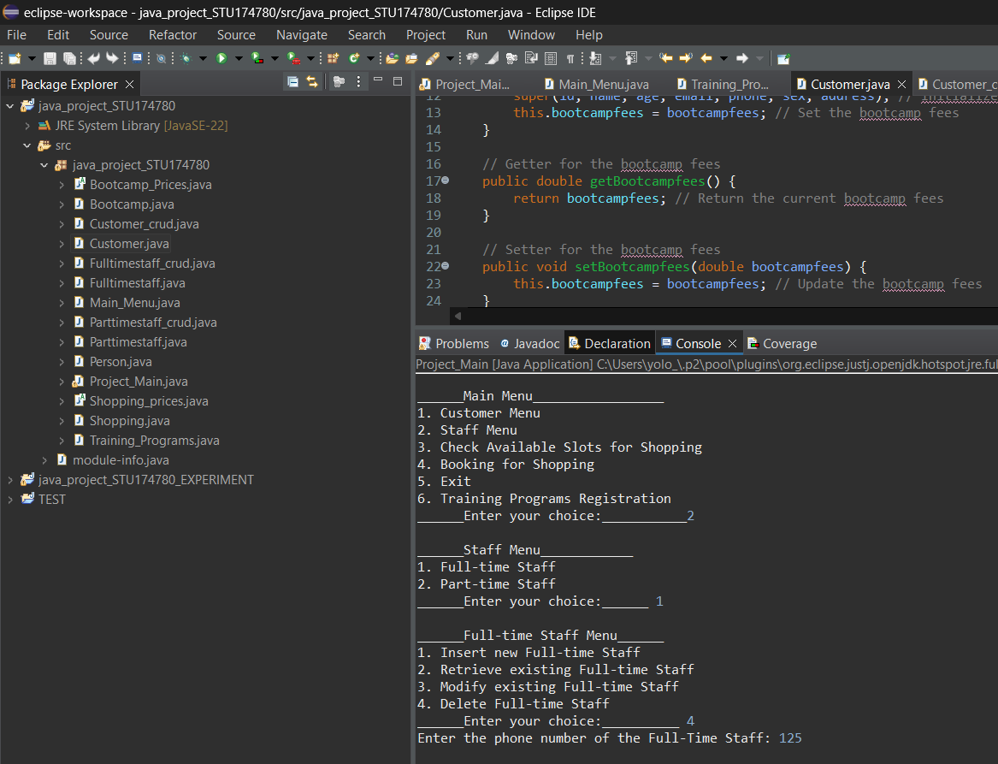

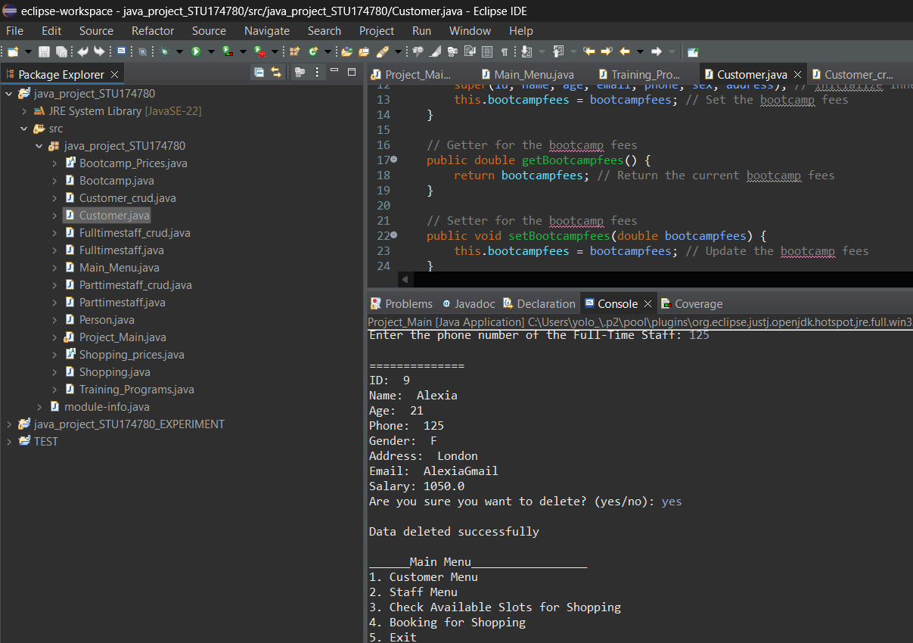

We can verify the deletion of the record by searching for it after.

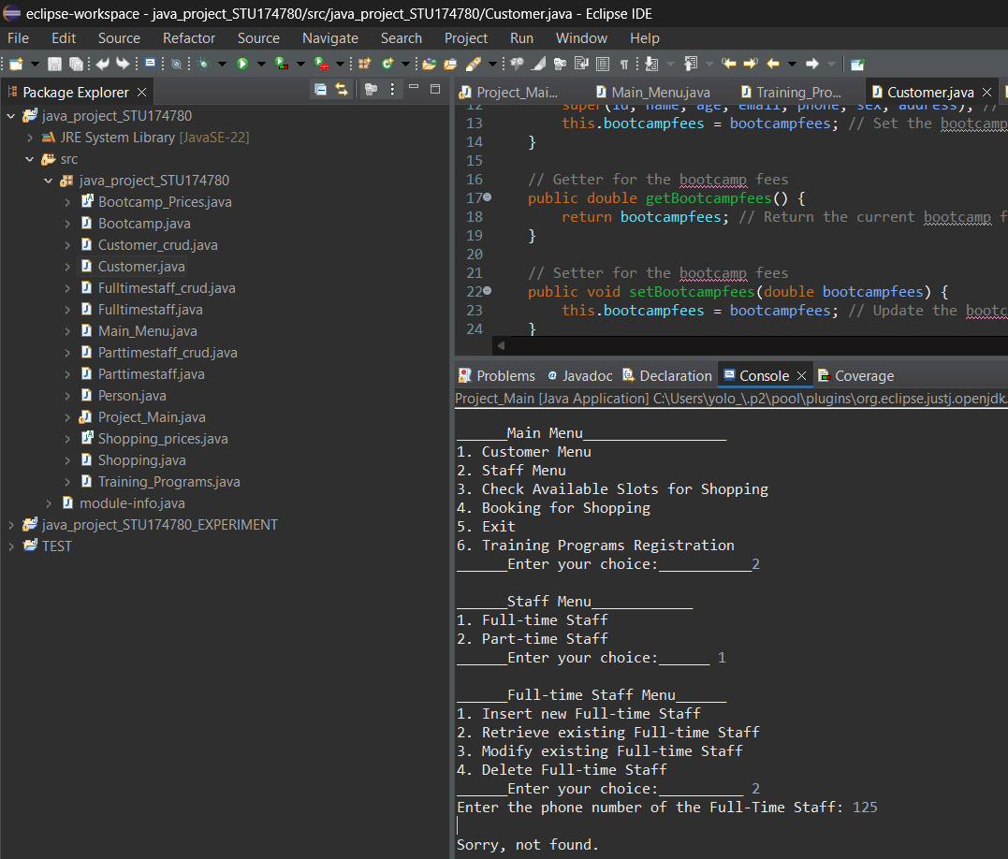

Parttime Menu:

**Parttime Add:**

The data insertion is done the same way as in the other two menus. Part time staff has the added records of hours and rate,relevant to part time staff.

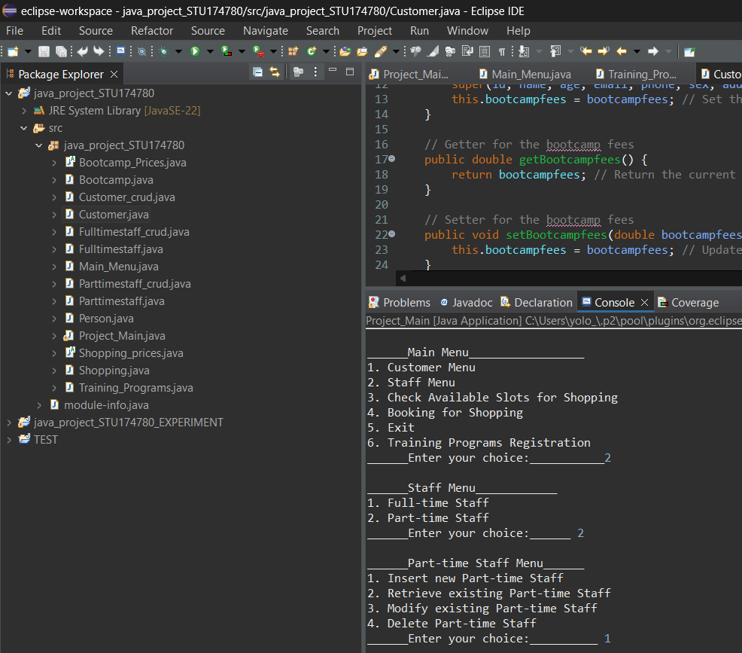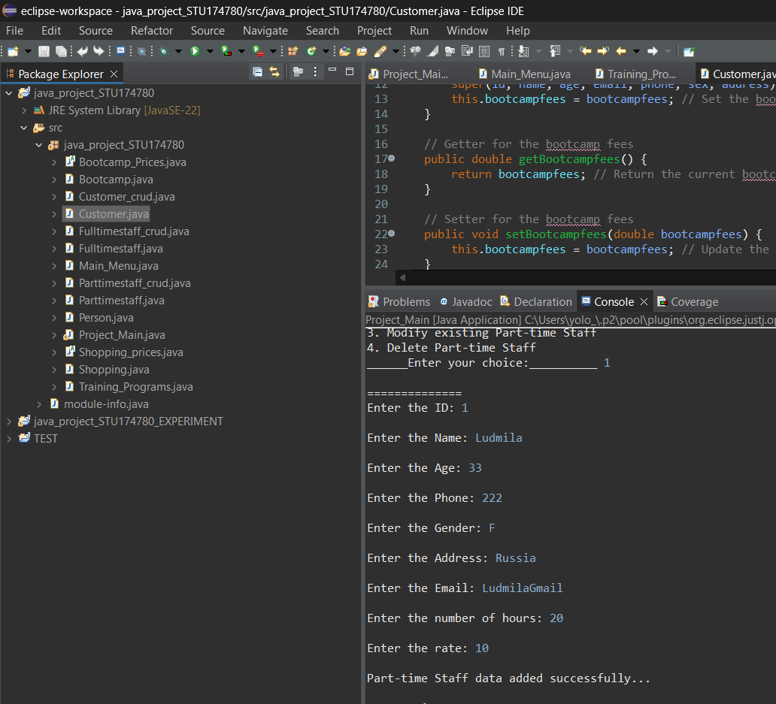

**Parttime Retrieve:**

The part time staff data is searched up by inserting the relevant phone number.

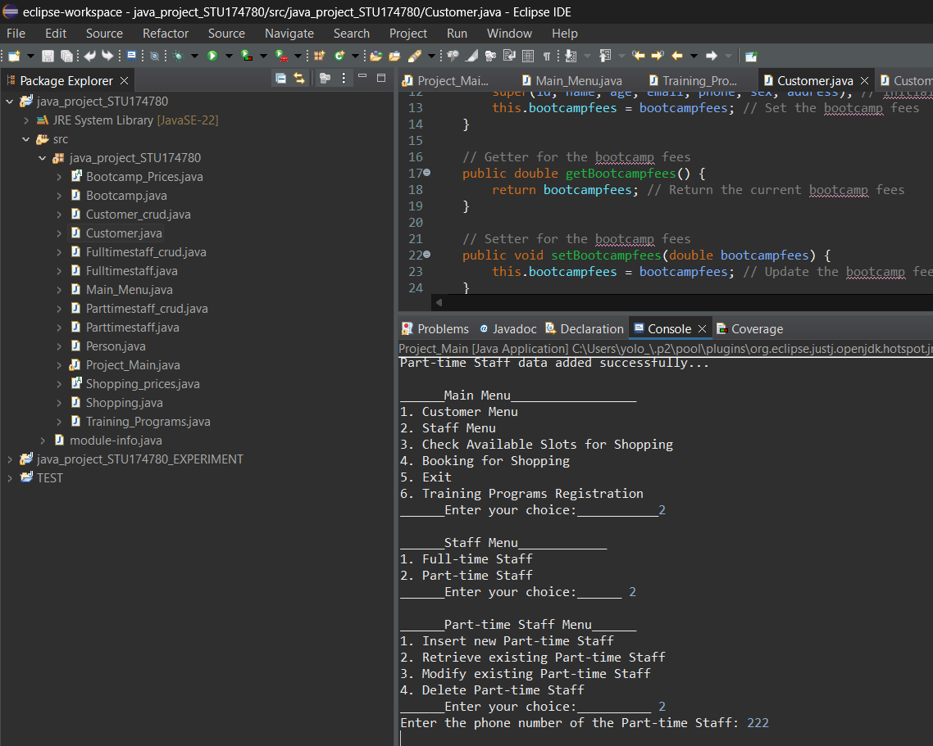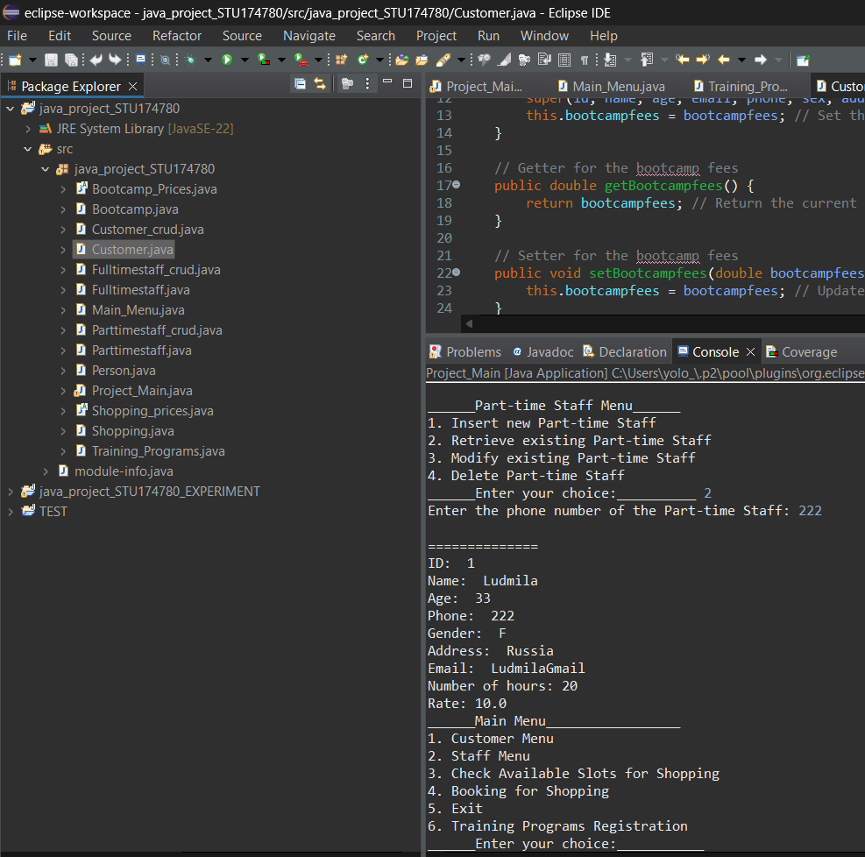

**Parttime Modify:**

In order to modify the part time records you need to insert the phone number of the staff member and then modify the relevant data.

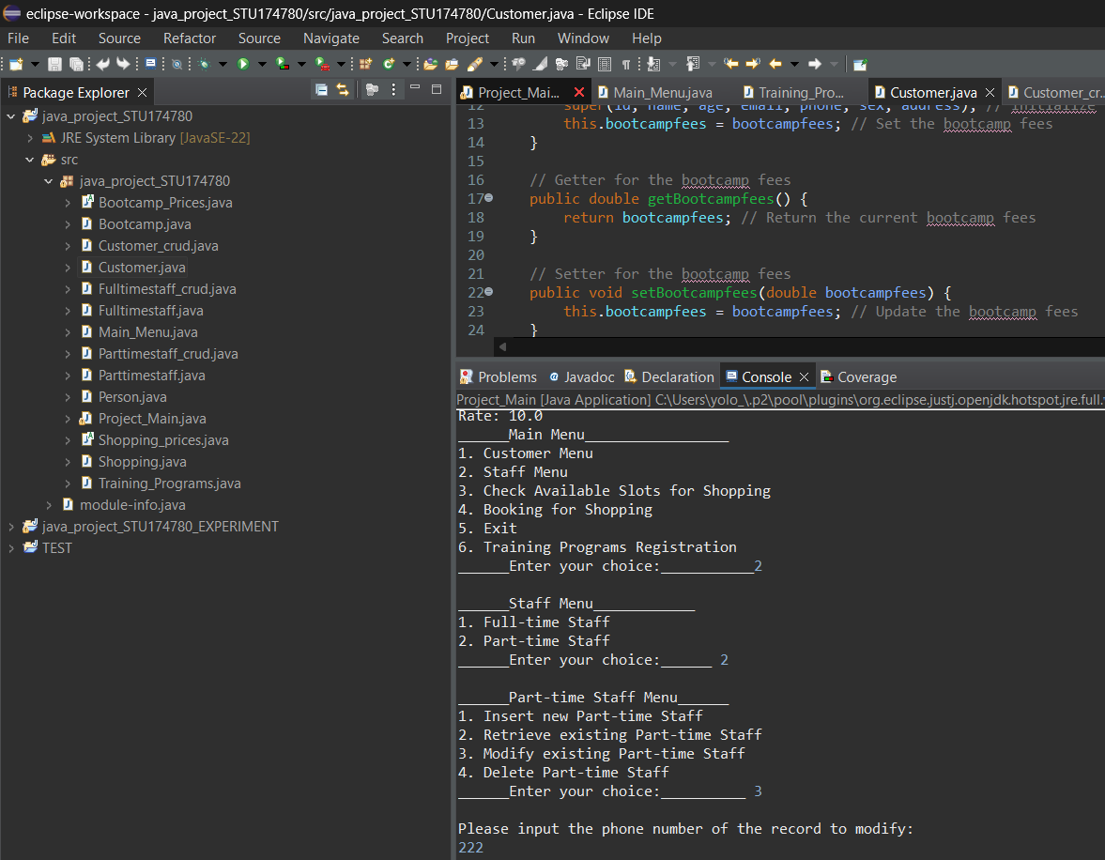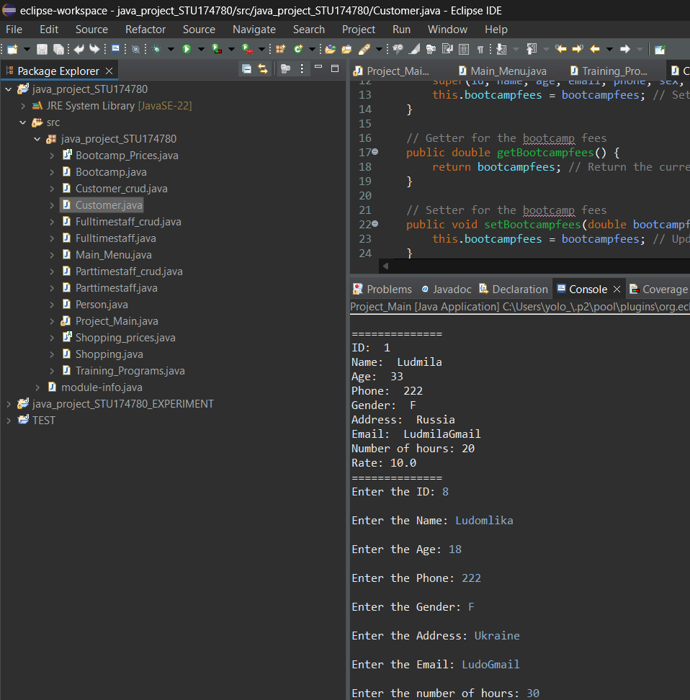

We can check the modification by searching the new record up.

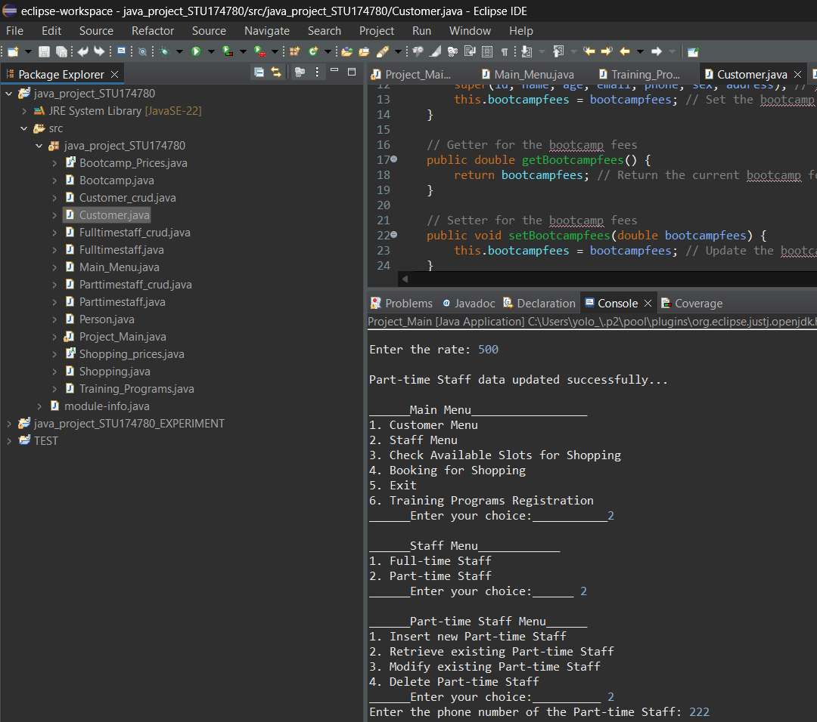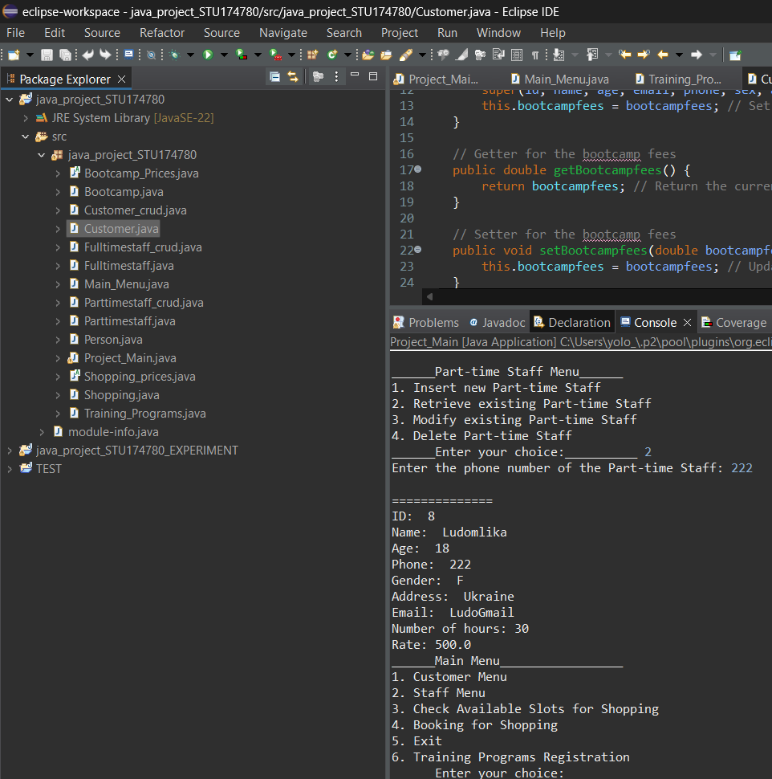

**Parttime Delete:**

To delete a part time record, insert the phone number and then confirm the deletion by typing “yes”.

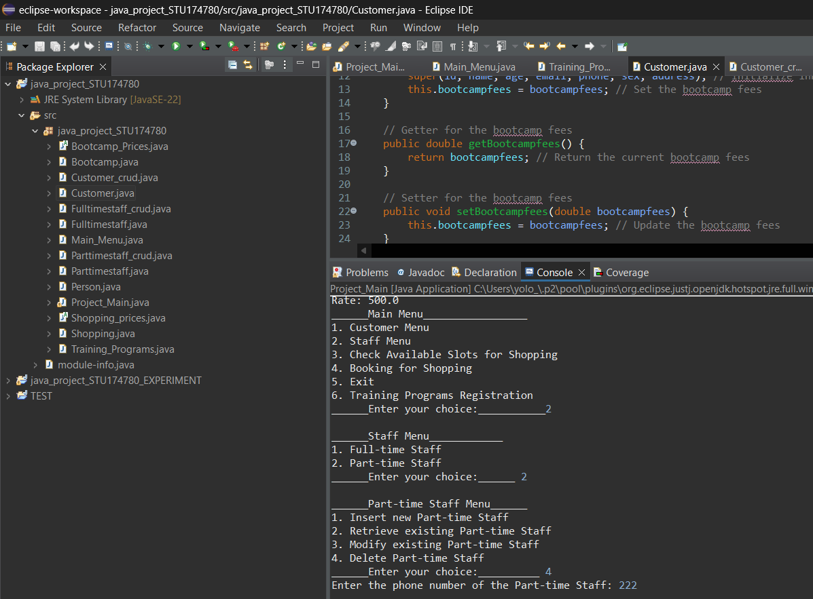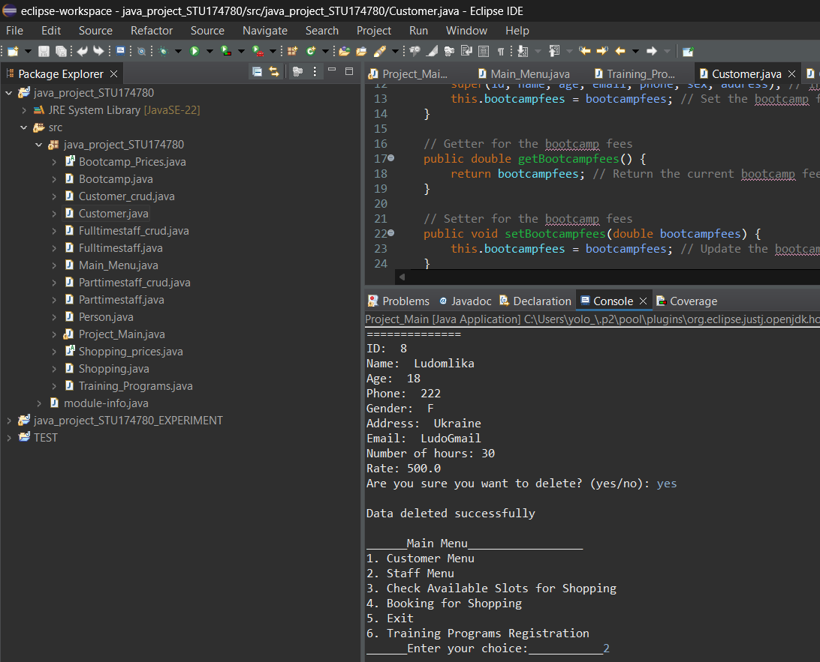

We can verify the deletion by trying to find the deleted record.

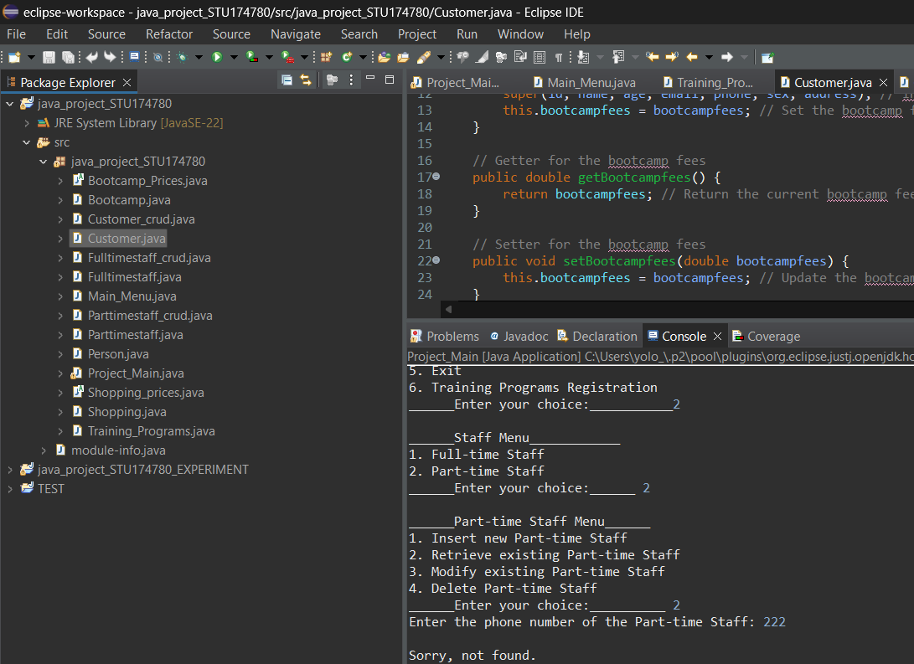

Shopping Interactions:

**Shopping Check:**

A customer can check the shopping slots available by choosing this option. If a certain time slot is booked it will say so next to the time slots displayed.

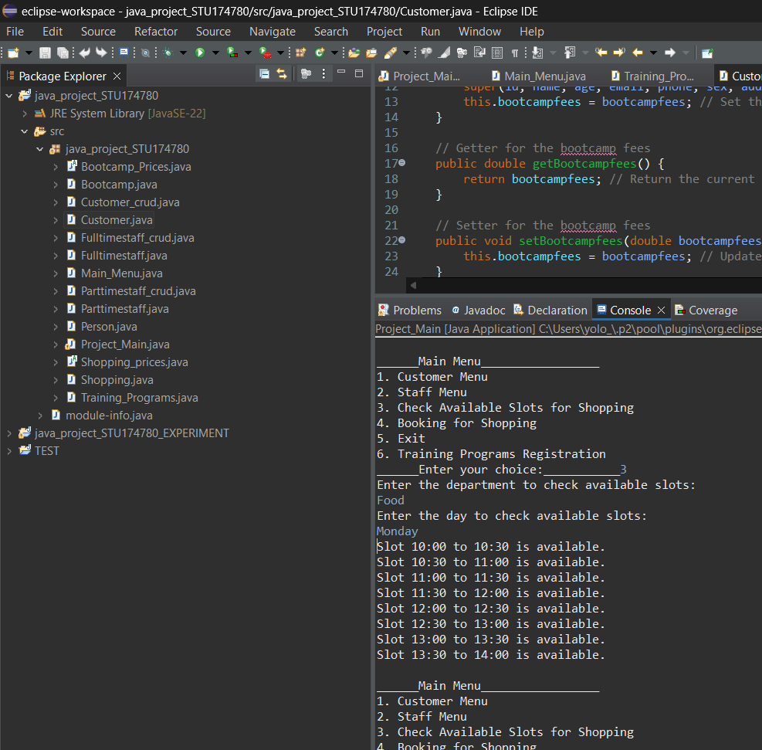

**Shopping Booking:**

When booking a shopping assisted trip to the store,you are prompted with the relevant staff in the store.Next to them it will say if they are free or not for a booking as well as their ID for booking purposes.(I did not show the full list of the customer ID’s as well for security reasons).After you input the relevant information regarding the booking,the program will print a receipt with the cost of the booking.The base cost is 50£.

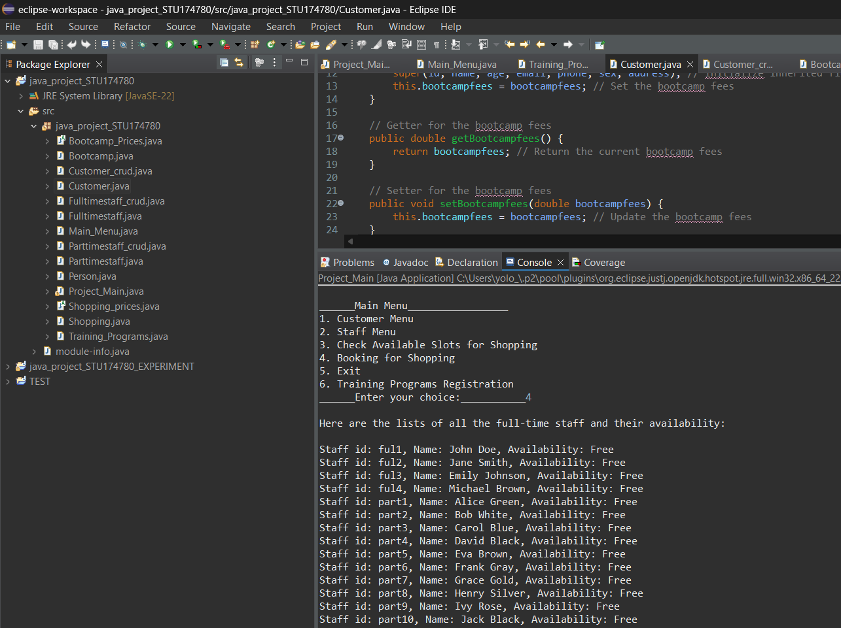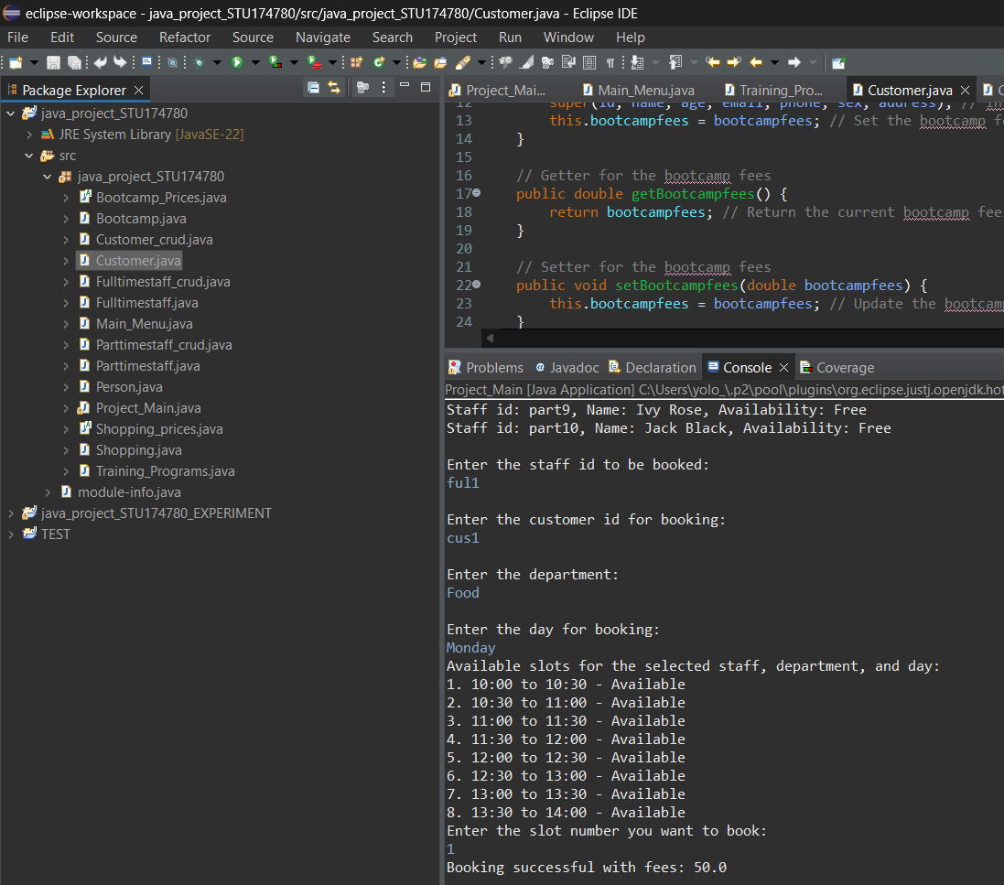

Workshop Registration:

In order to book a workshop session, you need to input the customer id and the relevant information about the workshop and time.You will be provided with a receipt after with the cost and overview of the workshop. Base price is 100£.

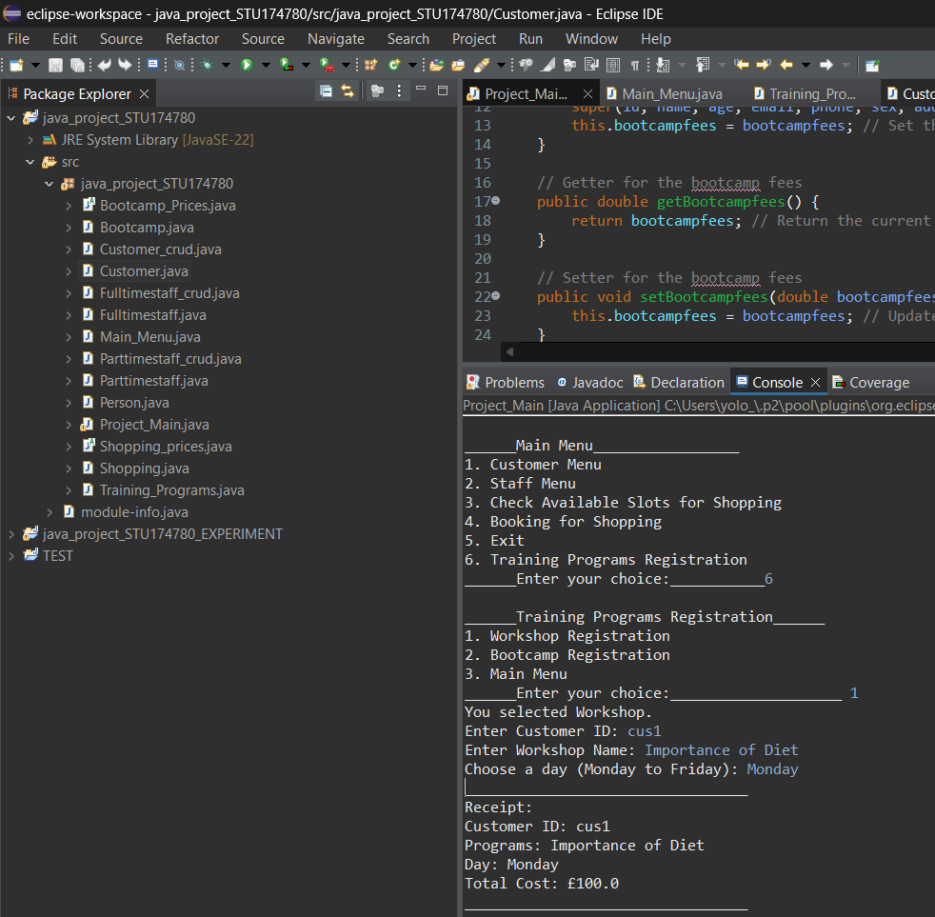

Bootcamp Registration:

In the case of the Bootcamps,the user goes trough the same process as In the workshop registration but is prompted with different prices and information for each bootcamp.The Bakery bootcamp has the price of 350£ and has an additional discount if another bootcamp is bought. In the example the user bought two bootcamps,including the bakery one.In the receipt the discount is applied accordingly and the price is shown along with the other booking information.

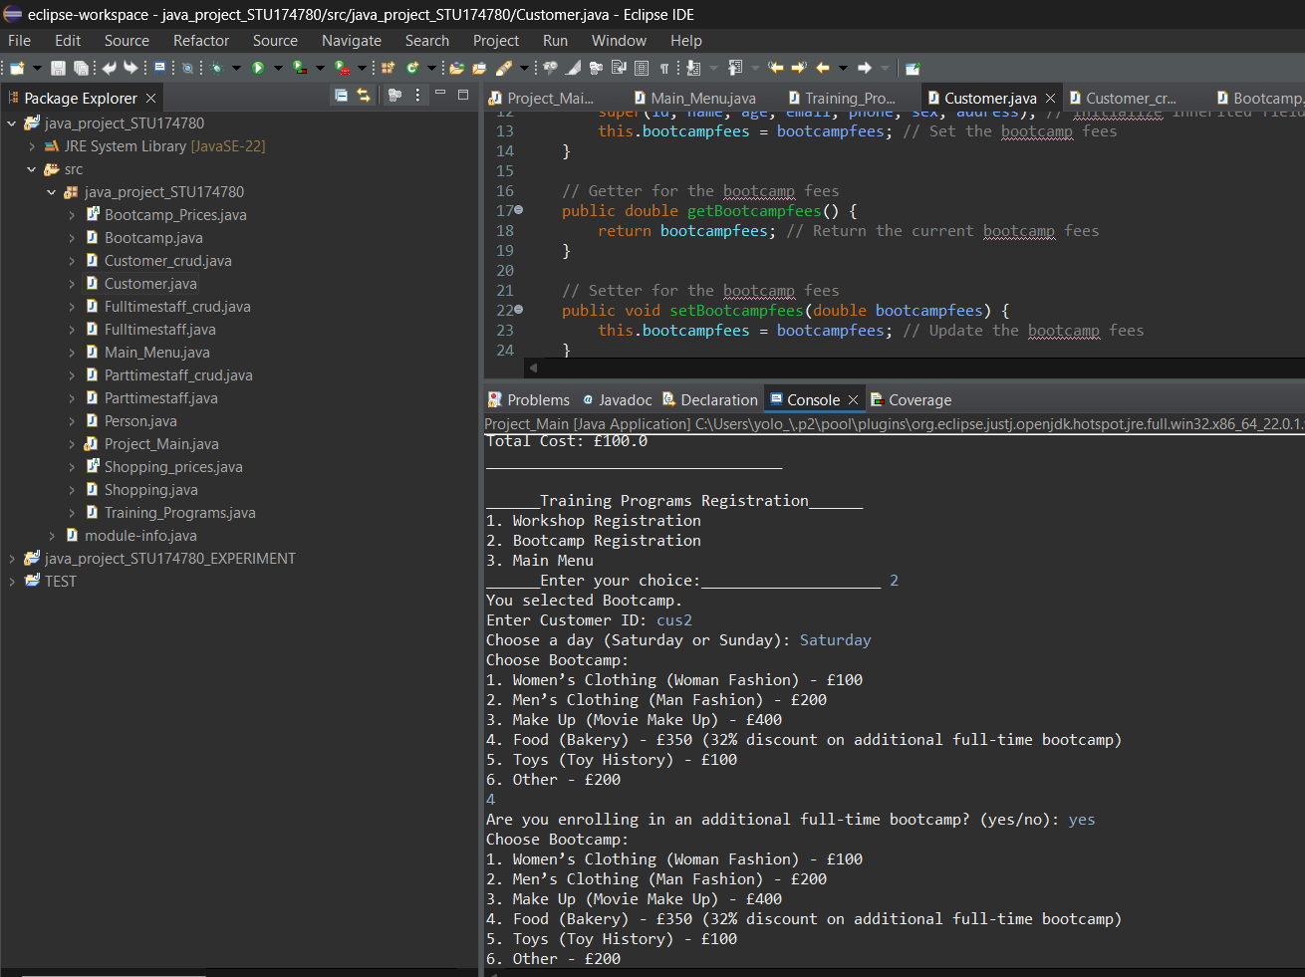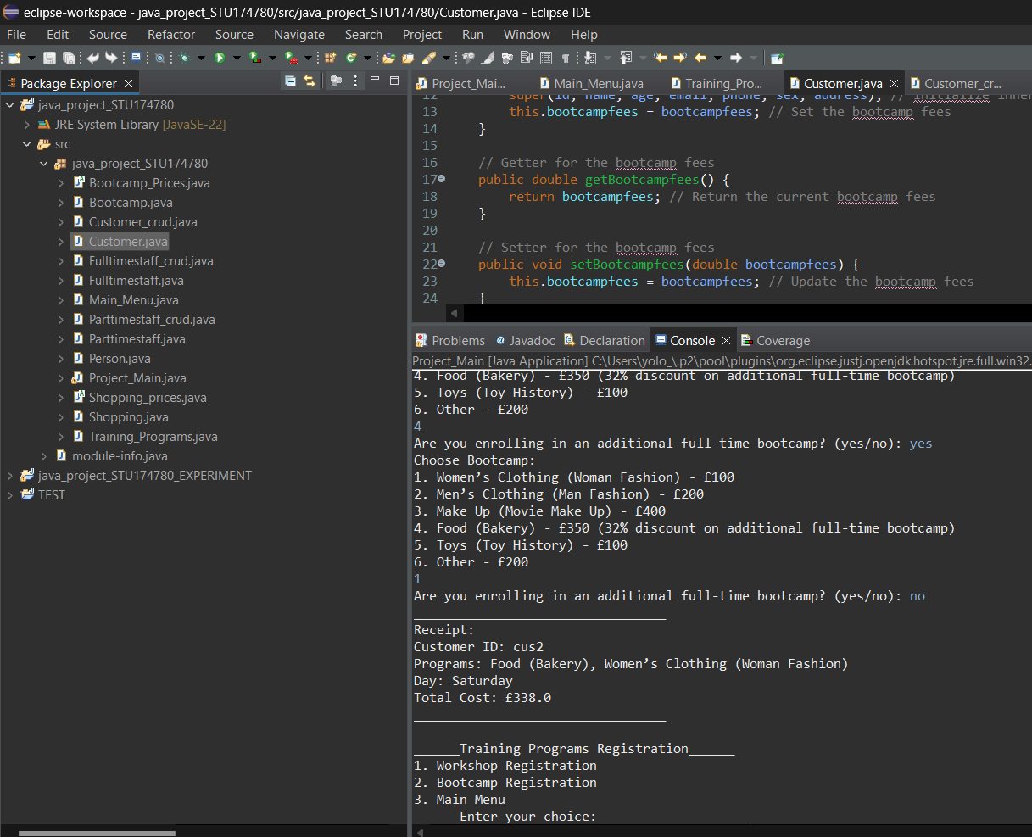

References:

Richard, W. and Lewis, J. P., (2000). *Fundamentals of OOP and data structures in Java* [online].

Cambridge: Cambridge University Press.

Simon, K., (2014). *Object Oriented Programming Using Java* [online].

London: Bookboon.

Ralph, M. and Ralph, W., (2017). *Java, Java, Java Object-Oriented Problem Solving* [online]. Third Edition.

Hartford: Trinity College.

Bibliography:

Richard, D. and Stuart, H., (1999). Programming Java: An Introduction to Programming Using Java [online]. Wisconsin: Cole Publishing Co.

Ralph, M. and Ralph, W., (2017). *Java, Java, Java Object-Oriented Problem Solving* [online]. Third Edition.

Hartford: Trinity College.

Simon, K., (2014). *Object Oriented Programming Using Java* [online].

London: Bookboon.

Richard, W. and Lewis, J. P., (2000). *Fundamentals of OOP and data structures in Java* [online].

Cambridge: Cambridge University Press.

GeeksforGeeks, (2023). *Introduction of Object Oriented Programming* [online].

Noida: GeeksforGeeks.

Available from:<https://www.geeksforgeeks.org/introduction-of-object-oriented-programming/>

[Accessed 20 July 2024]

Sonoo, J., (2024). *Java OOPs Concepts* [online].

Noida: Javapoint.

Available from: <https://www.javatpoint.com/java-oops-concepts>

[Accessed 19 July 2024]

Stackify, (2024). *What Are OOP Concepts in Java? How They Work and More* [online].

Huntington Beach: Stackify.

Available from: <https://stackify.com/oops-concepts-in-java/>

[Accessed 19 July 2024]

Patrick, C., (2022). *Object-Oriented Programming in Java – A Beginner's Guide* [online].

San Francisco: freeCodeCamp.

Available from: <https://www.freecodecamp.org/news/object-oriented-programming-concepts-java/>

[Accessed 18 July 2024]

w3resource, (2024). *Java Object Oriented Programming - Exercises, Practice, Solution* [online].

Burdwan: w3resource.

Available from: <https://www.w3resource.com/java-exercises/oop/index.php>

[Accessed 18 July 2024]

Tutorials Point, (2024). *Java - OOPs (Object-Oriented Programming) Concepts* [online].

Nizam: Tutorials Point.

Available from: <https://www.tutorialspoint.com/java/java_oops_concepts.htm>

[Accessed 18 July 2024]

Appendix:

Person Test Code

package test;

public class Person {

private String id;

private String name;

private int age;

private String email;

private String phone;

private String sex;

private String address;

public Person(String id, String name, int age, String email, String phone, String sex, String address) {

this.id = id;

this.name = name;

this.age = age;

this.email = email;

this.phone = phone;

this.sex = sex;

this.address = address;

}

// Getters and Setters

public String getId() { return id; }

public void setId(String id) { this.id = id; }

public String getName() { return name; }

public void setName(String name) { this.name = name; }

public int getAge() { return age; }

public void setAge(int age) { this.age = age; }

public String getEmail() { return email; }

public void setEmail(String email) { this.email = email; }

public String getPhone() { return phone; }

public void setPhone(String phone) { this.phone = phone; }

public String getSex() { return sex; }

public void setSex(String sex) { this.sex = sex; }

public String getAddress() { return address; }

public void setAddress(String address) { this.address = address; }

}

package test;

public class PersonTest {

public static void main(String[] args) {

// Create a Person object

Person person = new Person("1", "John Doe", 30, "john.doe@example.com", "123-456-7890", "Male", "123 Elm St");

// Test getters

if ("1".equals(person.getId())) {

System.out.println("Person ID Test Passed");

} else {

System.out.println("Person ID Test Failed");

}

if ("John Doe".equals(person.getName())) {

System.out.println("Person Name Test Passed");

} else {

System.out.println("Person Name Test Failed");

}

if (30 == person.getAge()) {

System.out.println("Person Age Test Passed");

} else {

System.out.println("Person Age Test Failed");

}

if ("john.doe@example.com".equals(person.getEmail())) {

System.out.println("Person Email Test Passed");

} else {

System.out.println("Person Email Test Failed");

}

if ("123-456-7890".equals(person.getPhone())) {

System.out.println("Person Phone Test Passed");

} else {

System.out.println("Person Phone Test Failed");

}

if ("Male".equals(person.getSex())) {

System.out.println("Person Sex Test Passed");

} else {

System.out.println("Person Sex Test Failed");

}

if ("123 Elm St".equals(person.getAddress())) {

System.out.println("Person Address Test Passed");

} else {

System.out.println("Person Address Test Failed");

}

// Test setters

person.setName("Jane Doe");

if ("Jane Doe".equals(person.getName())) {

System.out.println("Person SetName Test Passed");

} else {

System.out.println("Person SetName Test Failed");

}

person.setAge(35);

if (35 == person.getAge()) {

System.out.println("Person SetAge Test Passed");

} else {

System.out.println("Person SetAge Test Failed");

}

}

}

Bootcamp_Prices Test Code

package test_2;

abstract class Bootcamp_Prices {

public abstract double getBootcampCost(int bootcampChoice);

public abstract double applyDiscount(double baseCost, boolean hasAdditionalBootcamp);

}

package test_2;

public class BootcampTest {

public static void main(String[] args) {

// Anonymous subclass to provide concrete implementation

Bootcamp_Prices bootcampPrices = new Bootcamp_Prices() {

@Override

public double getBootcampCost(int bootcampChoice) {

switch (bootcampChoice) {

case 1: return 100; // Women’s Clothing

case 2: return 200; // Men’s Clothing

case 3: return 400; // Make Up

case 4: return 350; // Food

case 5: return 100; // Toys

case 6: return 200; // Other

default: return 0; // Invalid choice

}

}

@Override

public double applyDiscount(double baseCost, boolean hasAdditionalBootcamp) {

// Apply 32% discount if the base cost is 350 and additional bootcamp is true

if (hasAdditionalBootcamp && baseCost == 350) {

return baseCost * (1 - 0.32); // Correctly apply 32% discount

}

return baseCost; // Return base cost if no discount applies

}

};

// Test getBootcampCost method

double cost1 = bootcampPrices.getBootcampCost(1);

if (cost1 == 100) {

System.out.println("Bootcamp Cost Test Passed for choice 1");

} else {

System.out.println("Bootcamp Cost Test Failed for choice 1");

}

double cost4 = bootcampPrices.getBootcampCost(4);

if (cost4 == 350) {

System.out.println("Bootcamp Cost Test Passed for choice 4");

} else {

System.out.println("Bootcamp Cost Test Failed for choice 4");

}

// Test applyDiscount method

double discountedCost1 = bootcampPrices.applyDiscount(350, true);

// Expected value: 350 * (1 - 0.32) = 350 * 0.68 = 238.0

if (Math.abs(discountedCost1 - 238.0) < 0.001) {

System.out.println("Bootcamp Discount Test Passed for cost 350 with additional bootcamp");

} else {

System.out.println("Bootcamp Discount Test Failed for cost 350 with additional bootcamp");

}

double discountedCost2 = bootcampPrices.applyDiscount(100, false);

// Expected value: 100 (no discount applied)

if (Math.abs(discountedCost2 - 100.0) < 0.001) {

System.out.println("Bootcamp Discount Test Passed for cost 100 without additional bootcamp");

} else {

System.out.println("Bootcamp Discount Test Failed for cost 100 without additional bootcamp");

}

}

}

Training Programs class

package java_project_STU174780;

import java.util.ArrayList;

public class Training_Programs {

private String customerId; // Unique identifier for the customer

private ArrayList<String> programNames; // List to keep track of enrolled program names

private String day; // The day chosen by the customer for their programs

private double totalCost; // Accumulated cost of all the programs the customer is enrolled in

// Constructor initializes the customer's ID and preferred day, and prepares for program enrollment

public Training_Programs(String customerId, String day) {

this.customerId = customerId;

this.day = day;

this.programNames = new ArrayList<>(); // Initialize the list to store program names

this.totalCost = 0; // Start with no cost

}

// Returns the customer's ID

public String getCustomerId() {

return customerId;

}

// Returns the list of programs the customer is enrolled in

public ArrayList<String> getProgramNames() {

return programNames;

}

// Returns the day the customer has selected for the programs

public String getDay() {

return day;

}

// Returns the total cost of the enrolled programs

public double getTotalCost() {

return totalCost;

}

// Adds a program to the customer's list and updates the total cost

public void addProgram(String programName, double cost) {

this.programNames.add(programName); // Add the program to the list

this.totalCost += cost; // Update the total cost

}

// Applies a discount to the total cost if certain conditions are met

public void applyDiscount() {

// Discount applies only if the customer is enrolled in more than one program

if (this.programNames.size() > 1) {

for (String program : this.programNames) {

// Check if one of the enrolled programs is "Food (Bakery)"

if (program.contains("Food (Bakery)")) {

this.totalCost -= 350 * 0.32; // Apply a 32% discount on £350

break; // Stop after applying the discount to avoid multiple discounts

}

}

}

}

// Prints a detailed receipt for the customer

public void printReceipt() {

System.out.println("_________________________________");

System.out.println("Receipt:");

System.out.println("Customer ID: " + customerId); // Display the customer's ID

System.out.println("Programs: " + String.join(", ", programNames)); // List all enrolled programs

System.out.println("Day: " + day); // Display the chosen day

System.out.println("Total Cost: £" + totalCost); // Show the total cost

System.out.println("_________________________________");

}

// Static method to return the cost of a specific bootcamp based on user's choice

public static double getBootcampCost(int bootcampChoice) {

switch (bootcampChoice) {

case 1:

return 100; // Cost for Women’s Clothing (Woman Fashion)

case 2:

return 200; // Cost for Men’s Clothing (Man Fashion)

case 3:

return 400; // Cost for Make Up (Movie Make Up)

case 4:

return 350; // Cost for Food (Bakery)

case 5:

return 100; // Cost for Toys (Toy History)

case 6:

return 200; // Cost for Other (Placeholder for future bootcamps)

default:

return 0; // Default cost for unknown choices

}

}

// Static method to return the name of a specific bootcamp based on user's choice

public static String getBootcampName(int bootcampChoice) {

switch (bootcampChoice) {

case 1:

return "Women’s Clothing (Woman Fashion)"; // Name for choice 1

case 2:

return "Men’s Clothing (Man Fashion)"; // Name for choice 2

case 3:

return "Make Up (Movie Make Up)"; // Name for choice 3

case 4:

return "Food (Bakery)"; // Name for choice 4

case 5:

return "Toys (Toy History)"; // Name for choice 5

case 6:

return "Food (Italian Cooking)"; // Name for choice 6

default:

return "Unknown"; // Default name for unknown choices

}

}

}

Shopping class

package java_project_STU174780;

public class Shopping {

private String customerId; // ID of the customer making the booking

private String staffId; // ID of the staff member being booked

private String department; // Department where the staff member works

private String day; // Day of the booking

private int slotNo; // Slot number for the booking (1-based index)

private double fees; // Total fees for the booking

private int[] booking; // Array representing the availability of 8 slots

// Constructor to initialize a new shopping/booking instance

// Initializes the booking array with 8 slots (0 for available, 1 for booked)

public Shopping(String customerId, String staffId, String department, String day, int slotNo) {

this.customerId = customerId;

this.staffId = staffId;

this.department = department;

this.day = day;

this.slotNo = slotNo;

this.booking = new int[8]; // Initialize array for 8 time slots

this.fees = 0; // Start with no fees

}

// Returns the customer ID

public String getCustomerId() {

return customerId;

}

// Returns the staff ID

public String getStaffId() {

return staffId;

}

// Returns the department name

public String getDepartment() {

return department;

}

// Returns the day of the booking

public String getDay() {

return day;

}

// Returns the slot number for the booking

public int getSlotNo() {

return slotNo;

}

// Returns the total fees for the booking

public double getFees() {

return fees;

}

// Returns the booking array representing slot availability

public int[] getBooking() {

return booking;

}

// Calculates the fees for the booking

// Currently, it's a static fee of 50

public void calculate_fees() {

this.fees = 50; // Apply a fixed fee of 50 for now

}

// Marks a slot as booked

// Slot number provided is 1-based, so we adjust by subtracting 1

public void setBooking(int slotNo) {

this.booking[slotNo - 1] = 1; // Mark the slot as booked (1)

}

}

Shopping_prices class

package java_project_STU174780;

public abstract class Shopping_prices {

// Base fee for shopping, set to a default value of 5

// This fee is the starting point before any additional calculations

public static double base_fees = 5;

// Abstract method to calculate fees

// This method should be implemented by any subclass

// Each subclass will have its own way of calculating the total fees

public abstract void calculate_fees();

}

Project_Main class

package java_project_STU174780;

import java.util.ArrayList;

import java.util.Scanner;

public class Project_Main {

public static void main(String[] args) {

Scanner scanner = new Scanner(System.in); // Initialize scanner for user input

Customer_crud Crud_Customer = new Customer_crud(); // CRUD operations for managing customer data

Fulltimestaff_crud Crud_fulltimestaff = new Fulltimestaff_crud(); // CRUD operations for managing full-time staff data

Parttimestaff_crud Crud_parttimestaff = new Parttimestaff_crud(); // CRUD operations for managing part-time staff data

ArrayList<Shopping> shopping_booking = new ArrayList<>(); // List to store all shopping bookings

ArrayList<Training_Programs> trainingPrograms = new ArrayList<>(); // List to store all training program enrollments

// Define the time slots available for bookings

String[] timing = {

"10:00 to 10:30", "10:30 to 11:00", "11:00 to 11:30",

"11:30 to 12:00", "12:00 to 12:30", "12:30 to 13:00",

"13:00 to 13:30", "13:30 to 14:00"

};

// Main loop to keep the application running until the user decides to exit

while (true) {

Main_Menu.main_menu(); // Display the main menu to the user

int choice = scanner.nextInt(); // Read the user's choice from the menu

scanner.nextLine(); // Consume the leftover newline character

// Handle customer-related operations

if (choice == 1) {

Main_Menu.customer_menu(); // Show the customer management options

int customer_choice = scanner.nextInt(); // Get user's choice for customer operations

scanner.nextLine(); // Consume newline character

// Perform the selected CRUD operation on customer data

if (customer_choice == 1) {

Crud_Customer.insert(); // Add a new customer

} else if (customer_choice == 2) {

Crud_Customer.retrieve(); // Retrieve customer details

} else if (customer_choice == 3) {

Crud_Customer.modify(); // Modify existing customer information

} else if (customer_choice == 4) {

Crud_Customer.delete(); // Delete a customer record

}

}

// Handle staff-related operations

else if (choice == 2) {

Main_Menu.staff_menu(); // Show options for staff management

int staff_choice = scanner.nextInt(); // Get user's choice for staff operations

scanner.nextLine(); // Consume newline character

// Perform operations based on the type of staff

if (staff_choice == 1) {

Main_Menu.fulltimestaff_menu(); // Display full-time staff management options

int fts_choice = scanner.nextInt(); // Get choice for full-time staff operations

scanner.nextLine(); // Consume newline character

// Execute the selected operation on full-time staff data

if (fts_choice == 1) {

Crud_fulltimestaff.insert(); // Add a new full-time staff member

} else if (fts_choice == 2) {

Crud_fulltimestaff.retrieve(); // Retrieve full-time staff details

} else if (fts_choice == 3) {

Crud_fulltimestaff.modify(); // Modify details of existing full-time staff

} else if (fts_choice == 4) {

Crud_fulltimestaff.delete(); // Delete a full-time staff record

}

} else if (staff_choice == 2) {

Main_Menu.parttimestaff_menu(); // Display part-time staff management options

int pts_choice = scanner.nextInt(); // Get choice for part-time staff operations

scanner.nextLine(); // Consume newline character

// Execute the selected operation on part-time staff data

if (pts_choice == 1) {

Crud_parttimestaff.insert(); // Add a new part-time staff member

} else if (pts_choice == 2) {

Crud_parttimestaff.retrieve(); // Retrieve part-time staff details

} else if (pts_choice == 3) {

Crud_parttimestaff.modify(); // Modify details of existing part-time staff

} else if (pts_choice == 4) {

Crud_parttimestaff.delete(); // Delete a part-time staff record

}

}

}

// Check availability of booking slots

else if (choice == 3) {

System.out.println("Enter the department to check available slots: ");

String department = scanner.nextLine(); // Get department from the user

System.out.println("Enter the day to check available slots: ");

String day = scanner.nextLine(); // Get day from the user

// Check each time slot for availability

for (int i = 1; i <= 8; i++) {

boolean isSlotAvailable = true; // Assume slot is available by default

for (Shopping s : shopping_booking) {

if (s.getDepartment().equals(department) && s.getDay().equals(day)) {

if (s.getBooking()[i - 1] == 1) { // Check if slot is booked

isSlotAvailable = false;

System.out.println("Slot " + timing[i - 1] + " is booked.");

break;

}

}

}

if (isSlotAvailable) {

System.out.println("Slot " + timing[i - 1] + " is available.");

}

}

}

// Handle staff availability and booking

else if (choice == 4) {

System.out.println("\nHere are the lists of all the full-time staff and their availability: \n");

ArrayList<Fulltimestaff> fts_data = Crud_fulltimestaff.getFulltimestaff_data(); // Get full-time staff data

ArrayList<Parttimestaff> pts_data = Crud_parttimestaff.getParttimestaff_data(); // Get part-time staff data

ArrayList<Customer> customer_data = Crud_Customer.getCustomer_data(); // Get customer data

// Display availability for full-time staff

for (Fulltimestaff x : fts_data) {

System.out.print("Staff id: " + x.getId() + ", Name: " + x.getName() + ", Availability: ");

boolean isBooked = false;

for (Shopping s : shopping_booking) {

if (x.getId().equals(s.getStaffId())) {

System.out.print("Booked");

isBooked = true;

break;

}

}

if (!isBooked) {

System.out.print("Free");

}

System.out.print("\n");

}

// Display availability for part-time staff

for (Parttimestaff x : pts_data) {

System.out.print("Staff id: " + x.getId() + ", Name: " + x.getName() + ", Availability: ");

boolean isBooked = false;

for (Shopping s : shopping_booking) {

if (x.getId().equals(s.getStaffId())) {

System.out.print("Booked");

isBooked = true;

break;

}

}

if (!isBooked) {

System.out.print("Free");

}

System.out.print("\n");

}

// Proceed with booking a staff member

System.out.println("\nEnter the staff id to be booked: ");

String staff_id = scanner.nextLine(); // Get staff ID for booking

System.out.println("\nEnter the customer id for booking: ");

String cust_id = scanner.nextLine(); // Get customer ID

System.out.println("\nEnter the department: ");

String departmentForBooking = scanner.nextLine(); // Get department for booking

System.out.println("\nEnter the day for booking: ");

String booking_day = scanner.nextLine(); // Get day for booking

// Display available slots for the selected staff, department, and day

System.out.println("Available slots for the selected staff, department, and day: ");

for (int i = 1; i <= 8; i++) {

boolean isSlotAvailable = true; // Assume slot is available initially

for (Shopping s : shopping_booking) {

if (s.getStaffId().equals(staff_id) && s.getDay().equals(booking_day)) {

if (s.getBooking()[i - 1] == 1) { // Check if slot is already booked

isSlotAvailable = false;

System.out.println((i) + ". " + timing[i - 1] + " - Booked");

break;

}

}

}

if (isSlotAvailable) {

System.out.println((i) + ". " + timing[i - 1] + " - Available");

}

}

System.out.println("Enter the slot number you want to book: ");

int slot_no = scanner.nextInt(); // Get slot number for booking

scanner.nextLine(); // Consume newline character

// Create and add new shopping booking record

Shopping shopping = new Shopping(cust_id, staff_id, departmentForBooking, booking_day, slot_no);

shopping.calculate_fees(); // Calculate fees for the booking

shopping_booking.add(shopping); // Add booking to the list

System.out.println("Booking successful with fees: " + shopping.getFees());

}

// Handle training programs

else if (choice == 6) {

while (true) {

Main_Menu.training_programs_menu(); // Display training programs menu

int trainingChoice = scanner.nextInt(); // Get user's choice for training programs

scanner.nextLine(); // Consume newline character

// Handle workshop bookings

if (trainingChoice == 1) {

System.out.println("You selected Workshop.");

System.out.print("Enter Customer ID: ");

String customerId = scanner.nextLine(); // Get customer ID

System.out.print("Enter Workshop Name: ");

String workshopName = scanner.nextLine(); // Get workshop name

System.out.print("Choose a day (Monday to Friday): ");

String day = scanner.nextLine(); // Get day

// Validate the day input

if (!day.equalsIgnoreCase("Monday") && !day.equalsIgnoreCase("Tuesday") &&

!day.equalsIgnoreCase("Wednesday") && !day.equalsIgnoreCase("Thursday") &&

!day.equalsIgnoreCase("Friday")) {

System.out.println("Invalid day. Please enter a day between Monday and Friday.");

} else {

// Create and add new workshop booking

Training_Programs workshop = new Training_Programs(customerId, day);

workshop.addProgram(workshopName, 100); // Add the workshop program with a fixed cost

trainingPrograms.add(workshop); // Add to the list of training programs

workshop.printReceipt(); // Print the booking receipt

}

}

// Handle bootcamp bookings

else if (trainingChoice == 2) {

System.out.println("You selected Bootcamp.");

System.out.print("Enter Customer ID: ");

String customerId = scanner.nextLine(); // Get customer ID

System.out.print("Choose a day (Saturday or Sunday): ");

String day = scanner.nextLine(); // Get day

// Validate the day input

if (!day.equalsIgnoreCase("Saturday") && !day.equalsIgnoreCase("Sunday")) {

System.out.println("Invalid day. Please enter Saturday or Sunday.");

} else {

// Create a new bootcamp booking

Training_Programs bootcamp = new Training_Programs(customerId, day);

while (true) {

System.out.println("Choose Bootcamp:");

System.out.println("1. Women’s Clothing (Woman Fashion) - £100");

System.out.println("2. Men’s Clothing (Man Fashion) - £200");

System.out.println("3. Make Up (Movie Make Up) - £400");

System.out.println("4. Food (Bakery) - £350 (32% discount on additional full-time bootcamp)");

System.out.println("5. Toys (Toy History) - £100");

System.out.println("6. Other - £200");

int bootcampChoice = scanner.nextInt(); // Get choice for bootcamp

scanner.nextLine(); // Consume newline character

double cost = Training_Programs.getBootcampCost(bootcampChoice); // Get cost of selected bootcamp

String bootcampName = Training_Programs.getBootcampName(bootcampChoice); // Get name of selected bootcamp

bootcamp.addProgram(bootcampName, cost); // Add bootcamp program

// Check if the user wants to enroll in additional bootcamps

System.out.print("Are you enrolling in an additional full-time bootcamp? (yes/no): ");

String enrollAdditionalInput = scanner.nextLine();

if (!enrollAdditionalInput.equalsIgnoreCase("yes")) {

break; // Exit loop if no additional enrollment

}

}

bootcamp.applyDiscount(); // Apply discount if applicable

trainingPrograms.add(bootcamp); // Add to list of training programs

bootcamp.printReceipt(); // Print the booking receipt

}

}

// Return to the main menu

else if (trainingChoice == 3) {

break; // Exit training programs menu

}

// Handle invalid choices in training programs menu

else {

System.out.println("Invalid choice. Try again."); // Prompt user to try again

}

}

}

// Exit the application

else if (choice == 5) {

System.out.println("Exiting the program.");

break; // Exit the main loop and terminate the application

}

// Handle invalid menu choices

else {

System.out.println("Invalid choice. Try again."); // Prompt user to enter a valid choice

}

}

scanner.close(); // Close the scanner to release resources

}

}

Person class

package java_project_STU174780;

import java.util.Scanner;

public class Person {

// Scanner object to handle user input

Scanner scanner = new Scanner(System.in);

// Private fields to store personal details

private String id; // Unique identifier for the person

private String name; // Name of the person

private int age; // Age of the person

private String email; // Email address of the person

private String phone; // Phone number of the person

private String sex; // Gender of the person

private String address; // Residential address of the person

// Default constructor

public Person() {

// Initializes a new Person object with default values

}

// Parameterized constructor to initialize all fields

public Person(String id, String name, int age, String email, String phone, String sex, String address) {

this.id = id; // Set the ID of the person

this.name = name; // Set the name of the person

this.age = age; // Set the age of the person

this.email = email; // Set the email address of the person

this.phone = phone; // Set the phone number of the person

this.sex = sex; // Set the gender of the person

this.address = address; // Set the residential address of the person

}

// Getter and setter methods for each field

public String getId() {

return id; // Returns the ID of the person

}

public void setId(String id) {

this.id = id; // Sets the ID of the person

}

public String getName() {

return name; // Returns the name of the person

}

public void setName(String name) {

this.name = name; // Sets the name of the person

}

public int getAge() {

return age; // Returns the age of the person

}

public void setAge(int age) {

this.age = age; // Sets the age of the person

}

public String getEmail() {

return email; // Returns the email address of the person

}

public void setEmail(String email) {

this.email = email; // Sets the email address of the person

}

public String getPhone() {

return phone; // Returns the phone number of the person

}

public void setPhone(String phone) {

this.phone = phone; // Sets the phone number of the person

}

public String getSex() {

return sex; // Returns the gender of the person

}

public void setSex(String sex) {

this.sex = sex; // Sets the gender of the person

}

public String getAddress() {

return address; // Returns the address of the person

}

public void setAddress(String address) {

this.address = address; // Sets the address of the person

}

// Method to print the person's details

public void print() {

System.out.println("\n==============");

System.out.println("ID: " + id); // Print the ID of the person

System.out.println("Name: " + name); // Print the name of the person

System.out.println("Age: " + age); // Print the age of the person

System.out.println("Phone: " + phone); // Print the phone number of the person

System.out.println("Gender: " + sex); // Print the gender of the person

System.out.println("Address: " + address); // Print the address of the person

System.out.println("Email: " + email); // Print the email address of the person

}

// Method to input and set the person's details from user input

public void input() {

System.out.println("\n==============");

System.out.print("Enter the ID: ");

id = scanner.nextLine(); // Read the ID from user input

System.out.print("Enter the Name: ");

name = scanner.nextLine(); // Read the name from user input

System.out.print("Enter the Age: ");

age = scanner.nextInt(); // Read the age from user input

scanner.nextLine(); // Consume the newline character left by nextInt()

System.out.print("Enter the Phone: ");

phone = scanner.nextLine(); // Read the phone number from user input

System.out.print("Enter the Gender: ");

sex = scanner.nextLine(); // Read the gender from user input

System.out.print("Enter the Address: ");

address = scanner.nextLine(); // Read the address from user input

System.out.print("Enter the Email: ");

email = scanner.nextLine(); // Read the email address from user input

}

}

Parttimestaff class

package java_project_STU174780;

public class Parttimestaff extends Person {

// Additional fields specific to part-time staff

private int nhour; // Number of hours worked by the part-time staff

private double rate; // Hourly rate for the part-time staff

// Default constructor

public Parttimestaff() {

// Initializes a new Parttimestaff object with default values

}

// Constructor to initialize all fields, including those from the Person superclass

public Parttimestaff(String id, String name, int age, String email, String phone, String sex, String address, int nhour, double rate) {

super(id, name, age, email, phone, sex, address); // Initialize fields from Person class

this.nhour = nhour; // Set the number of hours worked

this.rate = rate; // Set the hourly rate

}

// Getter method for the number of hours worked

public int getNhour() {

return nhour; // Return the number of hours worked

}

// Setter method for the number of hours worked

public void setNhour(int nhour) {

this.nhour = nhour; // Set the number of hours worked

}

// Getter method for the hourly rate

public double getRate() {

return rate; // Return the hourly rate

}

// Setter method for the hourly rate

public void setRate(double rate) {

this.rate = rate; // Set the hourly rate

}

// Method to print all details of the part-time staff

@Override

public void print() {

super.print(); // Call the print method from the Person class to print common details

System.out.println("\nNumber of hours: " + nhour); // Print the number of hours worked

System.out.println("Rate: " + rate); // Print the hourly rate

}

// Method to input details for the part-time staff

@Override

public void input() {

super.input(); // Call the input method from the Person class to input common details

System.out.print("Enter the number of hours: "); // Prompt user to enter the number of hours worked

nhour = scanner.nextInt(); // Read the number of hours from user input

System.out.print("Enter the rate: "); // Prompt user to enter the hourly rate

rate = scanner.nextDouble(); // Read the hourly rate from user input

scanner.nextLine(); // Consume the newline character left by nextDouble()

}

}

Parttimestaff_crud class

package java_project_STU174780;

import java.util.ArrayList;

import java.util.Scanner;

public class Parttimestaff_crud {

// Scanner to handle user input

Scanner scanner = new Scanner(System.in);

// List to store part-time staff records

private ArrayList<Parttimestaff> parttimestaff_data = new ArrayList<>();

// Constructor to initialize the list with some dummy records

public Parttimestaff_crud() {

// Adding dummy records to simulate a database of part-time staff

parttimestaff_data.add(new Parttimestaff("part1", "Alice Green", 22, "alice.green@example.com", "555-111-2222", "Female", "202 Birch St", 20, 15.0));

parttimestaff_data.add(new Parttimestaff("part2", "Bob White", 25, "bob.white@example.com", "555-222-3333", "Male", "303 Cedar St", 25, 16.0));

parttimestaff_data.add(new Parttimestaff("part3", "Carol Blue", 24, "carol.blue@example.com", "555-333-4444", "Female", "404 Fir St", 30, 14.5));

parttimestaff_data.add(new Parttimestaff("part4", "David Black", 27, "david.black@example.com", "555-444-5555", "Male", "505 Spruce St", 35, 17.0));

parttimestaff_data.add(new Parttimestaff("part5", "Eva Brown", 26, "eva.brown@example.com", "555-555-6666", "Female", "606 Maple St", 15, 15.5));

parttimestaff_data.add(new Parttimestaff("part6", "Frank Gray", 23, "frank.gray@example.com", "555-666-7777", "Male", "707 Elm St", 18, 16.5));

parttimestaff_data.add(new Parttimestaff("part7", "Grace Gold", 30, "grace.gold@example.com", "555-777-8888", "Female", "808 Oak St", 22, 16.0));

parttimestaff_data.add(new Parttimestaff("part8", "Henry Silver", 29, "henry.silver@example.com", "555-888-9999", "Male", "909 Pine St", 28, 14.0));

parttimestaff_data.add(new Parttimestaff("part9", "Ivy Rose", 21, "ivy.rose@example.com", "555-999-0000", "Female", "1010 Cedar St", 32, 15.0));

parttimestaff_data.add(new Parttimestaff("part10", "Jack Black", 28, "jack.black@example.com", "555-000-1111", "Male", "1111 Birch St", 40, 17.5));

}

// Method to get the name of a part-time staff member by their ID

public String get_name_by_id(String id) {

for (Parttimestaff x : parttimestaff_data) {

if (x.getId().equals(id)) {

return x.getName(); // Return the name if ID matches

}

}

return null; // Return null if no match is found

}

// Method to print all part-time staff names and IDs

public void print_all_names() {

for (Parttimestaff x : parttimestaff_data) {

System.out.println("\nPart-time Staff ID: " + x.getId() + " , Name: " + x.getName());

}

}

// Method to add a new part-time staff record

public void insert() {

Parttimestaff new_data = new Parttimestaff(); // Create a new Parttimestaff object

new_data.input(); // Gather input from the user for the new record

parttimestaff_data.add(new_data); // Add the new record to the list

System.out.println("\nPart-time Staff data added successfully...");

}

// Method to modify an existing part-time staff record

public void modify() {

try {

System.out.println("\nPlease input the phone number of the record to modify: ");

String search_phone = scanner.nextLine(); // Get the phone number of the record to modify

boolean found = false;

for (Parttimestaff x : parttimestaff_data) {

if (x.getPhone().equals(search_phone)) {

found = true;

x.print(); // Print the current record details

Parttimestaff modified_data = new Parttimestaff(); // Create a new object to hold modified data

modified_data.input(); // Gather new input from the user

parttimestaff_data.remove(x); // Remove the old record from the list

parttimestaff_data.add(modified_data); // Add the modified record to the list

System.out.println("\nPart-time Staff data updated successfully...");

break; // Exit loop after successful modification

}

}

if (!found) {

System.out.println("\nSorry, not found."); // Inform user if record was not found

}

} catch (Exception ex) {

System.out.println("\nSomething went wrong..."); // Handle any unexpected errors

}

}

// Method to retrieve and print details of a part-time staff member by their phone number

public void retrieve() {

System.out.print("Enter the phone number of the Part-time Staff: ");

String entered_phone = scanner.nextLine(); // Get the phone number of the staff member to retrieve

boolean found = false;

for (Parttimestaff x : parttimestaff_data) {

if (x.getPhone().equals(entered_phone)) {

found = true;

x.print(); // Print the details of the found staff member

break; // Exit loop after successful retrieval

}

}

if (!found) {

System.out.println("\nSorry, not found."); // Inform user if record was not found

}

}

// Method to delete a part-time staff record by their phone number

public void delete() {

System.out.print("Enter the phone number of the Part-time Staff: ");

String entered_phone = scanner.nextLine(); // Get the phone number of the staff member to delete

boolean found = false;

for (Parttimestaff x : parttimestaff_data) {

if (x.getPhone().equals(entered_phone)) {

found = true;

x.print(); // Print the details of the staff member to be deleted

System.out.print("\nAre you sure you want to delete? (yes/no): ");

String response = scanner.nextLine(); // Get confirmation from the user

if (response.toLowerCase().equals("yes")) {

parttimestaff_data.remove(x); // Remove the record from the list if confirmed

System.out.println("\nData deleted successfully");

}

break; // Exit loop after deletion

}

}

if (!found) {

System.out.println("\nSorry, not found."); // Inform user if record was not found

}

}

// Getter for the list of part-time staff data

public ArrayList<Parttimestaff> getParttimestaff_data() {

return parttimestaff_data; // Return the list of part-time staff records

}

// Setter for the list of part-time staff data

public void setParttimestaff_data(ArrayList<Parttimestaff> parttimestaff_data) {

this.parttimestaff_data = parttimestaff_data; // Set the list of part-time staff records

}

}

Main_Menu class

package java_project_STU174780;

/**

* This class provides various menu options for navigating the system.

*/

public class Main_Menu {

/**

* Displays the main menu options for the user.

*/

public static void main_menu() {

System.out.println("\n______Main Menu_________________");

System.out.println("1. Customer Menu");

System.out.println("2. Staff Menu");

System.out.println("3. Check Available Slots for Shopping");

System.out.println("4. Booking for Shopping");

System.out.println("5. Exit");

System.out.println("6. Training Programs Registration");

System.out.print("______Enter your choice:___________");

}

/**

* Displays the customer menu options.

*/

public static void customer_menu() {

System.out.println("\n_______Customer Menu_________");

System.out.println("1. Insert New Customer");

System.out.println("2. Retrieve Existing Customer");

System.out.println("3. Modify Existing Customer");

System.out.println("4. Delete Customer");

System.out.print("____Enter your choice:______ ");

}

/**

* Displays the staff management menu options.

*/

public static void staff_menu() {

System.out.println("\n______Staff Management Menu____________");

System.out.println("1. Full-time Staff");

System.out.println("2. Part-time Staff");

System.out.print("______Enter your choice:______ ");

}

/**

* Displays the menu options for managing full-time staff.

*/

public static void fulltimestaff_menu() {

System.out.println("\n______Full-time Staff Menu______");

System.out.println("1. Insert new Full-time Staff");

System.out.println("2. Retrieve existing Full-time Staff");

System.out.println("3. Modify existing Full-time Staff");

System.out.println("4. Delete Full-time Staff");

System.out.print("______Enter your choice:__________ ");

}

/**

* Displays the menu options for managing part-time staff.

*/

public static void parttimestaff_menu() {

System.out.println("\n______Part-time Staff Menu______");

System.out.println("1. Insert new Part-time Staff");

System.out.println("2. Retrieve existing Part-time Staff");

System.out.println("3. Modify existing Part-time Staff");

System.out.println("4. Delete Part-time Staff");

System.out.print("______Enter your choice:__________ ");

}

/**

* Displays the menu options for training programs registration.

*/

public static void training_programs_menu() {

System.out.println("\n______Training Programs Registration______");

System.out.println("1. Workshop Registration");

System.out.println("2. Bootcamp Registration");

System.out.println("3. Main Menu");

System.out.print("______Enter your choice:____________________ ");

}

}

Fulltimestaff class

package java_project_STU174780;

/**

* Represents a full-time staff member with additional salary attribute.

*/

public class Fulltimestaff extends Person {

private double salary; // The salary of the full-time staff member

// Default constructor

public Fulltimestaff() {

super(); // Calls the default constructor of the superclass (Person)

}

// Constructor for initializing all attributes, including inherited ones

public Fulltimestaff(String id, String name, int age, String email, String phone, String sex, String address, double salary) {

super(id, name, age, email, phone, sex, address); // Initializes inherited attributes

this.salary = salary; // Sets the salary for this instance

}

// Getter for the salary

public double getSalary() {

return salary; // Returns the salary of the full-time staff member

}

// Setter for the salary

public void setSalary(double salary) {

this.salary = salary; // Updates the salary of the full-time staff member

}

// Override of the print method to include salary information

@Override

public void print() {

super.print(); // Calls the print method from the superclass (Person)

System.out.print("\nSalary: " + salary); // Prints the salary of the full-time staff member

}

// Override of the input method to include salary input

@Override

public void input() {

super.input(); // Calls the input method from the superclass (Person)

System.out.print("\nEnter the salary: "); // Prompts user to enter the salary

if (scanner.hasNextDouble()) {

salary = scanner.nextDouble(); // Reads the salary input from the user

} else {

System.out.println("Invalid input for salary. Please enter a numeric value.");

scanner.next(); // Consume invalid input

input(); // Re-invoke input to get valid input

}

scanner.nextLine(); // Consume the newline character left by nextDouble()

}

}

Fulltimestaff_crud class

package java_project_STU174780;

import java.util.ArrayList;

import java.util.Scanner;

/**

* Class to manage CRUD operations for full-time staff records.

*/

public class Fulltimestaff_crud {

Scanner scanner = new Scanner(System.in); // Scanner for reading user input

private ArrayList<Fulltimestaff> fulltimestaff_data = new ArrayList<>(); // List to hold all full-time staff records

// Constructor to initialize with some dummy full-time staff records

public Fulltimestaff_crud() {

// Adding dummy full-time staff records to the list

fulltimestaff_data.add(new Fulltimestaff("ful1", "John Doe", 30, "john.doe@example.com", "111-111-1111", "Male", "123 Elm St", 1500));

fulltimestaff_data.add(new Fulltimestaff("ful2", "Jane Smith", 28, "jane.smith@example.com", "222-222-2222", "Female", "456 Oak St", 1600));

fulltimestaff_data.add(new Fulltimestaff("ful3", "Emily Johnson", 35, "emily.johnson@example.com", "333-333-3333", "Female", "789 Pine St", 1700));

fulltimestaff_data.add(new Fulltimestaff("ful4", "Michael Brown", 40, "michael.brown@example.com", "444-444-4444", "Male", "101 Maple St", 1800));

}

// Method to find and return the name of a full-time staff member by their ID

public String get_name_by_id(String id) {

for (Fulltimestaff staff : fulltimestaff_data) {

if (staff.getId().equals(id)) { // Check if the ID matches

return staff.getName(); // Return the name if ID is found

}

}

return null; // Return null if no match is found

}

// Method to print the ID and name of all full-time staff members

public void print_all_names() {

for (Fulltimestaff staff : fulltimestaff_data) {

System.out.println("\nFull-Time Staff ID: " + staff.getId() + " , Name: " + staff.getName()); // Display ID and name

}

}

// Method to add a new full-time staff member to the list

public void insert() {

Fulltimestaff new_data = new Fulltimestaff(); // Create a new Fulltimestaff object

new_data.input(); // Collect input from the user

fulltimestaff_data.add(new_data); // Add the new staff member to the list

System.out.println("\nFull-Time Staff data added successfully..."); // Confirmation message

}

// Method to modify an existing full-time staff record

public void modify() {

try {

System.out.println("\nPlease input the phone number of the record to modify: ");

String search_phone = scanner.nextLine(); // Prompt for phone number to search

boolean found = false; // Flag to check if the record is found

for (Fulltimestaff staff : fulltimestaff_data) {

if (staff.getPhone().equals(search_phone)) { // Check if the phone number matches

found = true;

staff.print(); // Print current details of the staff member

Fulltimestaff modified_data = new Fulltimestaff(); // Create a new object for modified data

modified_data.input(); // Collect new input from the user

fulltimestaff_data.remove(staff); // Remove the old record

fulltimestaff_data.add(modified_data); // Add the modified data

System.out.println("\nFull-Time Staff data updated successfully..."); // Confirmation message

break;

}

}

if (!found) {

System.out.println("\nSorry, not found."); // Message if no record is found

}

} catch (Exception ex) {

System.out.println("\nSomething went wrong: " + ex.getMessage()); // Error handling message with exception details

}

}

// Method to retrieve and display a full-time staff record by phone number

public void retrieve() {

System.out.print("Enter the phone number of the Full-Time Staff: ");

String entered_phone = scanner.nextLine(); // Prompt for phone number

boolean found = false; // Flag to check if the record is found

for (Fulltimestaff staff : fulltimestaff_data) {

if (staff.getPhone().equals(entered_phone)) { // Check if the phone number matches

found = true;

staff.print(); // Print details of the found staff member

break;

}

}

if (!found) {

System.out.println("\nSorry, not found."); // Message if no record is found

}

}

// Method to delete a full-time staff record by phone number

public void delete() {

System.out.print("Enter the phone number of the Full-Time Staff: ");

String entered_phone = scanner.nextLine(); // Prompt for phone number

boolean found = false; // Flag to check if the record is found

for (Fulltimestaff staff : fulltimestaff_data) {

if (staff.getPhone().equals(entered_phone)) { // Check if the phone number matches

found = true;

staff.print(); // Print details of the staff member to be deleted

System.out.print("\nAre you sure you want to delete? (yes/no): ");

String response = scanner.nextLine(); // Prompt for confirmation

if (response.equalsIgnoreCase("yes")) { // Check if user confirms deletion

fulltimestaff_data.remove(staff); // Remove the staff member from the list

System.out.println("\nData deleted successfully"); // Confirmation message

}

break;

}

}

if (!found) {

System.out.println("\nSorry, not found."); // Message if no record is found

}

}

// Getter for the list of full-time staff data

public ArrayList<Fulltimestaff> getFulltimestaff_data() {

return fulltimestaff_data; // Return the list of full-time staff records

}

// Setter for the list of full-time staff data

public void setFulltimestaff_data(ArrayList<Fulltimestaff> fulltimestaff_data) {

this.fulltimestaff_data = fulltimestaff_data; // Set the list of full-time staff records

}

}

Customer class

package java_project_STU174780;

/**

* Class representing a Customer with additional bootcamp fees attribute.

*/

public class Customer extends Person {

private double bootcampfees; // Variable to store the bootcamp fees for the customer

// Default constructor

public Customer() {}

// Constructor to initialize a Customer object with all details

public Customer(String id, String name, int age, String email, String phone, String sex, String address, double bootcampfees) {

super(id, name, age, email, phone, sex, address); // Initialize inherited fields

this.bootcampfees = bootcampfees; // Set the bootcamp fees

}

// Getter for the bootcamp fees

public double getBootcampfees() {

return bootcampfees; // Return the current bootcamp fees

}

// Setter for the bootcamp fees

public void setBootcampfees(double bootcampfees) {

this.bootcampfees = bootcampfees; // Update the bootcamp fees

}

// Override the print method to include bootcamp fees

@Override

public void print() {

super.print(); // Print inherited details

System.out.println("\nBootcamp fees: " + bootcampfees); // Print bootcamp fees

}

// Override the input method to include bootcamp fees

@Override

public void input() {

super.input(); // Collect inherited details

// Input bootcamp fees with validation

while (true) {

try {

System.out.print("\nEnter bootcamp fees: ");

bootcampfees = scanner.nextDouble(); // Collect and set bootcamp fees

// Validate the bootcamp fees

if (bootcampfees < 0) {

System.out.println("Bootcamp fees cannot be negative. Please enter a valid amount.");

continue;

}

scanner.nextLine(); // Consume the newline character

break; // Exit loop if input is valid

} catch (Exception e) {

System.out.println("Invalid input. Please enter a valid number.");

scanner.nextLine(); // Clear the invalid input

}

}

}

}

Customer_crud class

package java_project_STU174780;

import java.util.ArrayList;

import java.util.Scanner;

/**

* Class for managing CRUD operations on Customer data.

*/

public class Customer_crud {

private Scanner scanner = new Scanner(System.in); // Scanner for reading user input

private ArrayList<Customer> customer_data = new ArrayList<>(); // List to store customer data

public Customer_crud() {

// Initializing with some sample customer data

customer_data.add(new Customer("cus1", "Ronaldo", 24, "ronaldho@gmail.com", "London117", "Male", "123", 420.5));

customer_data.add(new Customer("cus2", "Toni", 18, "tonitoni@gmail.com", "London223", "Female", "234", 320.5));

customer_data.add(new Customer("cus3", "Knight", 44, "warrior@gmail.com", "London337", "Male", "456", 120.5));

customer_data.add(new Customer("cus4", "David", 33, "davidman@gmail.com", "London114", "Male", "123", 420.5));

customer_data.add(new Customer("cus5", "Drake", 23, "drake@gmail.com", "London225", "Female", "234", 320.5));

customer_data.add(new Customer("cus6", "Roger", 21, "rogerino@gmail.com", "London336", "Male", "456", 120.5));

}

// Helper method to find a customer by phone number

private Customer findCustomerByPhone(String phone) {

for (Customer x : customer_data) {

if (x.getPhone().equals(phone)) {

return x;

}

}

return null;

}

// Method to get the name of a customer by their ID

public String get_name_by_id(String id) {

for (Customer x : customer_data) {

if (x.getId().equals(id)) {

return x.getName();

}

}

return null;

}

// Method to print all customer names and their IDs

public void print_all_names() {

for (Customer x : customer_data) {

System.out.println("Customer ID: " + x.getId() + ", Name: " + x.getName());

}

}

// Method to add a new customer to the list

public void insert() {

Customer new_data = new Customer(); // Create a new Customer object

new_data.input(); // Collect input from user for the new customer

// Check for duplicates based on phone number

if (findCustomerByPhone(new_data.getPhone()) != null) {

System.out.println("Customer with this phone number already exists.");

return;

}

customer_data.add(new_data); // Add the new customer to the list

System.out.println("Customer data added successfully...");

}

// Method to modify an existing customer's details

public void modify() {

System.out.print("Please input the phone number of the record to modify: ");

String search_phone = scanner.nextLine(); // Get phone number to search for

Customer customer = findCustomerByPhone(search_phone);

if (customer != null) {

customer.print(); // Display current details of the customer

System.out.println("Enter new details for the customer:");

customer.input(); // Update customer details based on new input

System.out.println("Customer data updated successfully...");

} else {

System.out.println("Sorry, not found."); // Inform user if no match is found

}

}

// Method to retrieve and display a customer's details based on phone number

public void retrieve() {

System.out.print("Enter the phone number of the customer: ");

String entered_phone = scanner.nextLine(); // Get phone number to search for

Customer customer = findCustomerByPhone(entered_phone);

if (customer != null) {

customer.print(); // Display customer details

} else {

System.out.println("Sorry, not found."); // Inform user if no match is found

}

}

// Method to delete a customer based on phone number

public void delete() {

System.out.print("Enter the phone number of the customer: ");

String entered_phone = scanner.nextLine(); // Get phone number to search for

Customer customer = findCustomerByPhone(entered_phone);

if (customer != null) {

customer.print(); // Display customer details before deletion

System.out.print("Are you sure you want to delete? (yes/no): ");

String response = scanner.nextLine(); // Get confirmation from user

if (response.equalsIgnoreCase("yes")) {

customer_data.remove(customer); // Remove customer from list if confirmed

System.out.println("Data deleted successfully");

}

} else {

System.out.println("Sorry, not found."); // Inform user if no match is found

}

}

// Getter for the list of customers

public ArrayList<Customer> getCustomer_data() {

return customer_data;

}

// Setter for the list of customers

public void setCustomer_data(ArrayList<Customer> customer_data) {

this.customer_data = customer_data;

}

}

Bootcamp class

package java_project_STU174780;

/**

* Represents a Bootcamp with pricing and discount functionality.

*/

public class Bootcamp extends Bootcamp_Prices {

// Constants for bootcamp costs

private static final double WOMEN_CLOTHING_COST = 100.0;

private static final double MEN_CLOTHING_COST = 200.0;

private static final double MAKE_UP_COST = 400.0;

private static final double FOOD_COST = 350.0;

private static final double TOYS_COST = 100.0;

private static final double OTHER_COST = 200.0;

// Discount rate for Food (Bakery) bootcamp

private static final double DISCOUNT_RATE_FOOD = 0.32;

@Override

public double getBootcampCost(int bootcampChoice) {

// Determine the cost of a bootcamp based on the user's choice

switch (bootcampChoice) {

case 1: return WOMEN_CLOTHING_COST; // Women’s Clothing

case 2: return MEN_CLOTHING_COST; // Men’s Clothing

case 3: return MAKE_UP_COST; // Make Up

case 4: return FOOD_COST; // Food

case 5: return TOYS_COST; // Toys

case 6: return OTHER_COST; // Other

default:

System.out.println("Invalid bootcamp choice."); // Inform user of invalid choice

return 0; // Return 0 if the choice is invalid

}

}

@Override

public double applyDiscount(double baseCost, boolean hasAdditionalBootcamp) {

// Apply a discount if certain conditions are met

if (hasAdditionalBootcamp && baseCost == FOOD_COST) {

return baseCost * (1 - DISCOUNT_RATE_FOOD); // Apply a 32% discount for Food (Bakery) bootcamp

}

return baseCost; // Return the original cost if no discount is applied

}

}

Bootcamp_Prices class

package java_project_STU174780;

/**

* Abstract class representing the pricing structure for bootcamps.

* Subclasses are required to provide specific implementations for bootcamp costs and discounts.

*/

public abstract class Bootcamp_Prices {

//Retrieves the cost of a specific bootcamp based on the user's choice.

public abstract double getBootcampCost(int bootcampChoice);

//Applies any applicable discounts to the base cost of the bootcamp.

public abstract double applyDiscount(double baseCost, boolean hasAdditionalBootcamp);

}